**SUMMER INTERNSHIP AT INDIAN OIL CORPORATION LIMITED**

**TONDIARPET TERMINAL**

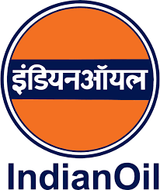

**AN INTERNSHIP REPORT**

***Submitted by***

##### G.KEERTHIVASAN (2021505020)

***in partial fulfilment for the award of the***

***degree of***

**BACHELOR OF ENGINEERING**

***in***

**ELECTRONICS AND INSTRUMENTATION ENGINEERING**



**DEPARTMENT OF INSTRUMENTATION ENGINEERING**

**MADRAS INSTITUTE OF TECHNOLOGY**

**ANNA UNIVERSITY: CHENNAI-600 044**

**JUNE 2024**

**BONAFIDE CERTIFICATE**

This is to certify that the submitted report is a Bonafide work done by G.Keerthivasan (2021505020), B.E Electronics and Instrumentation Engineering, Madras Institute of Technology, Chromepet, and has done an internship in Indian Oil Corporation Limited at Tondiarpet Terminal as a part of the curriculum during the period of 12.06.2024 to 12.07.2024 regularly.

|  |  |
| --- | --- |
|  | **Mr.Rampothi kartheek**  **Assistant Manager**  (Tondiarpet Terminal) |

|  |  |  |
| --- | --- | --- |
|  |  |  |
|  |  |  |
|  |  |  |
|  |  |  |

# **ACKNOWLEDGEMENT**

I extend my sincere appreciation to **Prof. Dr. S. Srinivas**, Head of the Department, Electronics and Instrumentation Engineering, Anna University and for providing us with the valuable opportunity to intern at Indian Oil Corporation Limited.

We would like to thank the **Mrs. Meera, Chief** Terminal Manager of Indian Oil Cooperation Limited Tondiarpet Terminal, and **Mr. Rampothi Kartheek,** Assistant manager of Indian Oil Cooperation Limited Tondiarpet Terminal for giving us the golden opportunity to do an internship at IOCL.

We owe our sincere thanks to the Terminal team members for giving us access to various facilities available in the terminal for completing our intern work.

We are extremely grateful to all the engineers, plant operators and trainees who have taken time besides their busy schedule to explain about the storage and dispatch process taking place in IOCL, Tondiarpet Terminal. We express our warm gratitude to all the staff and management at IOCL, for their guidance and assistance.

# **DECLARATION**

G. KEERTHIVASAN (2021505020), pursuing Bachelor of Electronic and Instrumentation Engineering in Madras Institute of Technology, Anna University, Chromepet. Chennai, hereby declare this internship report at Indian Oil Corporation Limited (IOCL) in partial fulfillment of requirements of knowledge for our degree as our original work.

|  |
| --- |
| **KEERTHIVASAN G**  **(2021505020)** |

# **TABLE OF CONTENT**

|  |  |  |
| --- | --- | --- |
| **CHAPTER No.** | **TITLE** | **PAGE NO.** |
| 1 | **INTRODUCTION**   * 1. ABOUT THE COMPANY   2. VARIOUS OPERATIONS INCLUDE | 1 |
| 2 | **TONDAIRPET TERMINAL**  2.1 PLT-PIPELINE TRANSFER  2.2 PUMP OPERATION | 5 |
| 3 | **VALVES IN TONDAIRPET TERMINAL**  3.1 TYPES OF VALVES  3.2 GATE VALVES  3.3 GLOBE VALVES  3.4 NEEDLE AND BUTTERFLY VALVES  3.5 CHECK VALVES  3.6 DBBV(DOUBLE BLOCK&BLEED VALVES)  3.7 ROSOV(REMOTE OPERATED SHUT OFF VALVES)  3.8 DIGITAL CONTROL VALVE (DCV)  3.9 MOTOR OPERATED VALVE (MOV) | 11 |
| 4 | **FLOW METERS IN TONDAIRPET TERMINAL**  4.1 TYPES OF FLOWMETERS  4.2 MASS FLOW METER  4.3 POSITIVE DISPLACEMENT METER  4.4 TURBINE FLOW METER | 19 |
| 5 | **TANK FARM AREA**  5.1 INTRODUCTION 5.2 CLASSIFICATION OF PRODUCTS 5.3 DIFFERENT TYPES OF STORAGE TANKS  5.4 FIXED ROOF TANK  5.5 EXTERNAL FLOATING ROOF TANKS 5.6 INTERNAL FLOATING ROOF TANKS (IFRS) 5.7 ABOVE GROUND HORIZONTAL TANK  5.8 MEASUREMENT DEVICES IN TANK FARM AREA  5.9 RADAR GAUGE  5.10MSTW (MULTISPORT TEMPERATURE AND WATER SENSOR)  5.11AOPS (AUTOMATIC OVERSPILL SENSOR)  5.12 PRESSURE TRANSMITTER  5.13 DENSITY PROBE  5.14 SAFETY INTEGRATED LEVELS OF TANK  5.15 AIR VENTS IN TANKS | 24 |
| 6 | **TANK LORRY FILLING**  6.1 OPERATION OF TLF  6.2EQUIPMENT IN BAYS FOR LOADING FUEL  6.3 BATCH CONTROLLER  6.4 LOADING ARM INTERLOCK SENSOR  6.5 PROXIMITY CARD READER  6.6 OVERSPILL DETECTOR  6.7 FLOW METERS  6.8 DIGITAL CONTROL VALVE  6.9 REMOTE INTERACTION TERMINAL  6.10 EARTHING RELAY | 37 |
| 7 | **TANK WAGON FILLING**  7.1 INTRODUCTION  7.2 TANK WAGON LOADING (TW)  OPERATION | 50 |
| 8 | **SAFETY MEASURES**   * 1. TYPES OF SAFETY MEASURES   2. EMERGENCY SHUTDOWN (ESD)   3. HYDROCARBON DETECTION SYSTEM (HCD)   4. DYKE VALVE POSITION INDICATOR   5. SMOKE DETECTOR   6. MANUAL CALL POINT   8.7 EARTHING SYSTEM  8.8 NON SPARKLE TOOLS | 56 |
| 9 | **FIRE FIGHTING EQUIMENT**   * 1. INTRODUCTION   2. FIRE ENGINES   3. JOCKEY PUMP OPERATION   4. SPRINKLER SYSTEM   5. FOAM POURER SYSTEM   6. HIGH-VOLUME LONG RANGE MONITOR(HVLRM)   7. FIRE EXTINGUISHERS | 61 |
| 10 | **PROGRAMMABLE LOGIC CONTROLLER**  10.1 INTRODUCTION  10.2 PARTS OF PLC  10.3 ANALOG MODULE  10.4 DIGITAL MODULE  10.5 TYPES OF COMMUNICATION PROTOCOLS IN PLC | 66 |
| 11 | **AST PLC IN IOCL TONDAIRPET TERMINAL**  11.1 INTRODUCTION  11.2 SMART TERMINAL MANAGER  11.3 OPERATION PROCEDURE FOR TLF AT IOCL  11.4 PREPARATTON OF FTLLING ADVICE NOTE (FAN) IN SMARTTERMTNAL MANAGER(STM) | 73 |
| 12 | **HONEYWELL PLC IN IOCL TONDAIRPET**  **TERMINAL**  12.1 INTRODUCTION  12.2 SYSTEM ARCHITECTURE OVERVIEW OF HONEYWELL PLC  12.3 MAIN INDEX OF STATION SCADA  12.4 A DETAILED VIEW OF THE HSD BSVI STORAGE TANKS 6, 15 AND 16 AT THE TONDIARPET TERMINAL IN STATION SCADA | 80 |
| 13 | **PROJECT**  13.1 LIST OF PROJECTS  13.2 ENHANCING FUEL DELIVERY ACCURACY THROUGH AUTOMATED CALIBRATION OF POSITIVE DISPLACEMENT METERS AT TONDIARPET TERMINAL BAYS FOR TRUCK FILLING  13.3 FIELD DATA COLLECTION FOR TRACKING CALIBRATION DUE DATES AND SERIAL NUMBERS OF PD AND MASS FLOW METERS AT INDIAN OIL'S TONDIARPET TERMINAL  13.4 CPU CARD REPLACEMENT AND PARAMETER RECONFIGURATION FOR BAY 3 BATCH CONTROLLER  13.5 INSTALLATION OF MAGNETIC PROXIMITY SENSOR FOR DYKE DRAIN VALVE 10 ON TANK 2  13.6 TESTING AND VERIFICATION OF AOPS AT TANKS 15 AND 16 SYSTEMS AT VARIOUS LOCATIONS IN THE TANK FARM | 87 |
| 14 | **CONCLUSION** | 96 |

**LIST OF FIGURES**

|  |  |  |
| --- | --- | --- |
| **FIG NO.** | **TITLE** | **PAGE NO.** |
| 1.1 | PIPELINE OF IOCL | 4 |
| 2.1 | TERMINAL LAYOUT | 5 |
| 2.2 | CENTRIFUGAL PUMP | 8 |
| 3.1 | GATE VALVE | 12 |
| 3.2 | GLOBE VALVES | 12 |
| 3.3 | NEEDLE AND BUTTERFLY VALVES | 13 |
| 3.4 | CHECK VALVES | 13 |
| 3.5 | DBBV | 14 |
| 3.6 | ROSOV | 15 |
| 3.7 | GRAPHIC REPRESENTATION OF DCV WORKING | 16 |
| 3.8 | DCV | 16 |
| 3.9 | MOV | 18 |
| 4.1 | MASS FLOW METER | 19 |
| 4.2 | POSITIVE DISPLACEMENT METER | 21 |
| 4.3 | TURBINE FLOW METER | 23 |
| 5.1 | FIXED ROOF TANK | 26 |
| 5.2 | EXTERNAL FLOATING ROOF TANKS | 26 |
| 5.3 | INTERNAL FLOATING ROOF TANKS | 27 |
| 5.4 | SETTLER TANK | 28 |
| 5.5 | RADAR GAUGE | 30 |
| 5.6 | MSTW | 31 |
| 5.7 | WORKING OF AOPS | 32 |
| 5.8 | AOPS | 32 |
| 5.9 | PRESSURE TRANSMITTER | 33 |
| 5.10 | DENSITY PROBE | 34 |
| 5.11 | AIR VENT | 36 |
| 5.12 | AIR VENT WITH SILICA GEL TRAP | 36 |
| 6.1 | TLF SHED | 37 |
| 6.2 | BAYS | 37 |
| 6.3 | ARCHITECTURE OF BAYS | 42 |
| 6.4 | BATCH CONTROLLER | 43 |
| 6.5 | LOADING ARM INTERLOCK SENSOR | 44 |
| 6.6 | LOADING ARM | 45 |
| 6.7 | PROXIMITY CARD READER | 45 |
| 6.8 | OVERSPILL DETECTOR | 46 |
| 6.9 | DCV | 47 |
| 6.10 | REMOTE INTERACTION TERMINAL | 48 |
| 6.11 | EARTHING RELAY | 49 |
| 7.1 | WAGON | 50 |
| 7.2 | WAGON GANTRY | 51 |
| 8.1 | ESD | 56 |
| 8.2 | HCD | 57 |
| 8.3 | DYKE DRAIN VALVE POSITION INDICATOR | 57 |
| 8.4 | SMOKE DETECTOR | 58 |
| 8.5 | MCP | 59 |
| 8.6 | TANK EARTHING | 59 |
| 8.7 | PIPE BONDING | 60 |
| 8.8 | NON SPARKLE TOOL | 60 |
| 9.1 | FIRE ENGINE | 62 |
| 9.2 | JOCKEY PUMP OPERATION | 63 |
| 9.3 | WATER SPRINKLER FOR TANKS | 63 |
| 9.4 | FOAM POURER | 64 |
| 9.5 | HVLRM | 64 |
| 9.6 | FIRE EXTINGUISHERS | 65 |
| 10.1 | AST PLC | 66 |
| 10.2 | HONEYWELL PLC | 67 |
| 10.3 | PARTS OF PLC | 67 |
| 10.4 | ANALOG INPUT MODULE | 69 |
| 10.5 | DIGITAL INPUT MODULE | 70 |
| 11.1 | COMMUNICATION NETWORK BETWEEN AST AND IOCL | 74 |
| 11.2 | SYSTEM ARCHITECTURE OF AST | 75 |
| 11.3 | TRUCK QUEUE | 76 |
| 11.4 | BAY DETAILS | 76 |
| 11.5 | CONFIGURATION OF TANKS | 77 |
| 12.1 | SYSTEM ARCHITECTURE OF HONEYWELL PLC | 80 |
| 12.2 | MAIN INDEX OF STATION | 83 |
| 12.3 | TANK 6,15,16 STATUS IN STATION VIEW | 85 |
| 13.3 | MASTER PD METER SKID | 88 |
| 13.2 | BAY PD METER SKID | 88 |
| 13.3 | BATCH CONTROLLER | 91 |
| 13.4 | CPU CARD OF BATCH CONTROLLER | 92 |
| 13.5 | MAGNETIC PROXIMITY SENSOR | 93 |
| 13.6 | OSNA BARRIER RELAY | 94 |
| 13.7 | INSTALLATION OF MAGNETIC PROXIMITY SENSOR | 94 |
| 13.8 | STATION VIEW OF AOPS | 95 |
| 14.1 | AERIAL VIEW OF TONDIARPET TERMINAL | 96 |

**LIST OF TABLE**

|  |  |  |
| --- | --- | --- |
| **TABLE NO.** | **TITLE** | **PAGE NO.** |
| 2.1 | PUMPS PRESENT AND MAKE | 10 |
| 5.1 | SAFETY INTEGRITY LEVELS OF TANK IN TONDIARPET TERMINAL | 35 |
| 6.1 | TLF GANTRY WITH 12 BAYS AND LOADING POINTS | 38 |
| 9.1 | CLASS OF FIRES | 61 |
| 9.2 | PRESSURE SETTING OF FIRE ENGINES | 62 |
| 9.3 | PRESSURES SETTING OF JOCKEY PUMPS | 63 |
| 13.1 | PARAMETRS IN BATCH CONTROLLER TO BE CHANGED | 90 |
|  |  |  |
|  |  |  |
|  |  |  |
|  |  |  |

**CHAPTER 1**

**INTRODUCTION**

* 1. **ABOUT THE COMPANY**

CHENNAI TERMINAL TONDIARPET of

Indian Oil Corporation Limited, a Public Sector Undertaking is located on the Ennore High Road. The Terminal, spread in an area of 18 Acres was commissioned in 1963. The terminal is part of the Tondiarpet complex which includes Lube Blending Plant with area 8.7 acres and Drum Plant with area of 6.3 acres. Total area of Tondiarpet complex is 33.0 acres. The main activities at Tondiarpet Terminal include Receipt, Storage and Distribution of Petroleum products such as ATF (Aviation Turbine Fuel), MS (Motor spirit), HSD (High Speed Diesel), FO (Furnace Oil), NMA (N-Methylanille) and Ethanol. These products are received through Dock lines (White oil line & Black oil line) from CPCL, FST and Jetty.

#### 

#### 1.2 VARIOUS OPERATIONS INCLUDE:

1. Tank truck and wagon loading to supply product to various locations
2. Pipeline receipts from CPCL Chennai and coastal receipt through pipelines from FST Chennai & BD-I & BD-III Jetties.
3. Ethanol unloading from Tank Trucks.

As the Petroleum Products are flammable and can catch fire if exposed to ignition, facilities and Operations of the Terminal are designed and maintained to prevent any incidence of fire. All internal electrical facilities in the Terminal are designed to prevent generation of spark. Tank Trucks are allowed to enter the Terminal with PESO (Petroleum and Explosive Safety Organization) approved spark arrestors only so that sparks do not come out through exhaust from the trucks. Follows norms given by the OISD (Oil Industry Safety Directorate) for implements safety standards.

Intrinsically safe junction boxes are used in wire connections in the field to prevent fire accidents by limiting the amount of energy delivered to hazardous areas, thus creating an intrinsic barrier that reduces the risk of fire or explosion.

Earthing system is provided to dissipate static electrical charges to eliminate the chances of spark during product handling. Precautions are taken during execution of maintenance and project works involving welding, cutting, grinding or any other action that can generate spark.

The Terminal takes adequate care and precautions in its operations, however in an unlikely event of fire; the Terminal is equipped with firefighting facilities which include water storage tanks of 13336KL(Pump able quantity- 12802KL) filled with water, Auto Fire Hydrant System, Monitors, Carbon dioxide extinguisher and dry chemical powder extinguishers. Foam required to fight Petroleum fires, is kept ready in the Terminal for instant use in case of emergency. Facilities to cool the Tanks, Tank Trucks, Tank Lorry Filling Shed, Tank Wagons, and Tank Wagon Filling Shed have also been provided.

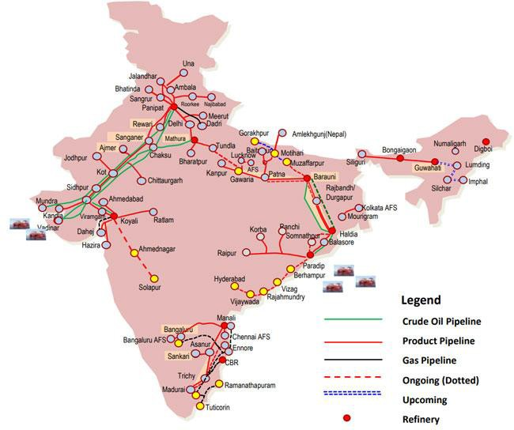 **FIG 1.1 PIPELINE OF IOCL**

# **CHAPTER 2**

# **TONDIARPET TERMINAL**

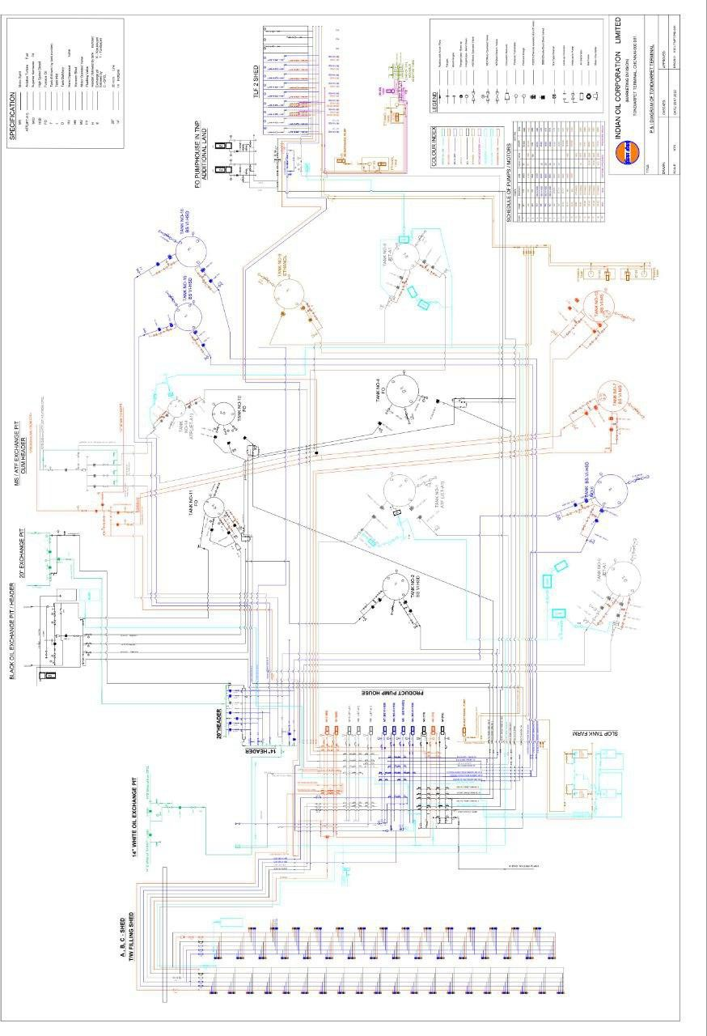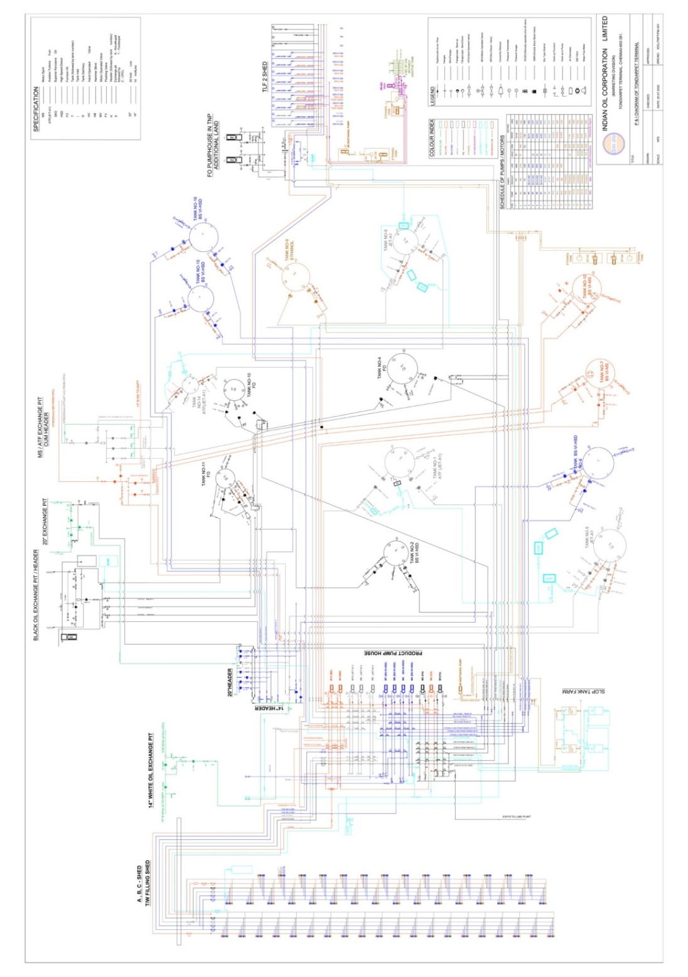

# FIG 1.2 TERMINAL LAYOUT

**FIG 2.1 TERMINAL LAYOUT**

**2.1 PLT-PIPELINE TRANSPORT**

* The products like:
  + ATF -AVIATION TURBINE FUEL
  + MS -MOTOR SPIRIT
  + HSD -HIGH SPEED DIESEL
  + FO -FURNACE OIL
  + Ethanol

Are received from CPCL through pipelines, FST & Tankers.

* The products are transported either through dedicated pipelines depending upon the characteristics of the product sent.
  + DEDICATED PIPELINES -used for the transport of only one product alone. It will be assigned for that product alone.
* The tanks must be nominated based on the guidelines for the storage of the products.
* Quality certificate of pipeline content and the nominated tank for PLT is collected.
* The nominated Tank has to be kept in Receipt mode. That is ROSOV and DBBV valve must be in opened condition.
* Opening of ROSOV must be done from the push button station outside the dyke
* Closing of ROSOSV must be one from the control room.
* DBBV can be opened or closed from the control room.
* DBBV can also opened by manual control in it or by push button station outside the dyke
* Expansion valves in the nominated receipt pipeline and tank should be in closed condition.
* The lining up of the nominated receipt tank is checked. The information is then passed to pump house.
* And the pumping starts at the lower flow rate. On confirmation of the product receipt into the tank the pumping rate is increased to operating level.
* The pipeline sample is monitored for every 10 minutes and temperature and density are measured.
* If variation is more than + 0.003 (0.0025 for ATF) investigation is to be held after stopping PLT.
* While receiving product in the pipeline, sample to be collected from line during initial, middle and end of the batch.
* After confirmation from pumping station for stoppage, ensure if the pipeline pressure is zero and close all the valves.
* Pipeline expansion valves to be opened.

# **2.2 PUMP OPERATION**

The pumps used in Tondiarpet Terminal are centrifugal pump. This pump works by using centrifugal force. In the pump, the liquid is forced to revolve and therefore exerts a centrifugal force on the liquid as in the case around the revolving wheel or impeller which is equal to the discharge pressure in head.

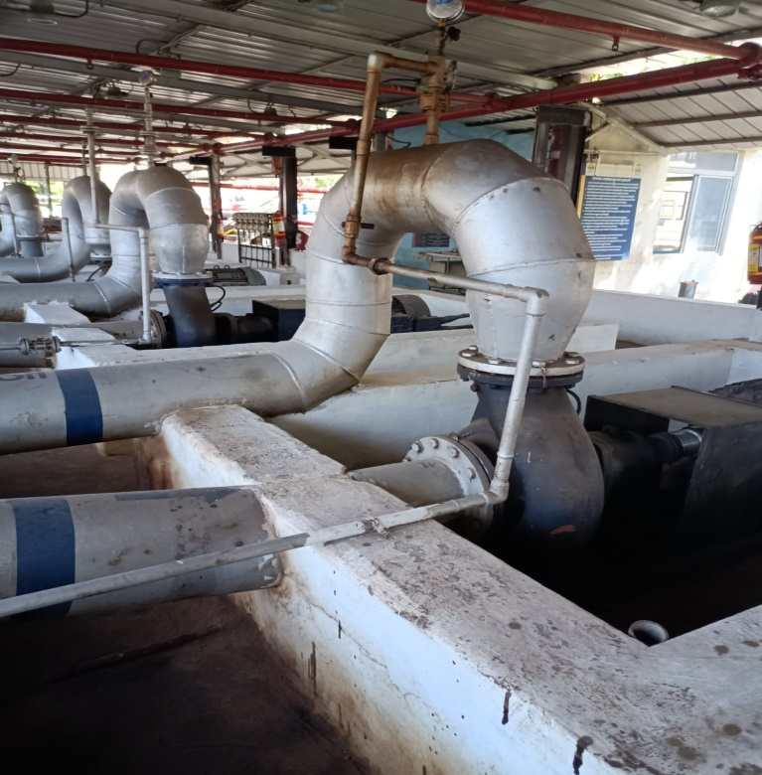

**FIG 2.2 CENTRIFUGAL PUMP**

Different parts of the centrifugal pumps:

* Stuffing Box
* Mechanical Seal
* Bearing Lubrication and Cooling
* Stuffing Box:

When pressure at its inner end is

Below atmospheric pressure, the stuffing box prevents air leakage into the pump and when pressure at the inner end is above atmospheric pressure, the stuffing box prevents liquid leaking out the pump.

* Mechanical Seal:

A mechanical seal provides a leak

Proof design with low power losses for a wide range of liquids.

* Bearing Lubrication and Cooling:

Ball bearings are generally grease lubricated although in large size bearings oil lubrication is frequently used. If the amount of heat generated in the bearings is too much to be dissipated by air cooling, water cooling becomes necessary.

PRIMING OF PUMPS:

Priming means removal of air, gas or vapours from the liquid ways of the pump by filling them with liquid to be pumped. When first put in service or after maintenance the liquid ways of the pumps are filled with air. When the liquid is introduced under pressure, the air is trapped in the pump.This air is vented out through a valve meant for this purpose.

**TABLE 2.1 PUMPS PRESENT AND MAKE**

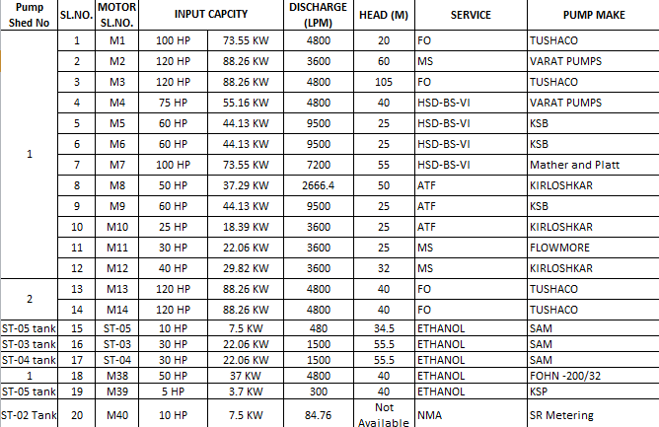

# **CHAPTER 3**

# **VALVES IN TONDAIRPET TERMINAL**

**3.1 TYPES OF VALVES**

In Tondiarpet terminal, different types of valves are used. They are mainly:

* Gate valves
* Globe valves
* Needle and butterfly valves
* Check valves
* DBBV(Double Block Bleed Valves)
* ROSOV(Remote Operated Shut Off Valves)
* Digital control valve (DCV)
* Motor operated valve (MOV)

###### 3.2 Gate Valves:

A Gate valve is a control valve that either allows media to flow through unobstructed or stops the fluid flow. The main advantage of a gate valve is the straight-through unobstructed passage way which induces minimal pressure loss over the valve. The unobstructed bore of a gate valve also allows for a pig's passage in cleaning pipe procedures.

However, gate valves are slower than quarter-turn valves and should only be used in the fully open or closed position, not to regulate the flow automated gate valves exist with either an electric or pneumatic actuator, but a manual gate valve is cost effective since gate valves are typically used infrequently.

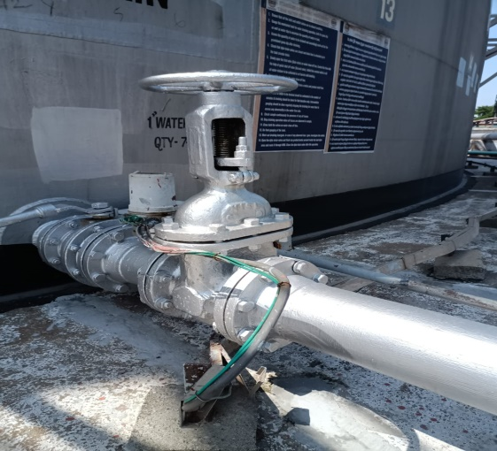

**FIG 3.1 GATE VALVE**

###### 3.3 Globe Valves:

A globe valve regulates flow in a pipeline.

It is used to control or stop the flow of liquid or gas through a pipe. It is comprised of a movable disk-type element and a stationary ring seat in a generally spherical body.

The seat of a globe valve is in the middle of and parallel to the pipe, and the opening in the seat is closed off with a disk or plug. Globe valves can be structured to handle flow in either direction.

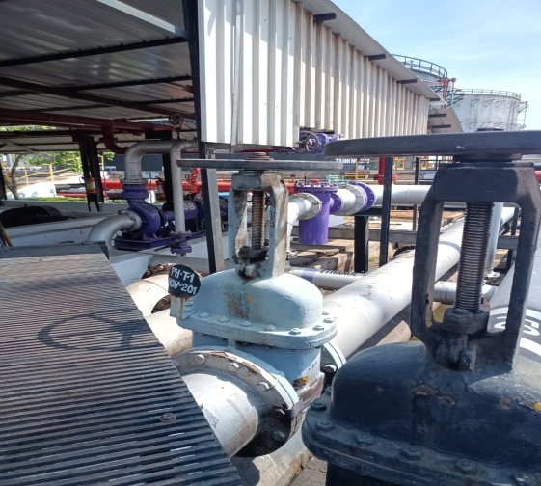

###### FIG 3.2 GLOBE VALVE

###### 3.4 Needle And Butterfly Valves:

Butterfly valves are a family of quarter-turn rotational motion valves that are used in pipelines to shut-off flow. It is often said that butterfly valves can be used to regulate the flow. However, it is not recommended, as it can damage the valve disk and have a negative effect on the sealing properties.

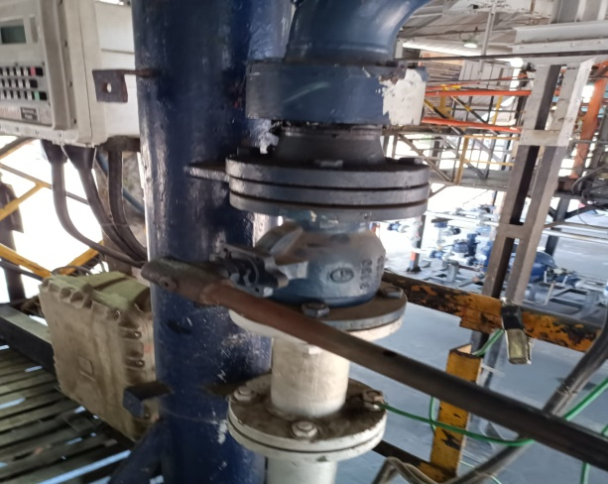

**FIG 3.3 NEEDLE AND BUTTERFLY VALVE**

###### 3.5 Check Valves or Non-Return Valves (NRV):

It is a one-way valve, in which the flow can run freely one way, but if the flow turns, the valve will close to protect the piping, other valves, pumps etc. If the flow turns and no check valve is installed, water hammer can occur. These are provided in the system to avoid back flow.

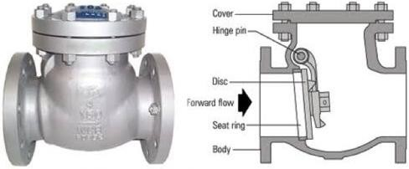

**FIG 3.4 CHECK VALVES**

##### 3.6 DOUBLE BLOCK BLEED VALVES (DBBV):

Double Block and Bleed Valve is a single assembly of two inline block valves and one bleed valve. The task of three separate valves is performed by this assembly while saving huge space, installation and maintenance time, weight, and cost.

The main aim to use a double block and bleed valve system is to ensure that the fluid from upstream and downstream do not reach other components of the system. So, engineers can easily bleed off or drain the remaining fluid from the intermediate section and execute maintenance, repair, or replacement work.

In a double block and bleed system, isolation is achieved both from upstream and downstream flow or Pressure. The bleed valve is used to drain the cavity created between two block valves

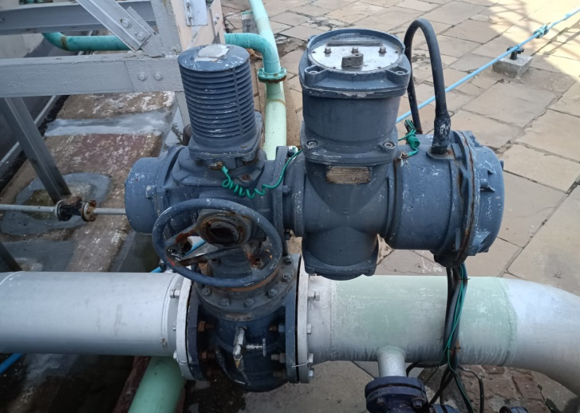.

**FIG 3.5 DBBV**

##### 

##### 3.7 REMOTE OPERATED SHUTOFF VALVE (ROSOV):

Remotely Operated Shut-Off Valve (ROSOV) is a type of Emergency Shut down Valve (ESDV) which allows a plant or facility to be isolated automatically from a safe location without the necessity for manual intervention that is designed and installed for the purpose of quickly isolating plant items which are used for the storage of hazardous substances.

In the Remote Operated Shut-Off Valve (ROSOV) scenario, in an emergency shutdown the actuator will immediately return to the predetermined safe position and will be ready to operate on then exit command when the ESD signal is reinstated.

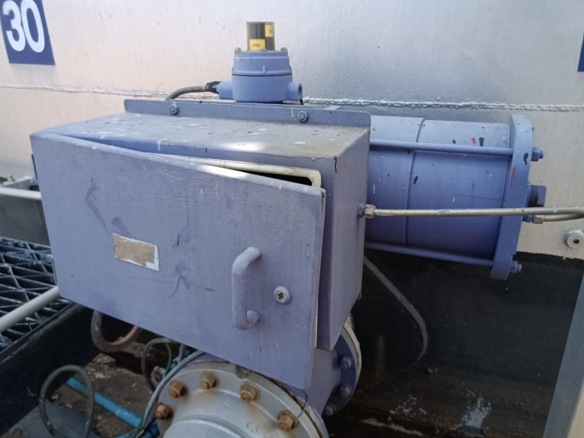

**FIG 3.6 ROSOV**

**3.8 DIGITAL CONTROL VALVE**

The Diaphragm [Digital Control Valve](https://instrumentationtools.com/digital-control-valve-calibration-procedure/) basically consists of a diaphragm operated main valve and two solenoid valves.Normally open (NO) solenoid connects the valve cover chamber to the upstream pressure, whereas normally closed (NC) solenoid connects the valve cover chamber to the downstream pressure.

When the Diaphragm Digital Control Valve is used with an electronic batch controller, it can be digitally controlled by operating the solenoid valves through any of these three stages :

* when NO and NC solenoids are energized, the valve opens gradually.
* when NC solenoid is de-energized (keeping NO solenoid energized), the valve locks at its current position.
* when NO and NC solenoids are de-energized, the valve closes gradually.

The operation of the valve is simple and is explained below. The total batch quantity delivered and controlled through the valve is divided into 7 stages (Refer graph) for the purpose of convenience.

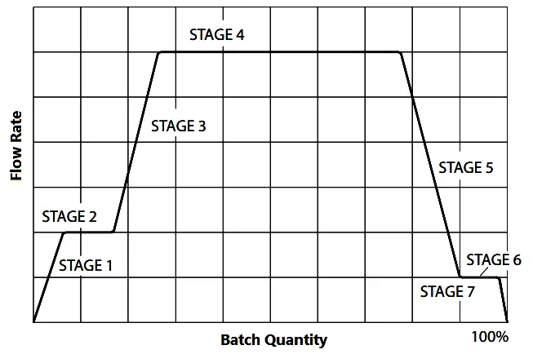

**FIG 3.7 GRAPHIC REPRESENTATION OF DCV WORKING**

Initially both NO and NC solenoid valves are in deenergised condition. The NO valve applies high upstream pressure on the diaphragm, whereas the NC valve prevents this pressure from getting drained to the downstream side

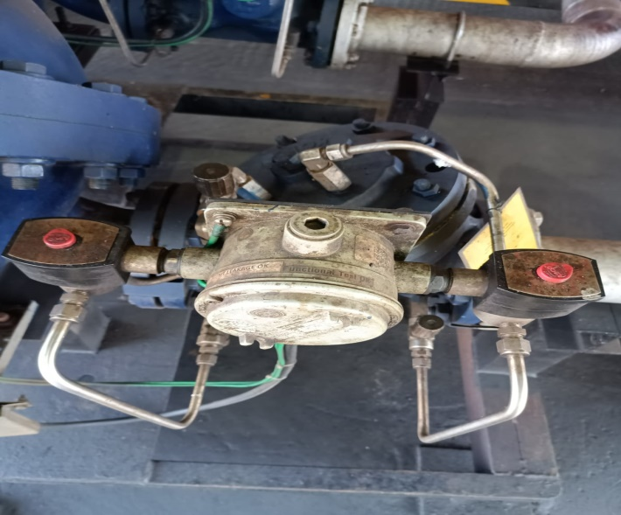

**FIG 3.8 DCV**

**Stage 1:** Both NO and NC solenoids are energized. NO valve now restricts the high upstream pressure from entering into the cover chamber. NC valve permits the pressure above the diaphragm to vent to the low downstream pressure. This creates a differential pressure across the diaphragm, the high upstream pressure acting from below the diaphragm opens the main valve and allows the flow to start through the valve.

### Stage 2: As the flow rate reaches predefined value (set in the batch controller as “Low Flow Start”) the NC valve is de-energized.This prevents further draining of the chamber and locks the valve at this flow rate. Initial delivery at slow speed avoids splashing of product and also avoids the generation of static charge.

### Stage 3: When sufficient quantity is delivered at the slow speed, the NC valve is energized again. This allows further draining of the chamber and hence increases the flow.

### Stage 4: When the flow reaches to the maximum level (set in the batch controller), the NC solenoid is de-energized. This maintains the constant high flow rate for the remaining batch.

During this stage, the flow rate control is done by the batch controller. When a number of flow meters are connected to the same pump, stopping (or starting) one or more meters increases (or decreases) the flow rate at the remaining meters.

When the flow rate increases, the NO [solenoid](https://instrumentationforum.com/t/solenoid-valve-theory/4117) is de-energized momentarily. This injects some high pressure in the cover chamber and makes the valve to throttle in order to maintain the set flow rate.

If the flow rate decreases, the NC solenoid is energized momentarily. This allows slight draining of the chamber and allows the valve to open further in order to maintain the set flow rate.

### Stage 5:At the end of the batch, the NO solenoid is de-energized. This injects high upstream pressure into the cover chamber and throttles the valve.

### Stage 6: When the valve throttles sufficiently to achieve the predefined slow closing flow rate (set in the batch controller), the NO solenoid is energized. This maintains the uniform flow rate.

### Stage 7: When the batch quantity is delivered, the NO solenoid is de-energized. (NC solenoid is already de-energized.) This applies high upstream pressure into the cover chamber, which makes the main valve to close completely to achieve bubble-tight shut-off.

**3.9 MOTOR OPERATED VALVE (MOV)**

A motor-operated valve (MOV) is a type of valve that is controlled by an electric motor. The motor rotates a shaft that is connected to the valve, which allows the valve to open or close based on the position of the motor. MOVs are commonly used in industrial and commercial applications to control the flow of fluids

**Working of a Motor Operated Valve:**

A motor-operated valve (MOV) uses an electric motor to open and close a valve. The motor is connected to the valve stem, which moves the valve’s closure element (such as a ball or gate) to change the flow of fluid through the valve when the motor is activated. The electric motor is controlled by a signal from a controller, which can be a simple switch, a programmable logic controller (PLC), or a more complex process control system. The controller sends a signal to the motor to open or close the valve based on the desired flow rate and the feedback from sensors monitoring the system’s pressure, temperature, and flow rate.

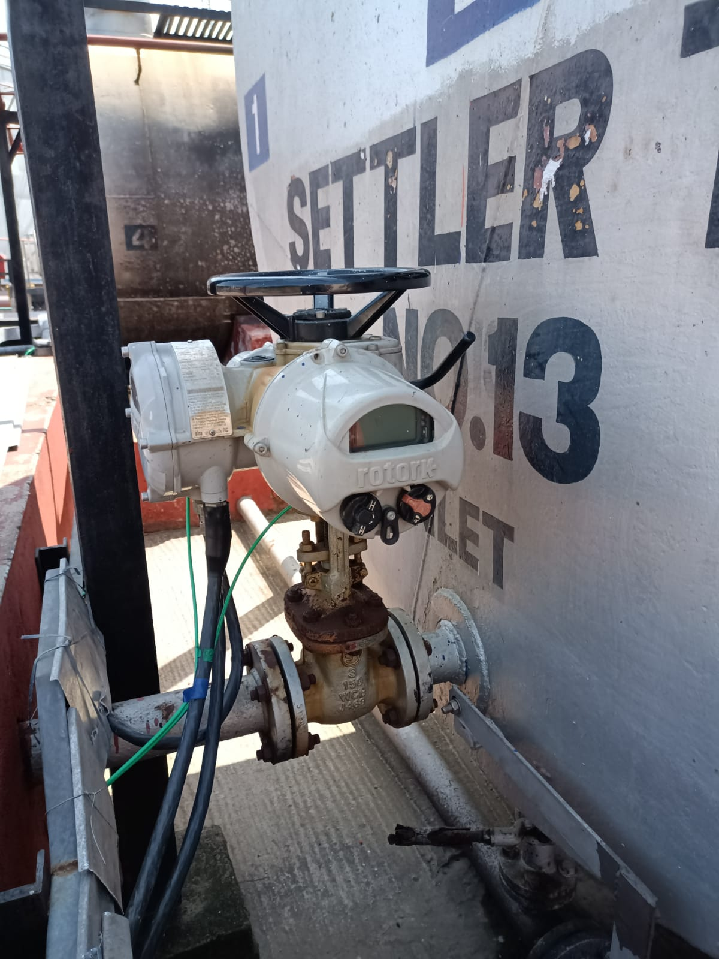

**FIG 3.9 MOV**

**CHAPTER 4**

**FLOWMETERS IN TONDAIRPET TERMINAL**

**4.1 TYPES OF FLOWMETERS**

In Indian Oil facilities, flow meters are essential tools used in bays and tanks for monitoring the product flow rate. The type of flow meter employed varies based on the product type to ensure accurate and efficient measurement:

# 

# Types of flow meters used:

# Mass flow meter

# Positive displacement meter

# Turbine flow meter

# **4.2 MASS FLOW METER**

# Used for measuring mass flow rate of Furnace Oil (FO) and water in calibration areas.

# 

The flow is guided into the U-shaped tube. When an oscillating excitation force is applied to the tube causing it to vibrate, the fluid flowing through the tube will induce a rotation or twist to the tube because of the Coriolis acceleration acting in opposite directions on either side of the applied force.

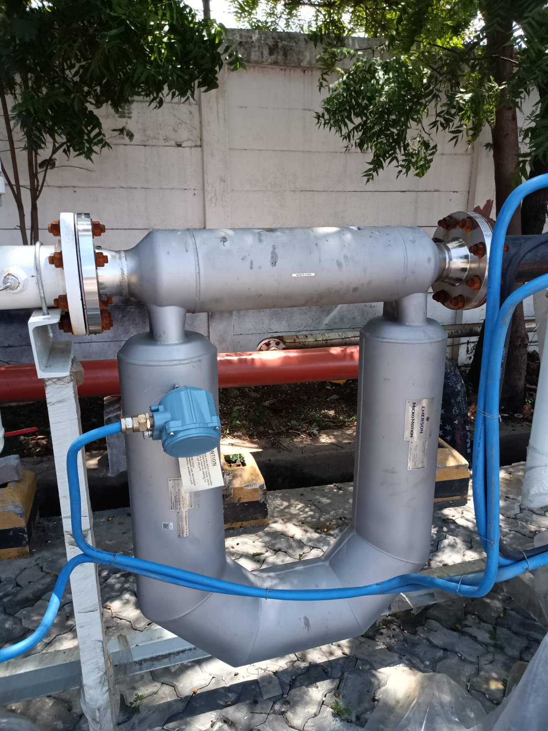

**FIG 4.1 MASS FLOW METER**

When the tube is moving upward during the first half of a cycle, the fluid flowing into the meter resists being forced up by pushing down on the tube. On the opposite side, the liquid flowing out of the meter resists having its vertical motion decreased by pushing up on the tube.

This action causes the tube to twist. When the tube is moving downward during the second half of the vibration cycle, it twists in the opposite direction.

This twist results in a phase difference (time lag) between the inlet side and the outlet side and this phase difference is directly affected by the mass passing through the tube.

**Fc= 2*m*w*V**

m= mass (kg),w= angular velocity (rad/s),V= velocity (m/s)

**Advantage:**

1. Coriolis flow meter is that it measures the mass flow rate directly which eliminates the need to compensate for changing temperature, viscosity, and pressure conditions.
2. A Coriolis flow meter is capable of measuring mass flow rate, volumetric flow rate, fluid density and temperature all from one instrument.

**4.3 POSITIVE DISPLACEMENT FLOW METER:**

Used for measuring flow rate of Motor Spirit (MS), High-Speed Diesel (HSD), and Aviation Turbine Fuel (ATF). The meter measures the volumetric flow rate by counting the number of times its internal compartments are filled and emptied

The Tri-Rotor type Positive Displacement Flow Meter, commonly called "PD Meter", measures the volume flow rate of a continuous flow stream by momentarily entrapping a discreet segment of the fluid into a chamber of precisely known volume and releasing that fluid back into the flow stream on the discharge side of the meter. This design has tree rotating parts that entrap fluid into the mentioned chamber which is formed between the rotors and an outer wall. By monitoring the number of entrapments for a known period of time or number of entrapments per unit time, the total volume of flow or the flow rate of the stream can be ascertained.

PD meters are precision instruments whose internal moving components are mass-balanced yet remain hydraulically imbalanced. The result is that the meter can measure very low flows of both liquids and gases without using external power. The PD meter derives the power necessary to work from the energy contained in the flow process.

As illustrated in the pictures below each moving chamber of fluid is separated from the next chamber by a capillary seal, the integrity of which is a function of the precision to which the meter is manufactured. This high precision allows these meters to be almost universally accepted as transfer standards when properly installed and flow-calibrated

Advances in technology allow the meters to be temperature-compensated and interfaced electronically with central control systems as easily as they can be the integral part of a truck-mounted delivery system. The total volume and the flow rate can then be displayed locally or transmitted to a remote monitoring station.

The Advantages of Meters Control PD Meters are the high quality, the high accuracy and the wide range of usage. Furthermore they are very reliable, insensitive to inlet flow profile distortions with long service time period due to lack of points of friction. Also they have low pressure drop across the meter.

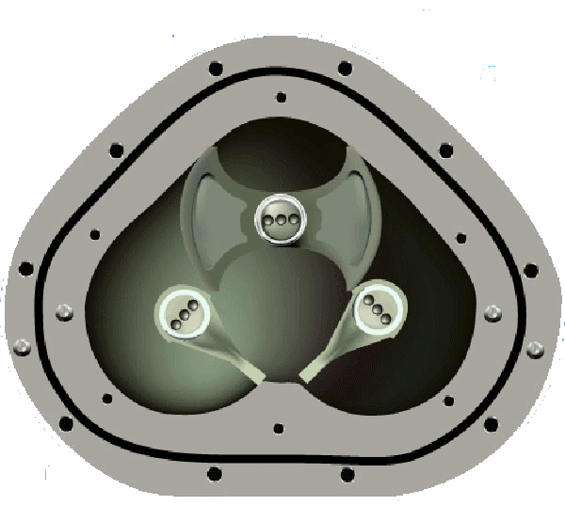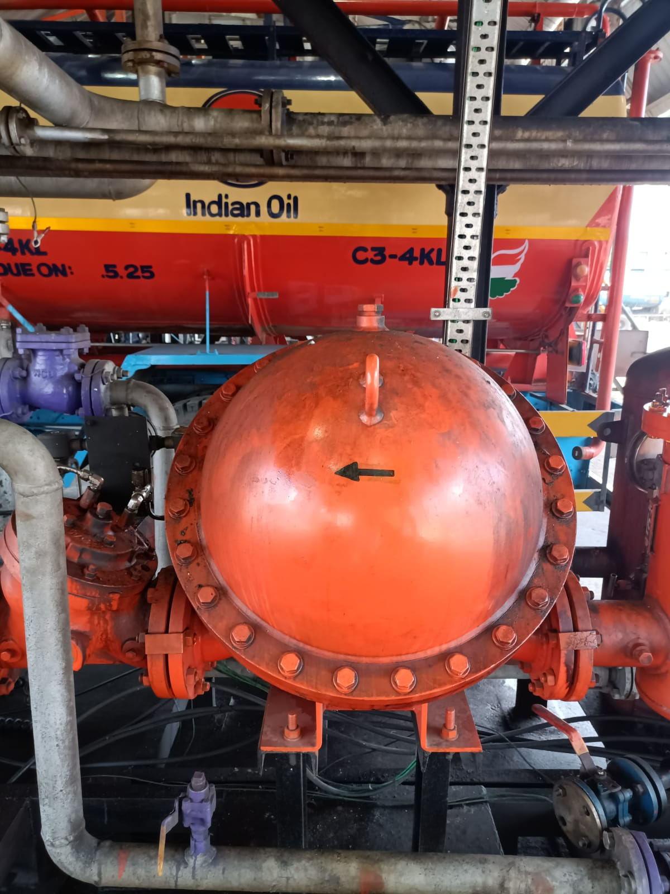

**FIG 4.2 POSITIVE DISPLACEMENT FLOWMETER**

# **4.4 TURBINE FLOW METER:**

The meter measures the fluid's velocity, which spins a rotor. The rotor's speed is proportional to the volumetric flow rate. The rotational speed is converted to a flow rate using the meter's calibration factor (K-factor), which relates rotor speed to volume flow rate. The total volume is then calculated by integrating the flow rate over the duration of the flow, giving the quantity supplied in units such as litres

It consists of a flow tube with end connections and a magnetic multi-bladed free-spinning rotor (impeller) mounted inside; in line with the flow. The [rotor](https://instrumentationtools.com/rotork-motor-operated-valve-basic-configuration/) is supported by a shaft that rests on internally mounted supports.

 The Supports in Process Automatics Turbine Flow Meters are designed to also act as flow straighteners, stabilizing the flow and minimizing the negative effects of turbulence.

The Supports also house the unique open bearings; allowing for the measured media to lubricate the bushes – prolonging the flow meter life span. The Supports are fastened by locking rings (circlips) on each end.

The rotor sits on a shaft, which in turn is suspended in the flow by the two supports. As the media flows, a force is applied on the rotor wings. The angle and shape of the wings transform the horizontal force into a perpendicular force, creating rotation. Therefore, the rotation of the rotor is proportional to the applied force of the [flow](https://instrumentationtools.com/magnetic-flowmeter-vs-turbine-flowmeter/).

Because of this, the rotor will immediately rotate as soon as the media induces a forward force. As the rotor cannot turn through the media on its own, it will stop as soon as the media stops. This ensures an extremely fast response time, making the Turbine Flow Meter ideal for batching applications.

A pick-up sensor is mounted above the rotor. When the magnetic blades pass by the pickup sensor, a signal is generated for each passing blade. This provides a pulsed signal proportional to the speed of the rotor and represents pulses per volumetric unit.; and as such the flow rate.

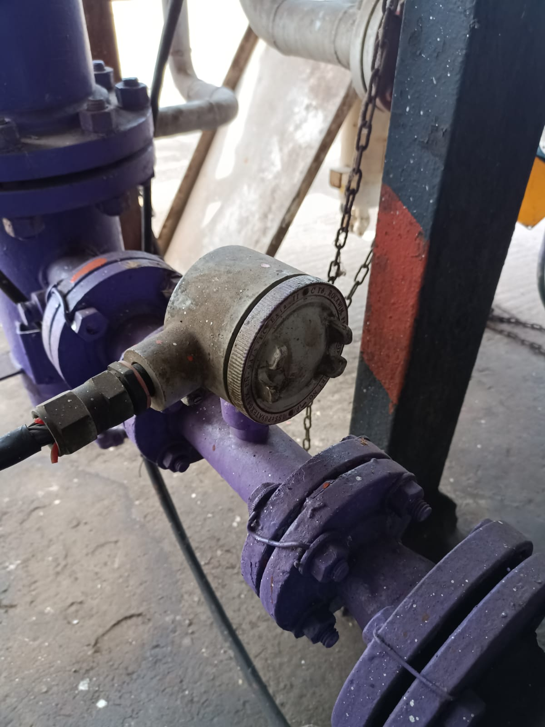

**FIG 4.3 TURBINE FLOW METER**

# 

# **CHAPTER 5**

# **TANK FARM AREA**

**5.1 INTRODUCTION**

The products received from CPCL through pipelines are stored in the terminal in storage tanks. The architecture of the storage tank varies for different products. The storage tanks are designed and built to the American petroleum institute API-650 specification.

The products are stored in different tanks based on their characteristics. There are various equipment and sensors to indicate the level, temperature, density, and there are also pressure vents at the roof of the storage tanks.

#### 5.2 CLASSIFICATTON OF PRODUCTS:

The products are classified into different classes according to their flash point as follows:

* Class A Petroleum: liquids which have flash point below 23degrees centigrade.
* Class B Petroleum: liquids which have flash point of 23 degree centigrade above but below 65 degrees centigrade.
* Class C Petroleum: liquids which have flash point of 65 degree centigrade above but below 93 degrees centigrade.
* Excluded Petroleum: liquids which have flash point of 93degree centigrade and above.

**5.3 DIFFERENT TYPES OF STORAGE TANKS**:

There is different type of storage tanks based on their roofs. In this terminal there are three major storage tanks they are

* Fixed roof tank
* External floating roof tank
* Internal floating roof tank
* Above ground horizontal tank

### 5.4 FIXED ROOF TANK:

A fixed roof storage tank is a type of storage tank that has a permanent roof structure, which remains fixed in place and does not move or open. It is commonly used for storing liquids, such as petroleum products, chemicals, and water.

The tank's roof is typically a welded or riveted steel plate that is permanently attached to the tank shell, providing structural integrity, and protecting the stored liquid from external elements.

Fixed roof storage tanks are designed to handle liquids that do not generate significant vapors or require pressure relief systems.

The products like ATF, HSD and FO are stored in fixed roof storage tanks. They are not suitable for storing gases or highly volatile substances.

The tanks are equipped with

* + Venting systems - to accommodate changes in liquid volume due to temperature variations or liquid level fluctuations, preventing the buildup of pressure or vacuum inside the tank.
  + Radar gauges- also known as tank level gauges or level transmitters are commonly used on the roofs of storage tanks to measure the liquid level inside the tank. These gauges utilize radar technology to provide accurate and reliable measurements without the need for direct contact with the liquid. There are usually two radar gauges at the top storage tanks.

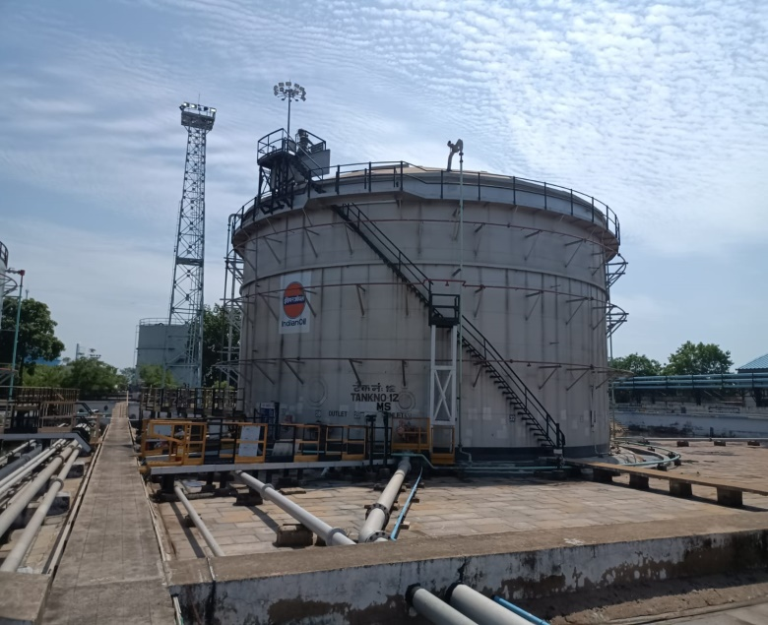

**FIG 5.1 FIXED ROOF TANK**

#### 5.5 EXTERNAL FLOATING ROOF TANKS (EFRs):

An External Floating Roof Tank has a fixed roof and a floating roof that rests on the surface of the stored liquid. The floating roof moves up and down with the liquid level, reducing the vapor space above the liquid and minimizing evaporative losses.

In this type of tanks products like MS and Ethanol. Like fixed roof tank it is also equipped with venting system and radar gauges.

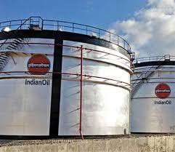

**FIG 5.2 EXTERNAL FLOATING ROOF TANK**

#### 5.6 INTERNAL FLOATING ROOF TANKS (IFRS):

Internal Floating Roof Tanks are commonly used for the storage of flammable liquids and volatile chemicals. Internal Floating Roof Tanks have a fixed roof, like other storage tanks, but also feature a floating roof inside the tank. The floating roof is designed to float on the surface of the stored liquid, reducing vapor space and minimizing product evaporation.

The floating roof in an IFR tank is typically made of lightweight materials like aluminum or stainless steel. It floats on the liquid surface and moves with the liquid level.

It is equipped with various equipment like:

* + Vents and Drains: IFR tanks are equipped with vents and drains to manage pressure, accommodate liquid level changes, and handle rainwater accumulation on the floating roof.
  + Pontoon or Leg Supports: The floating roof is supported by pontoon or leg supports that provide buoyancy and stability. These supports maintain the position of the floating roof as the liquid level changes.

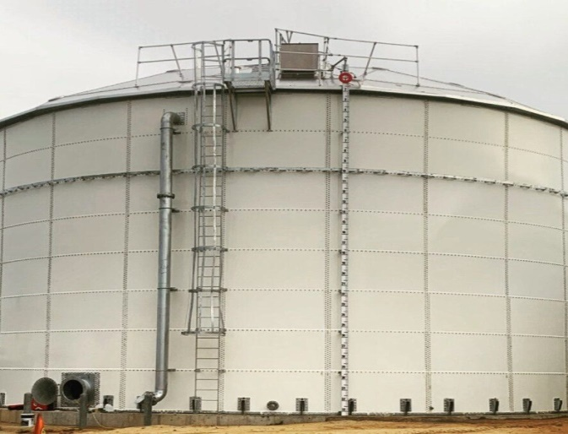

**FIG 5.3 INTERNAL FLOATING ROOF TANKS**

**5.7 ABOVE GROUND HORIZONTAL TANK**

The above ground horizontal tank, also known as a settler tank in IOCL, is designed specifically to separate suspended particles and impurities from fuel, ensuring cleaner and more efficient fuel usage. It is commonly used in various industrial processes, refineries, and fuel storage facilities.

The tank's structure consists of a large basin where the fuel can remain relatively still, allowing gravity to naturally separate the heavier particles from the fuel. The particles settle at the bottom of the tank, forming a layer of sludge, while the clarified fuel flows out from the top or the side of the tank.

Settler tanks are designed to handle a variety of fuels that contain suspended solids. They are not suitable for storing gases or highly volatile substances.

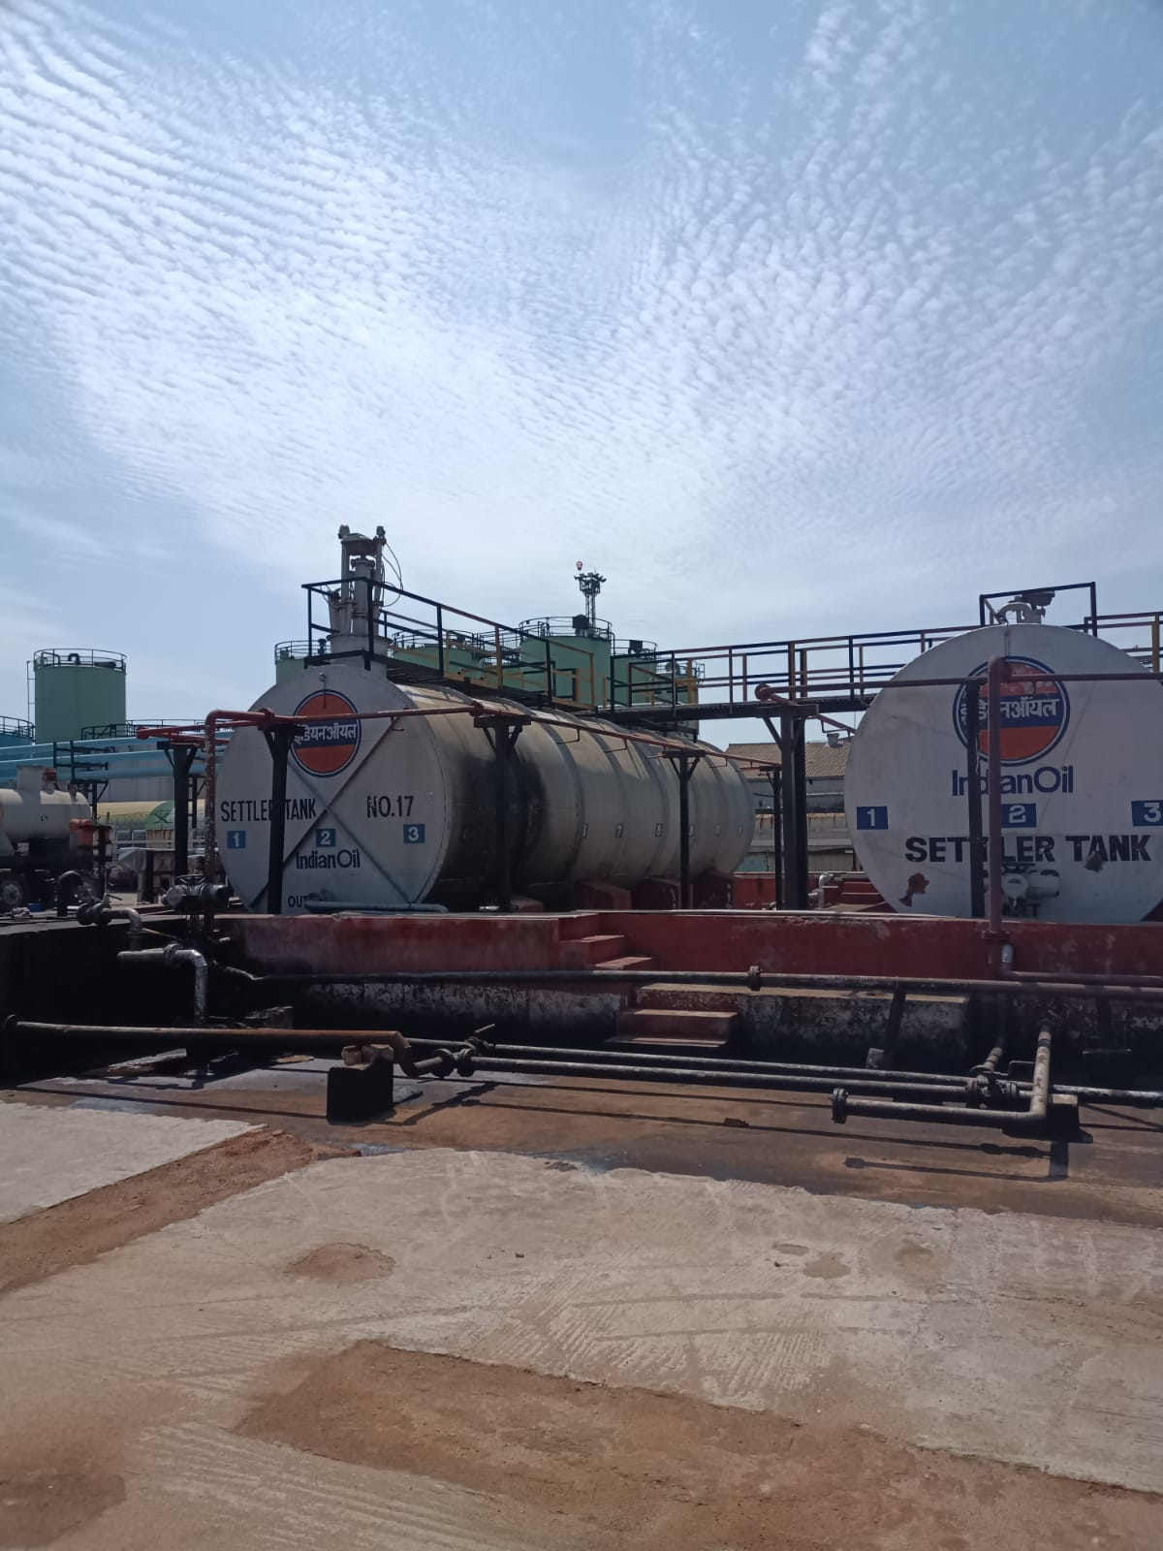

**FIG 5.4 ABOVE GROUND HORIZONTAL TANK**

**5.8 MEASUREMENT DEVICES IN TANK FARM AREA:**

In a tank farm, various equipment and parameters are crucial for monitoring and maintaining safe and efficient operations**.**

Equipment are:

* Radar gauge
* MSTW(Multisport temperature and water sensor)
* AOPS(Automatic Overspill sensor)
* Pressure transmitter
* Density probe

**5.9 RADAR GAUGE:**

These instruments operate on the principle of time-domain reflectometry (TDR), emitting microwave signals that travel down a probe into the fuel.

Upon reaching the fuel surface, a portion of the signal reflects back to the gauge. By measuring the time it takes for the signal to return, the radar gauge accurately calculates the distance to the fuel surface, thereby determining the fuel level inside the tank.

This method ensures precise and reliable measurements, unaffected by factors like temperature variations or vapor presence within the tank. Radar gauges are favored for their ability to provide real-time data, essential for efficient inventory management, operational safety, and regulatory compliance in fuel storage facilities and refineries**.**

They are two radar gauge used

1. Primary radar gauge: The primary radar gauge provides accurate, real-time level measurements essential for efficient inventory management and operational control. It is connected to the Honeywell process plc.
2. Secondary radar gauge: The secondary radar gauge serves as a backup, ensuring an additional layer of safety by monitoring fuel levels independently. This dual-gauge setup helps Indian Oil maintain precise control over fuel storage, enhancing both the safety and efficiency of their operations. Connected to the Honeywell safety plc.

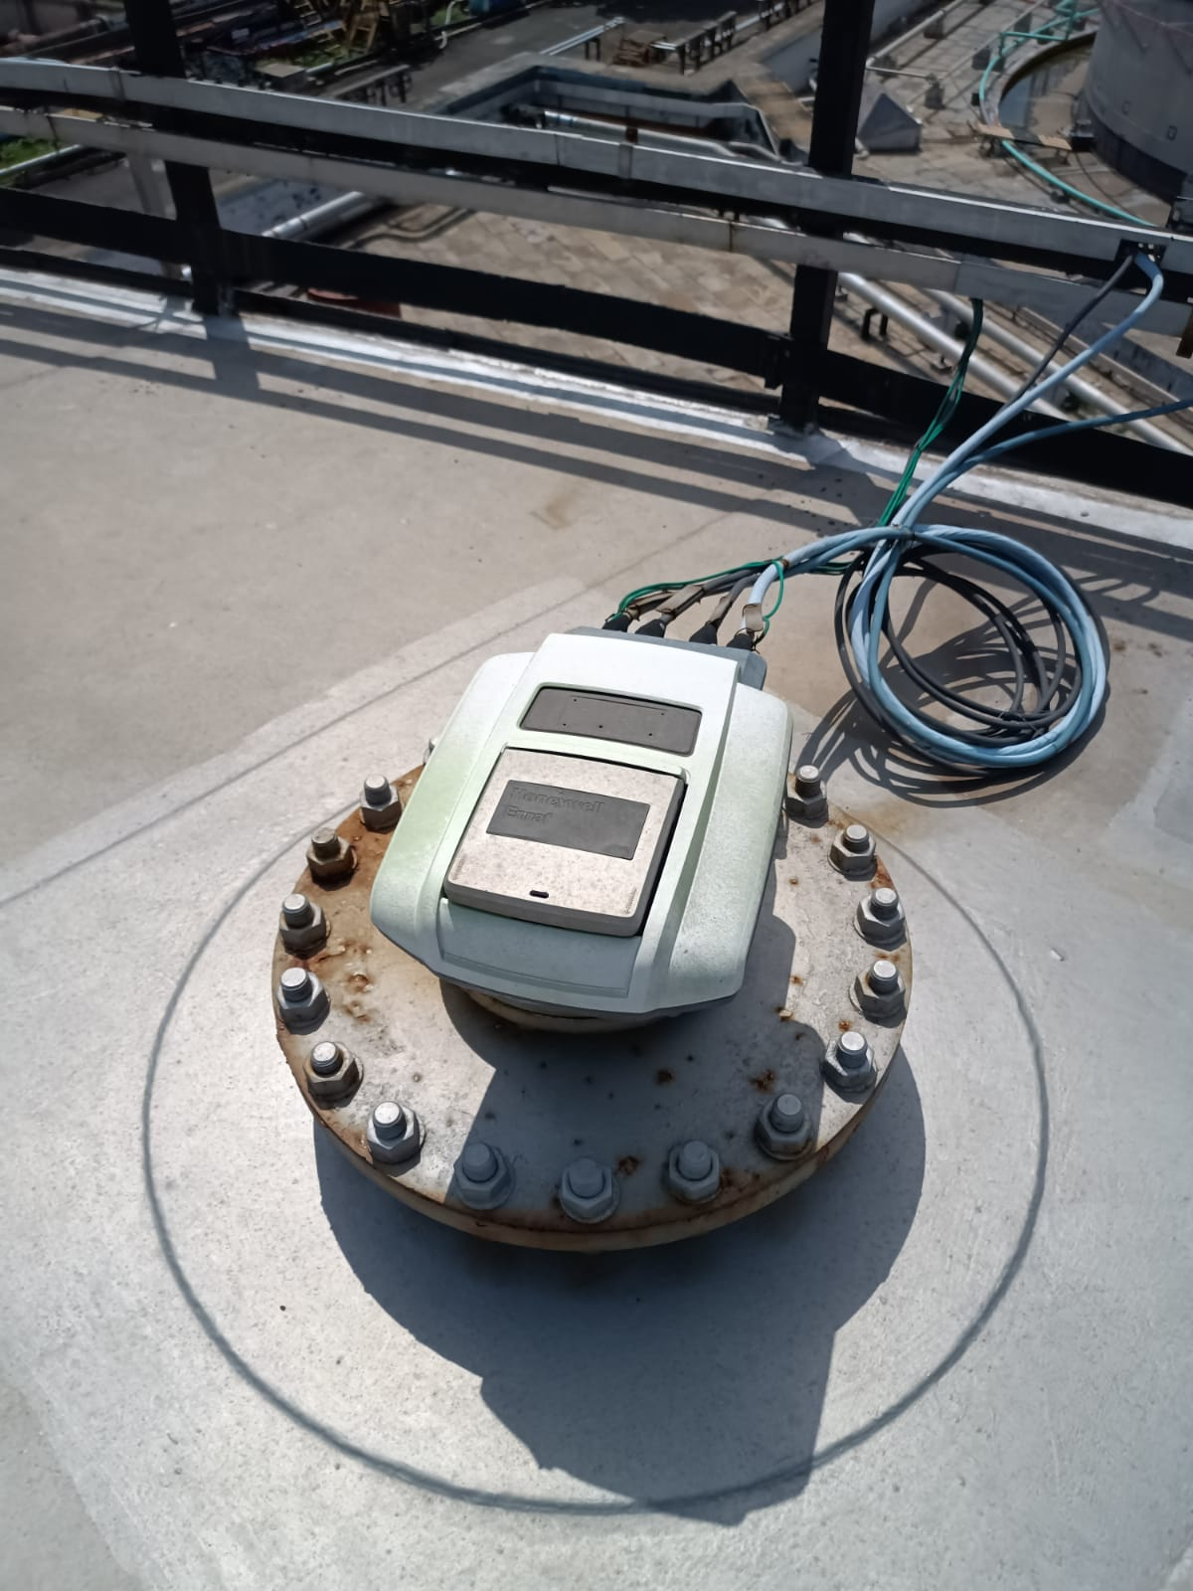

**FIG 5.5 RADAR GAUGE**

**5.10 MSTW (Multisport temperature and water sensor)**

The multi-spot temperature sensor system is installed at nine different points within the tank, providing a detailed temperature profile across various levels and locations. This setup ensures precise monitoring of temperature variations, which is crucial for preventing thermal degradation of the stored fuel and for optimizing heating and cooling processes.

Additionally, the water level sensor is strategically placed to detect any presence of water or contaminants at specific points within the tank. This is essential for maintaining fuel quality and preventing water ingress, which can lead to operational issues or contamination. Together, these sensors enhance the safety, efficiency, and reliability of the tank farm operations at Indian Oil.

* The MSTW probe is inserted vertically into the tank. Each temperature sensor measures the temperature at its specific location within the tank, providing a vertical temperature profile. These sensors can be resistance temperature detectors (RTDs), or other types of temperature sensing elements that convert temperature into an electrical signal.
* Water detection sensors, typically located at the bottom of the probe, are designed to identify the presence of water. These can be capacitive, resistive, or optical sensors that detect changes in the electrical properties or optical characteristics when water is present

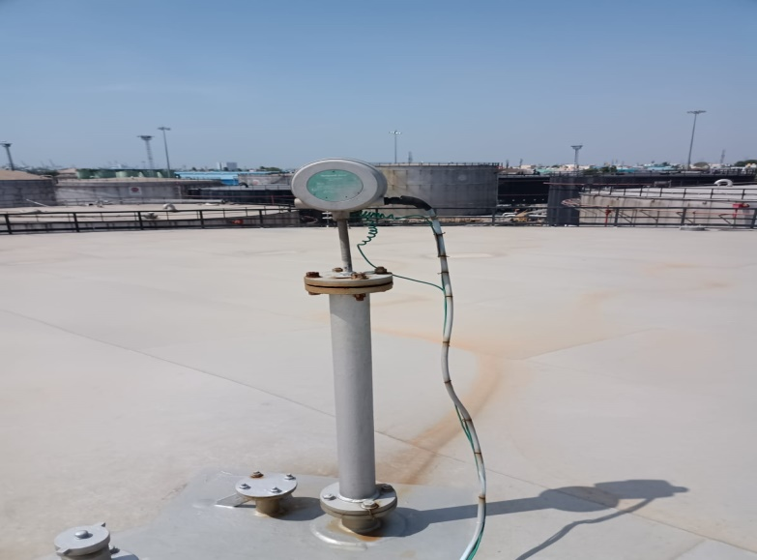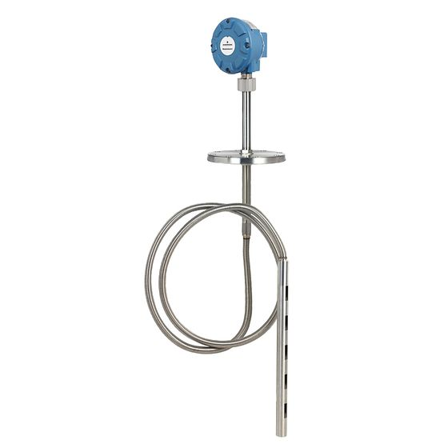

**FIG 5.6 MSTW**

**5.11 AOPS (Automatic Overspill sensor)**

The automatic overspill sensor is an essential safety feature used to prevent tank overfilling. This system employs a vibration fork, strategically placed at the end of the sensor within the storage tank. When the fuel level rises and reaches the predetermined safer limit, the liquid comes into contact with the vibration fork. This contact causes a change in the vibration frequency of the fork, which acts as a switch to signal that the maximum safe fuel level has been reached.

The system then triggers an alarm or automatically halts the filling process, ensuring that the tank does not overfill. This technology is crucial for maintaining safety standards, preventing spills, and ensuring environmental protection in fuel storage operations.

The natural frequency of oscillation for the tuning fork level switch decreases as it covered with the liquid application media. The threshold frequency is set to match the natural frequency of tuning fork type level switch under water as shown here

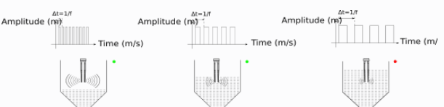   **FIG 5.7 WORKING OF AOPS**

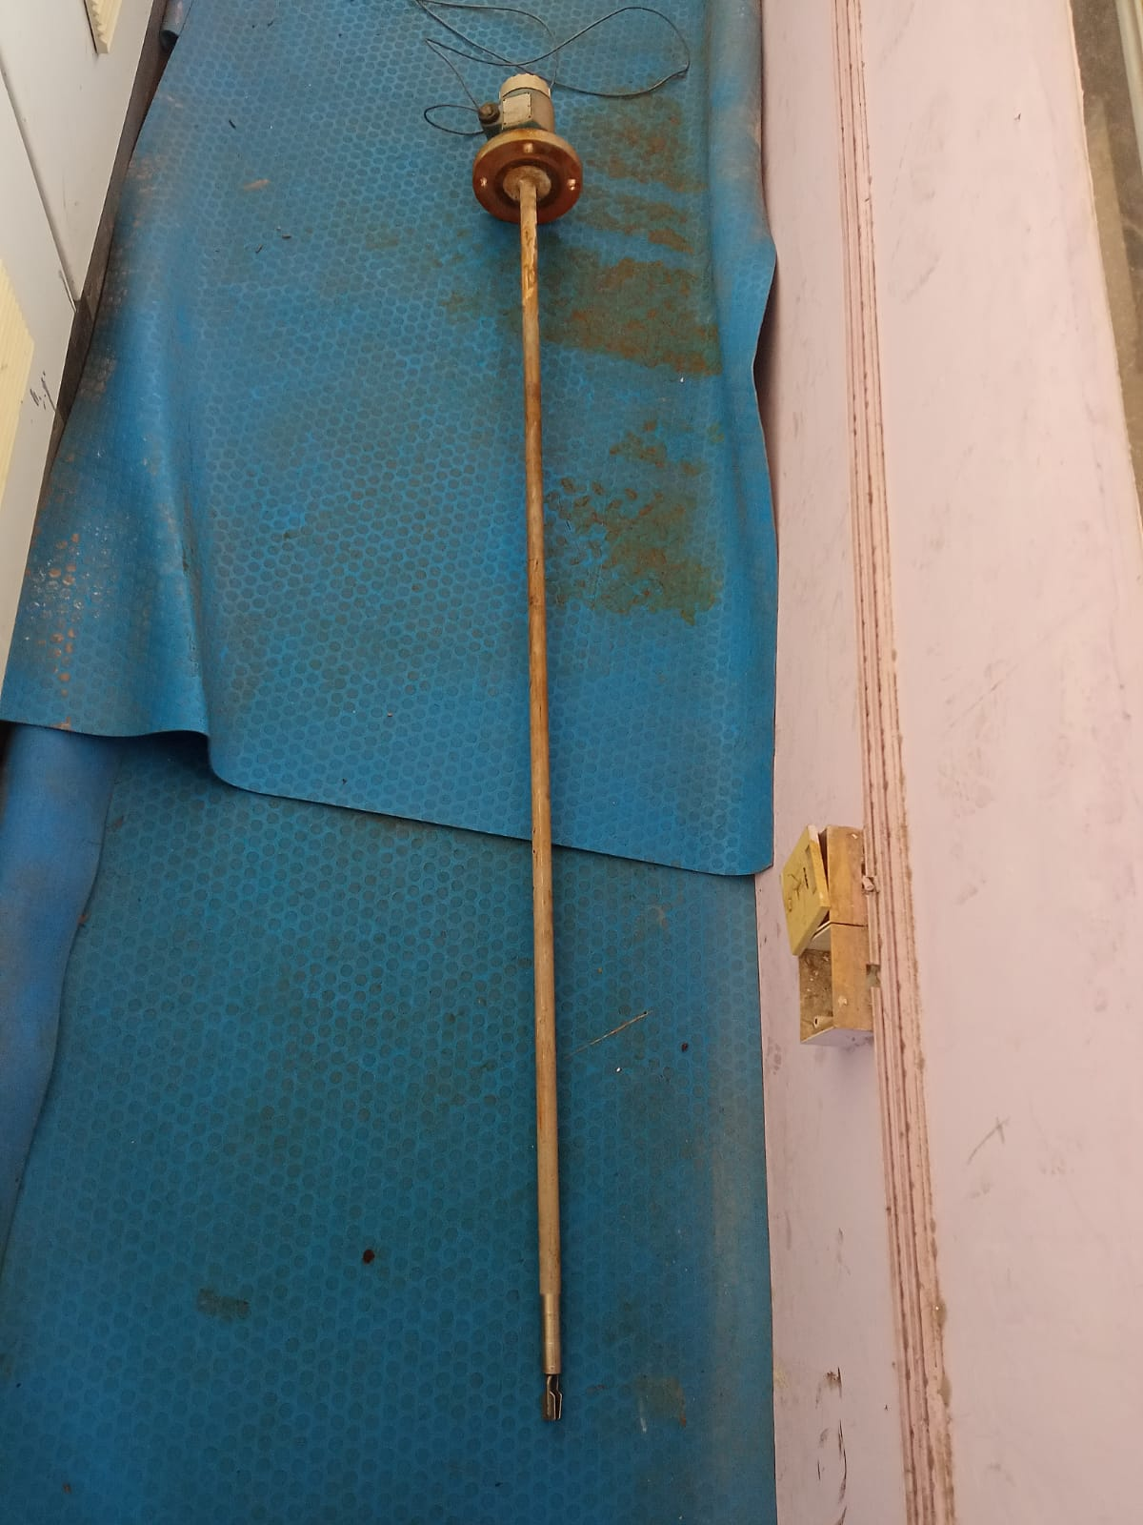

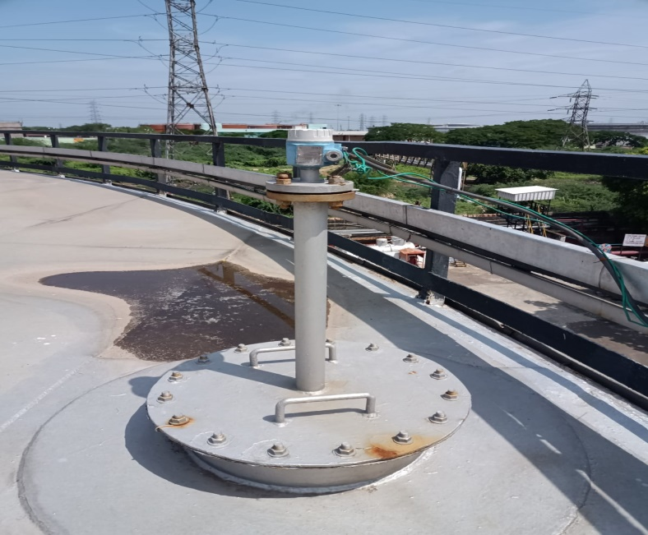

**FIG 5.8 AOPS**

**5.12 PRESSURE TRANSMITTER:**

Pressure transmitters are used at the bottom of the tank to measure the pressure exerted by the liquid column above. This pressure measurement can be used to determine the density of the stored fuel. The pressure at the bottom of the tank is directly proportional to the height of the liquid column and its density.

Follows HART communication(Highway Addressable Remote Transducer) and connected to top of the tank with MSTW

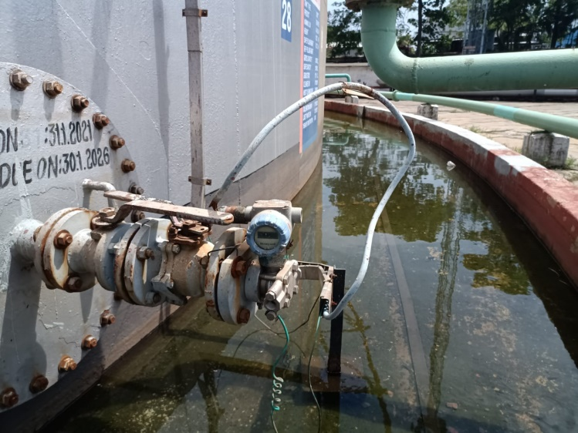

**FIG 5.9 PRESSURE TRANSMITTER**

P=ρ⋅g⋅h

Where 𝑃 is the pressure, ρ is the fuel density, g is the acceleration due to gravity, and h is the height of the fuel column.

**5.13 DENSITY PROBE**

A density probe, also known as a density meter or densitometer, is used in settler tanks to measure the density of the liquid

They use vibrating element density probe in Indian oil

**Working Principle:**

1) The probe has a vibrating element, such as a tuning fork or vibrating rod, located at the end of the probe that is submerged in the liquid.

2) When the probe is immersed in the liquid, the vibrating element oscillates at a specific frequency.

3) The frequency of these oscillations changes depending on the density of the liquid. The denser the liquid, the more it dampens the vibration, causing a decrease in the frequency.

4) The change in frequency is detected by the probe's electronics, which then convert this frequency change into a density measurement.

5) The density measurement is then transmitted to a control system or display unit, which can be used for monitoring and controlling the process

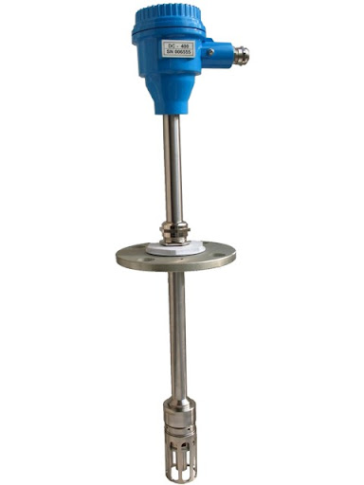

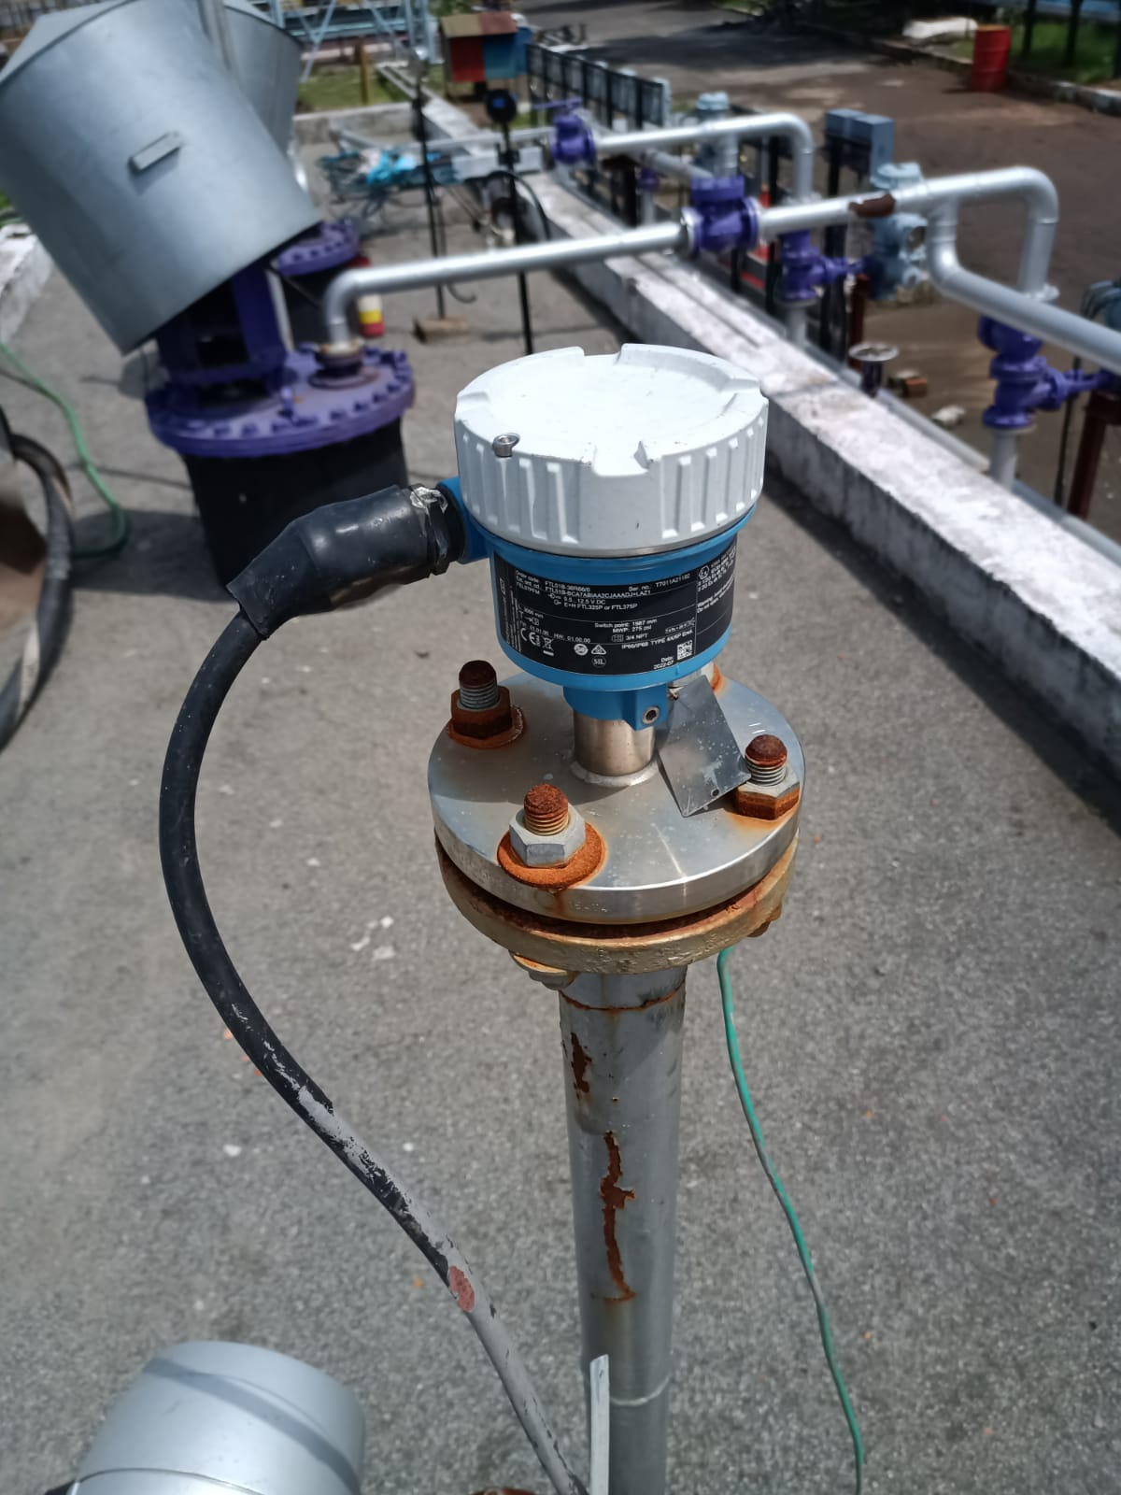

**FIG 5.10 DENSITY PROBE**

**5.14 SAFETY INTEGRATED LEVELS OF TANK:**

At the Tondiarpet Terminal of Indian Oil, there are a total of 13 storage tanks dedicated to different types of fuel and chemicals. This includes 2 tanks for Furnace Oil (FO), 2 tanks for Motor Spirit (MS), 4 tanks for Ethanol, 2 tanks for Aviation Turbine Fuel (ATF), and 3 tanks for High-Speed Diesel (HSD).

Each storage tank is equipped with four fixed level points to ensure safe and efficient operation:

1. **HHH (High-High-High) - Safety Filling Height**: This is the maximum allowable filling height for the tank, where an Automatic Overfill Prevention System (AOPS) is fixed. This system ensures that the tank does not overfill, providing a critical safety measure.
2. **HH (High-High)**: This level is set 10 minutes below the HHH level, based on the maximum inflow rate of the inlet valve. It serves as a precautionary level to manage the filling process and prevent reaching the HHH level.
3. **L (Low)**: This level is set 5 minutes above the LL level, based on the outlet flow rate. It ensures there is enough products in the tank to maintain the supply without reaching critically low levels.
4. **LL (Low-Low)**: This point is above the dead stock level, where the pump inlet is fixed for fuel supply. It ensures that the tank maintains a minimum operational level of fuel.

**Dead Stock**: This is the bottom layer of the tank where water and any contaminants such as dust settle. It is not used in normal fuel supply operations, ensuring that only clean product are pumped out of the tank.

**TABLE 5.1 SAFETY INTEGRITY LEVELS OF TANK IN TONDIARPET TERMINAL**

|  |  |  |  |  |  |  |  |
| --- | --- | --- | --- | --- | --- | --- | --- |
| TANK NO. | PRODUCT | HEIGHT IN METER | | | VOLUMES IN KL | | |
| HHH LEVEL | HH LEVEL | H LEVEL | H LEVEL | LL LEVEL | DEAD STOCK |
| 2 | FO | 7.4 | 7.101 | 6.952 | 5154 | 612 | 517 |
| 5 | ATF | 10.056 | 9.923 | 9.857 | 7312 | 676 | 581 |
| 6 | HSD | 7.31 | 7.013 | 6.865 | 5171 | 687 | 592 |
| 7 | MS | 7.85 | 7.593 | 7.464 | 2648 | 440 | 325 |
| 8 | ETHANOL | 9.736 | 9.465 | 9.33 | 3420 | 396 | 301 |
| 11 | FO | 9.905 | 9.718 | 9.625 | 3519 | 336 | 288 |
| 12 | MS | 8.71 | 8.453 | 8.324 | 2950 | 440 | 323 |
| 14 | ATF | 9.204 | 8.99 | 8.884 | 4110 | 435 | 340 |
| 15 | HSD | 9.58 | 9.341 | 9.222 | 8585 | 840 | 745 |
| 16 | HSD | 9.72 | 9.547 | 9.461 | 12314 | 1266 | 1171 |
| ST 03 | ETHANOL | 2.65 | 2.47 | 2.34 | 62 | 1.1 | 0 |
| ST 04 | ETHANOL | 2.65 | 2.47 | 2.34 | 62 | 1.1 | 0 |
| ST 05 | ETHANOL | 1.85 | 1.85 | 1.64 | 18 | 0.321 | 0 |

**5.15 AIR VENTS IN TANKS**

Air vents are installed in tanks to regulate pressure, prevent contaminants from entering, and ensure safety by avoiding pressure build-up, which can lead to structural damage or accidents. For ethanol tanks, air vents are specifically fixed based on the inlet and outlet flow rates.

Additionally, silica gel traps are used to prevent the mixing of ethanol with air moisture, ensuring the purity and integrity of the stored ethanol.

Air vents help in preventing vapor lock by allowing gases to escape and provide a means for pressure relief during thermal expansion and contraction of the tank contents.

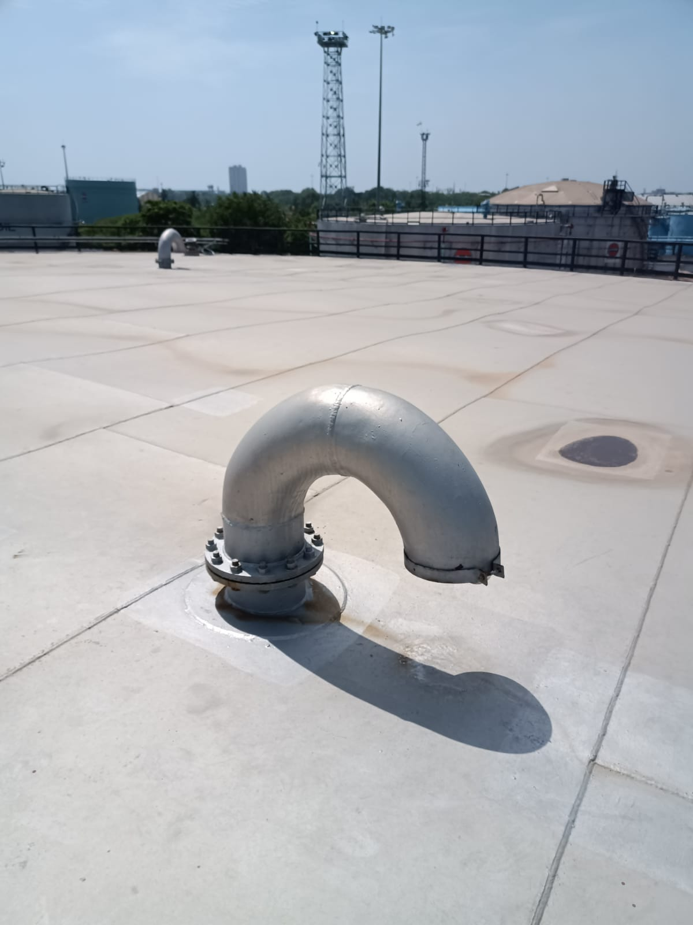

**FIG 5.11 AIR VENT**

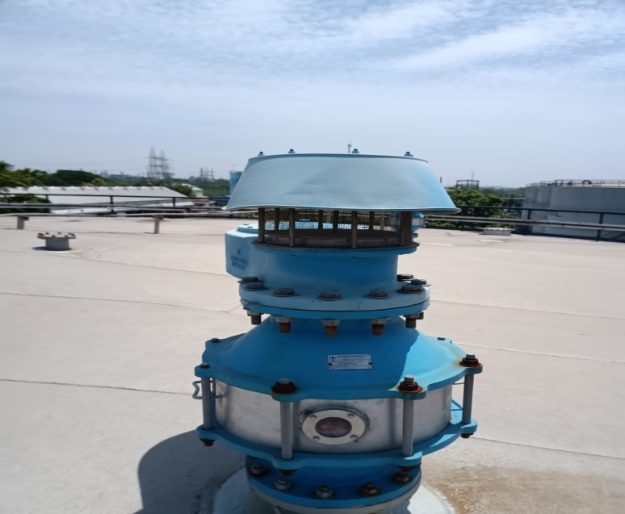

**FIG 5.12 AIR VENT WITH SILICA GEL TRAP**

**CHAPTER 6**

**TANK LORRY FILLING SHED**

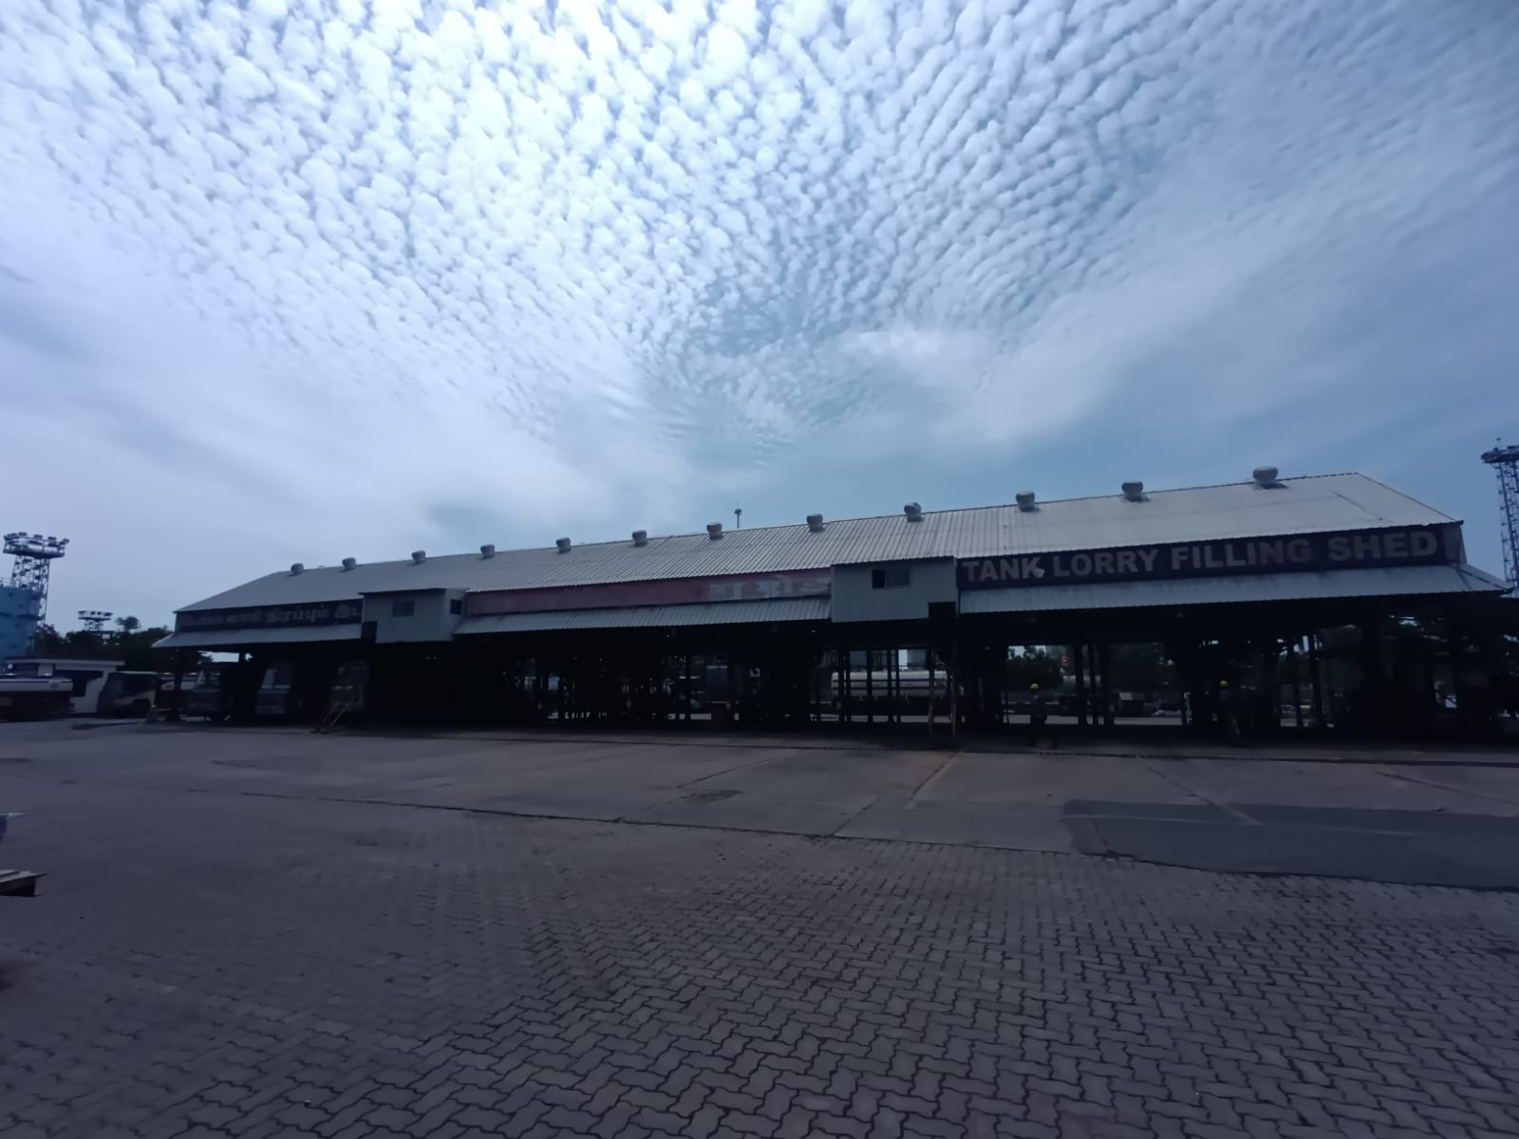

**FIG 6.1 TLF SHED**

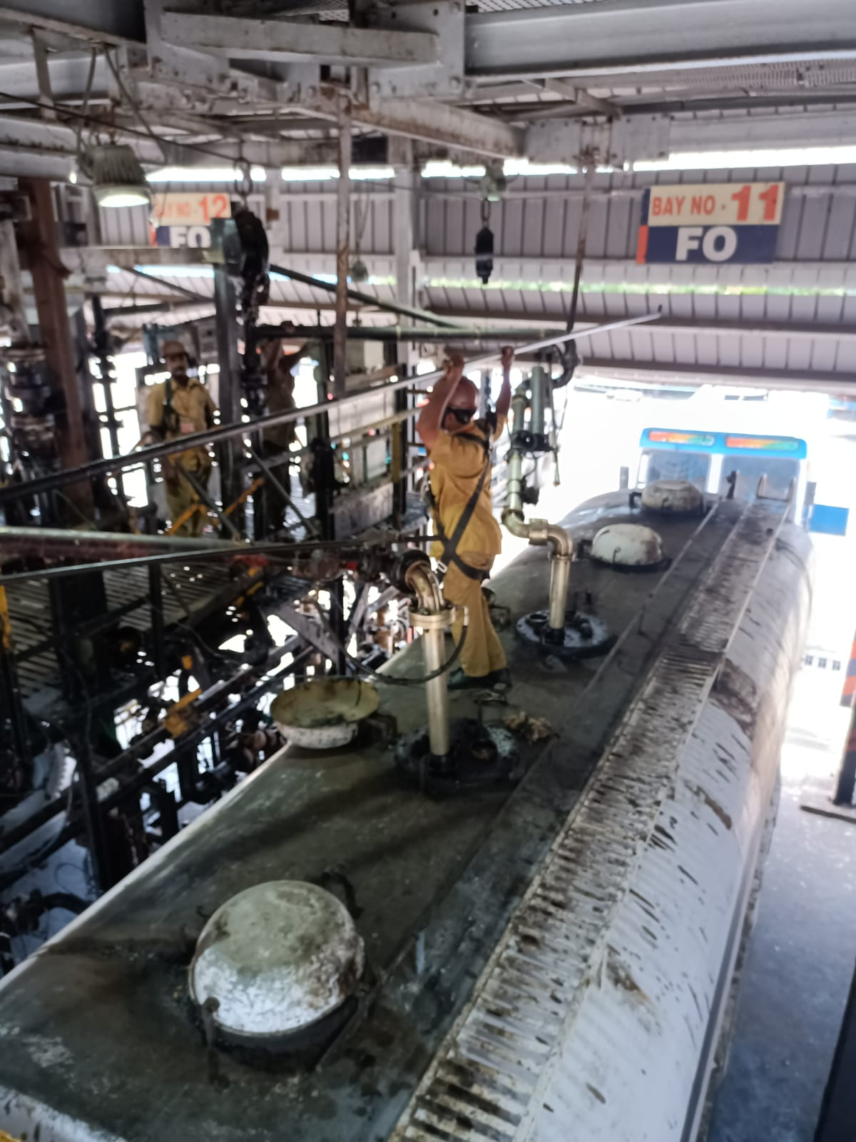

**FIG 6.2 BAYS**

**6.1 OPERATION IN TLF**

Tank Lorry Filling (TLF) is the area of the terminal where Tank Trunks (TTs) get filled with the amount of fuel that the dealer I customer requires.

All four products (ATF, MS, HSD, FO) handled in the terminal are distributed through TLF in IOCL, to TT to be distributed across various dealers in and around the city.

**TABLE 6.1 TLF GANTRY WITH 12 BAYS AND LOADING POINTS**

|  |  |  |
| --- | --- | --- |
| Product | No of Loading Points | Remarks |
| MS | 8 | Mix-8 |
| HSD | 10 | Mix-10 |
| FO | 2 | Dedicated-2 |
| ATF | 2 | Mix-2 |

A TT coming to receive its load first enters through the gate where its vehicle number and other details are checked with the load allotted for that TT and is proceeded to the waiting area where the geo-fenced lock is un locked and the TT is kept prepared for filling.

The tank geo-fenced lock is fitted in all TTs to prevent the theft of fuel while it is in transit and in turn prevent adulteration. The geo-fenced lock works by the principle of geo- location. The location co-ordinates of the TLF and the location of the customer (e.g., location of the dealer's filling station) are stored in the lock and can only be unlocked when the lock is in TLF location and by the password held by the dealer. Then, the bay for filling is allotted to the TT.

It moves to the filling bay, where the worker ground the TT to neutralize the static charge accumulated around the tank, which may be a cause to fire while filling fuel; then the worker enters the required quantity of fuel according to each compartment in the tank in the batch controller and starts to fill the compartment.

TTs have mixed compartments like MS/HSD in the same tank or dedicated tanks like ATF which are exclusive to only Filling ATF. FO TT s are generally old TT once used for filling MS/HSD.

The fuel from the tank flows via the pipe line. The pipe lines are recognized using the band color code. The fuel will reach the oval gear positive displacement flow meter in which it has a got a diaphragm.

This traps the fuel alternatively and pushes the fuel to the hydraulic NO-NC system. Based on the number of rotations of the positive displacement meter we can find the volume of the fuel using a pulse transmitter.

Finally, the fuel is sent to the strainer and reaches the load are according to the need. The requirements will be set in a batch control system, where we can set the Volume of the fuel to the loaded in Kiloliters.

Load arm is attached to a point optical sensor. It senses whether the load arm is inserted inside the tank properly or not. If the load or is not inserted properly the system will not allow to load fuel. This load arm also contains over flow really which acts a position sensor.

The tank loading system which is used in this terminal follows top loading. (i. e the fuel is loaded from the top). The tanks are of different types. The body of the tank can be divided into many compartments based on our needs.

It can be used as one big with full capacity for the same find of fuel. It can also be divided into 2 compartments, 4 compartments and a maximum of 6 compartments. Different class of fuels can be stored in different compartments.

There is a level measuring instrument called dip rod which is used to find the level inside the tank. For tanks with up to three compartments the shape of the dip rod is square, and for every additional compartment a side is added to the rod, i.e., for five and six compartments, pentagonal and hexagonal rods are used respectively.

The dip rod is three meter in length and has 1500 divisions each of 2mm. The dip rod has important markings on it, namely, the proof leaf, oil level and, level markings. Whenever this dip rod is inserted in the dip hole a pinch of water paste will be applied near the oil levels of that they get the level accurately. Each dip rod is registered to its TT and has the TT's vehicle number and chassis number marked on it.

Occasionally, officers test the fuel being filling for its density (at 15 degree Celsius), and record it, so check for consistency with the density value taken when the fuel is in the tank.

Here, ASTM (AMERICAN SOCIETY FOR TESTING and

MATERIALS)table 53 B and 54 B are to determine the density of the fuel sample at the temperature of 15 degree Celsius, as it is the global standard, since the density of a liquid varies as its temperature changes, the scale is adjusted to a certain temperature, usually about 15 degree Celsius., at which determinations must be made.

The reading of the hydrometer and the temperature of the fuel sample from the TT is referred against the respective ASTM table and 15 degree Celsius density is determined.

The filled TTs leave the bay and moves towards the exit gate where they receive the invoice for the fuel order.

**6.2 EQUIPMENT IN BAYS FOR LOADING FUEL:**

In the fuel loading operations at Indian Oil terminals, a comprehensive system is employed to ensure efficient, accurate, and safe loading of fuel into trucks.

The equipment are:

1. Batch controller
2. Loading arm interlock sensor
3. Proximity card reader
4. Overspill detector
5. Flow meters
6. Digital control valve
7. Remote interaction terminal
8. Earthing relay

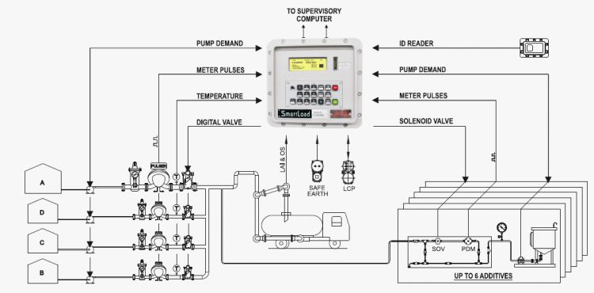

**FIG 6.3 ARCHITECTURE OF BAYS**

**6.3 BATCH CONTROLLER**

Smartload® is an advanced electronic preset controller utilized for loading and unloading precise quantities of liquid products, such as petroleum and chemicals, into or out of tank storage or pipelines, and into vehicles, rail wagons, vessels, or ships. It features easily configurable menus and a multi-language operator screen for user-friendly operation. This sophisticated Systek batch controller is employed at the Indian Oil Tondiarpet terminal. Used in loading bays, it allows operators to set the precise amount to be loaded manually, or it can operate in automatic mode by reading information from cards,

**Features**

* Easily configurable menus & multi-language operator screen is provided for ease of operation.
* Single arm or Dual arm applications
* Controls loading of base or blended product (up to 4components) with or without additives
* User configurable alarm text and alarm actions
* Controls Single or blended product loading with additives & Blends
* Direct interface with flow meters, Safety interlocks, card readers & automation software
* Controls Digital Control Valves, additive injector blocks
* Temperature & Pressure compensations as per API, IP or linear methods

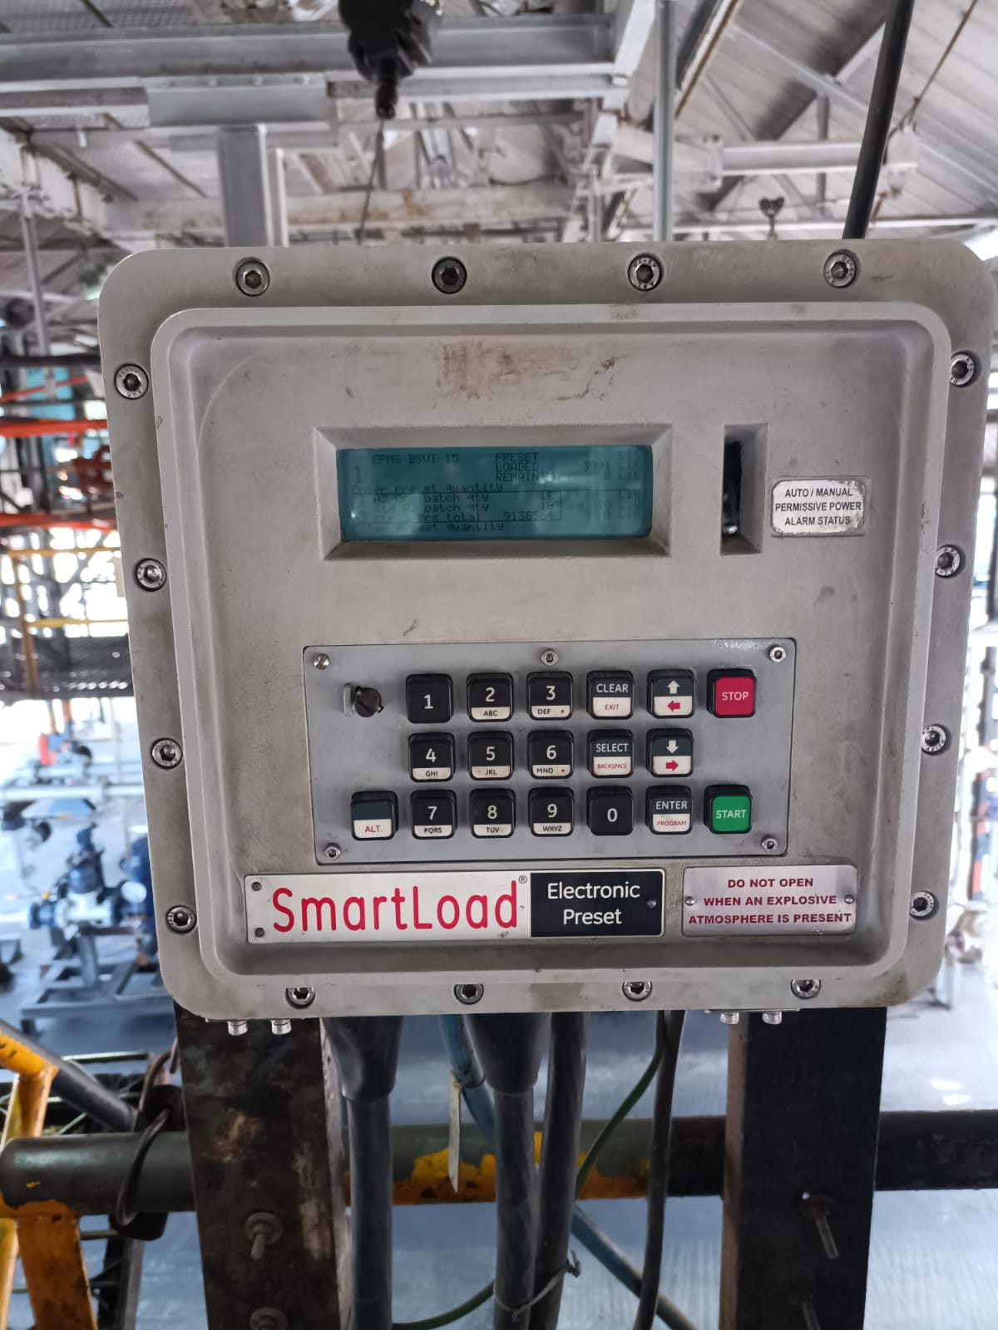

**FIG 6.4 BATCH CONTROLLER**

**6.4 LOADING ARM INTERLOCK SENSOR:**

The loading arm interlock system used in fuel loading bays, particularly with top loading arms, ensures safety and operational efficiency during the fuel transfer process. The top loading arm is a flexible pipe or arm that connects the storage tank to the vehicle (truck) for fuel transfer. Interlock sensors, equipped with three indicator lights red, yellow, and green detect the correct positioning and connection of the loading arm. When the operator manually positions the top loading arm over the vehicle's inlet, the interlock sensors confirm proper alignment and secure connection.

The red light indicates that the loading arm is not properly fixed, preventing the operation. The yellow light means that the system is ready for acknowledgment and that further action can be taken. The green light signals that the loading arm is securely connected and the system is ready to start filling. These sensors send signals to the control system, which verifies the correct positioning before authorizing fuel flow. Once the green light is on, the safety valves open, allowing fuel to be pumped from the storage tank through the top loading arm into the vehicle, with the batch controller managing the precise quantity of fuel being loaded. Throughout the process, the interlock system continuously monitors the arm's position, and any misalignment or disconnection triggers an immediate halt in fuel flow, indicated by the red light

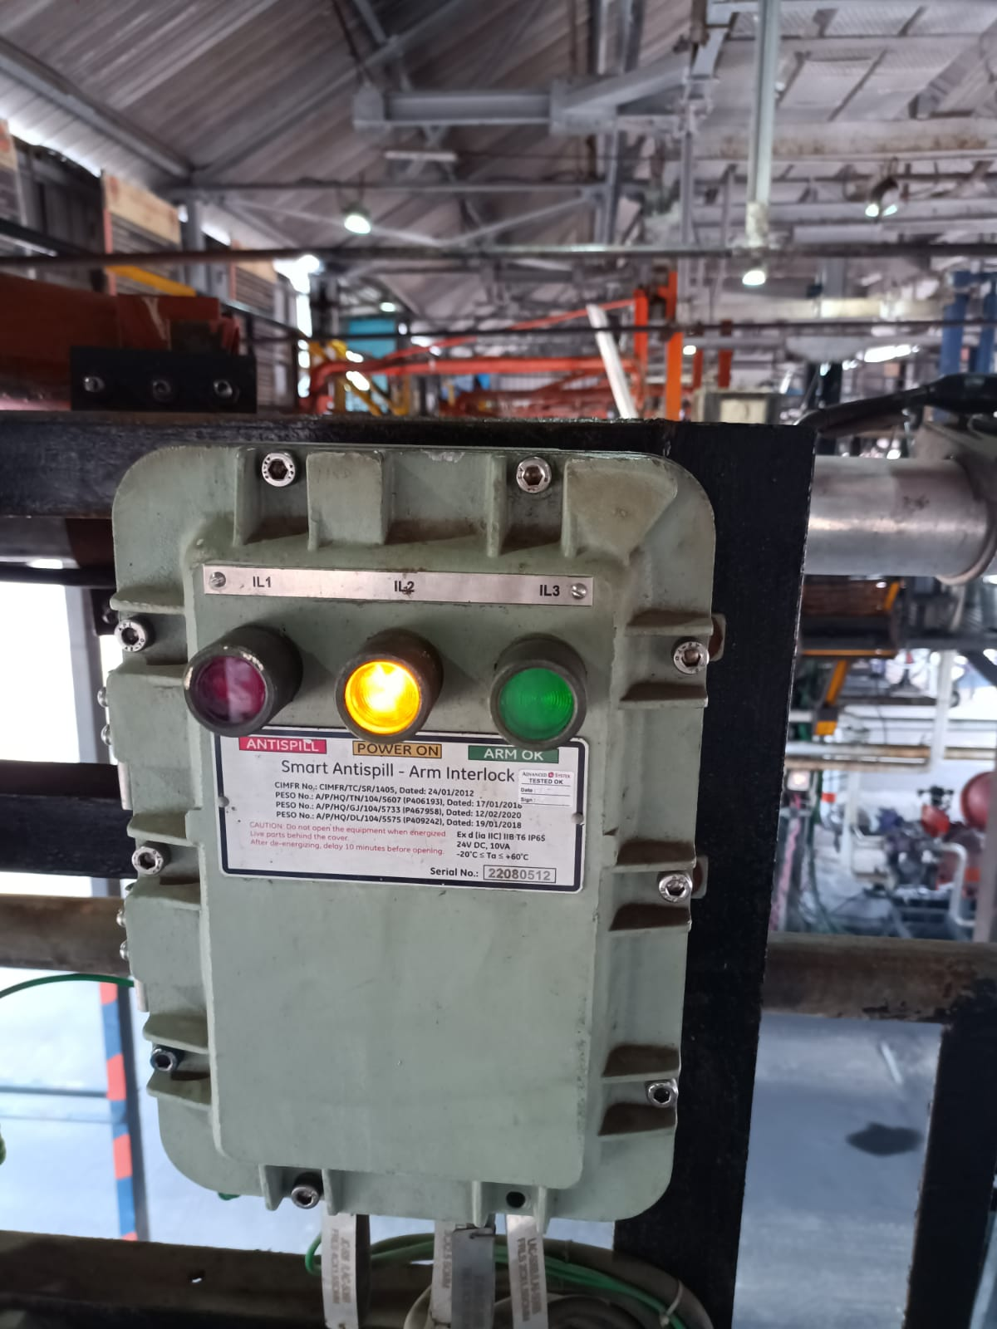

**FIG 6.5 LOADING ARM INTERLOCK**

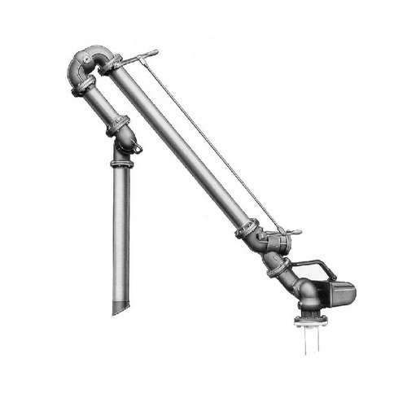

**FIG 6.6 LOADING ARM**

**6.5 PROXIMITY CARD READER**

The proximity card reader operates using non-contact technology, allowing the card to be read by simply passing it within a few centimeters of the glass window of the sentry. This card reader is primarily used to authenticate the cardholder and control access for individuals or vehicles into restricted areas. In the context of fuel filling automation, the card reader streamlines the process. At the gate, the card is provided, and details such as the product to be filled, the compartment, and the quantity are pre-set. Once at the loading bay, the operator only needs to securely fix the loading arm and place the card near the card reader to initiate the fuel filling process. This simplifies and automates the entire operation

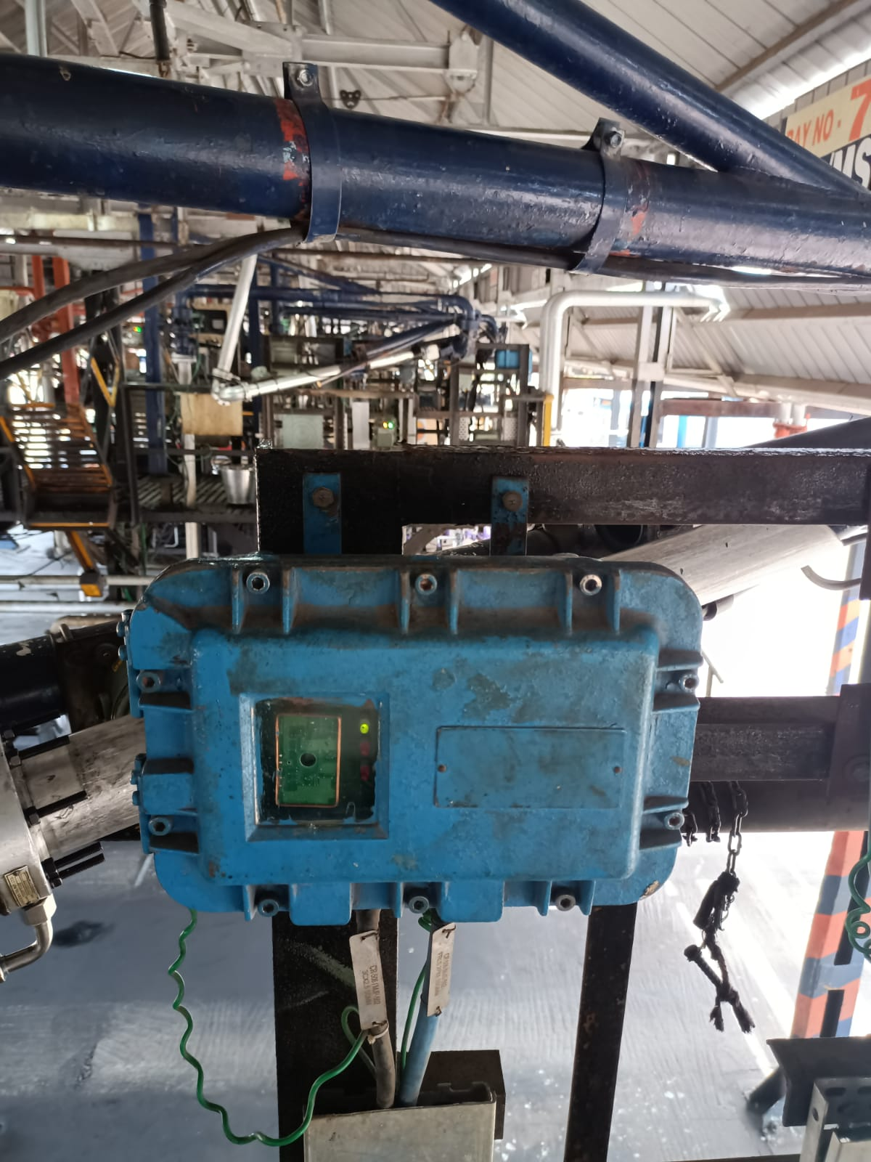

**FIG 6.7 PROXIMITY CARD READER**

**6.6 OVERSPILL DETECTOR**

#### An intelligent electronic interlock device used to provide safety during liquid loading applications. Arm Interlock ensures proper positioning of top-loading arm and monitors it throughout the loading operation.

#### Anti-spill/Overspill prevents over spillage of precious liquid from the tank-truck vehicle. It is designed to provide an automatic means to prevent the filling of a container beyond a predetermined level Overspill detection sensor is an integral part of the loading arm

#### https://www.advancedsystek.com/images/products/oversflow_prevention-2.jpg

#### FIG 6.8 OVERSPILL DETECTOR

**6.7 FLOW METERS**

In fuel loading operations, different types of flow meters are used based on the specific requirements and the type of product being handled:

1. Mass Flow Meter: Used for measuring flow rate of Furnace Oil (FO) and water in calibration areas.
2. Positive Displacement (PD) Flow Meter: Used for measuring flow rate of Motor Spirit (MS), High-Speed Diesel (HSD), and Aviation Turbine Fuel (ATF).
3. Turbine Flow Meter: Used for measuring flow rate of Ethanol.

**6.8 DIGITAL CONTROL VALVE:**

The Digital Control Valve is managed by a batch controller that regulates the fluid set point for filling operations. This advanced system ensures precise control over the quantity of fluid dispensed.

The batch controller initiates the opening of the valve by energizing both the normally open (NO) and normally closed (NC) solenoids, allowing the valve to open gradually. As the fluid flow rate reaches a predefined value, the NC solenoid is de-energized to lock the valve at this flow rate, avoiding splashing and static charge. The controller then re-energizes the NC solenoid to increase the flow rate and maintains it at a high level by cycling the solenoids as needed. Towards the end of the batch, the NO solenoid is de-energized to throttle the valve, and once the desired quantity is delivered, both solenoids are de-energized to close the valve completely, ensuring a precise and bubble-tight shut-off



**FIG 6.9 DCV**

**6.9 REMOTE INTERACTION TERMINAL:**

Found in a filling bay where a driver uses a proximity card reader to verify their credentials, acknowledges the verification, and then starts the filling process. If there is any problem during the filling, the driver can press the red "STOP" button to halt the operation

**Red button** labelled "STOP": Used to halt operations in case of an issue.

**Green button** labelled "START": Used to initiate the process.

**Orange button** labelled "NOWELEDGE" (likely a typo, meant to be "ACKNOWLEDGE"): Used to acknowledge a specific condition, likely after showing a card to a proximity card reader.

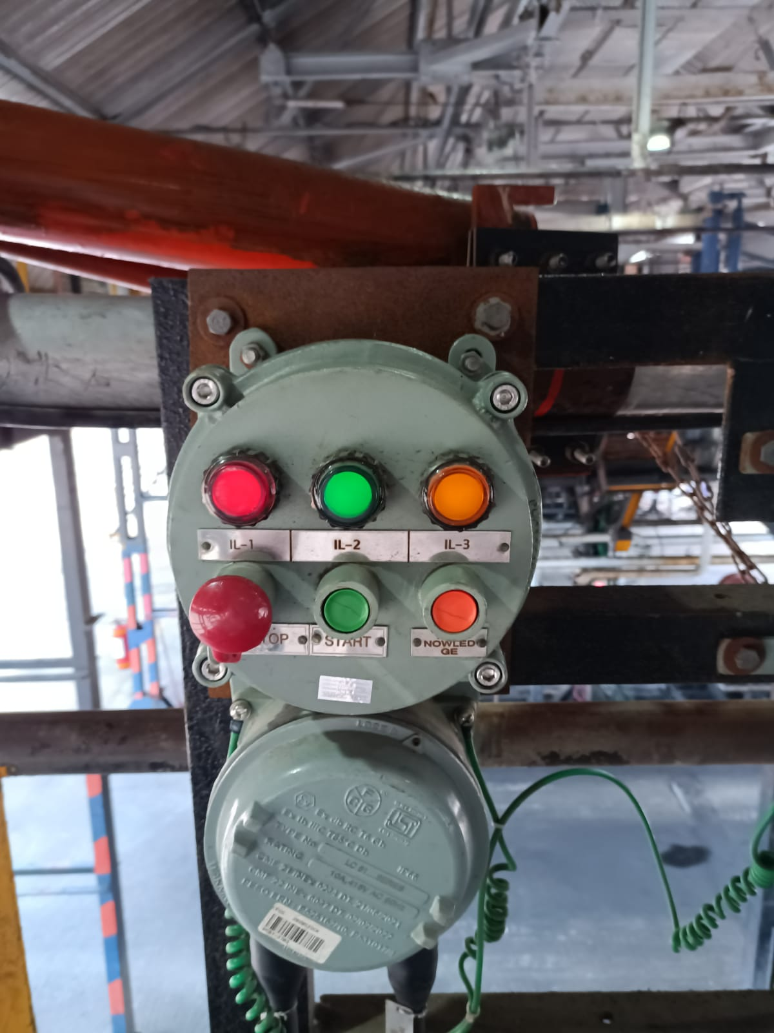

**FIG 6.10 REMOTE INTERACTION TERMINAL**

**6.10 EARTHING RELAY:**

#### The Earthing Relay senses the static-charge potential of the Tanker and provides a safe grounding path for this charge through a low impedance and intrinsically safe electronic module, which is itself housed in an explosion proof enclosure mounted near the loading terminal.

#### Earthing relay are connected through tank-truck only and not through any gantry structure. It ensures this by measuring a capacitance of the object on which clamps are connected. The measured capacitance value is compared with the programmed capacitance value for road tankers. If it is found within a range of tank trucks, the device recognizes it as positive connection to tank truck.

#### After a connection on a tank-truck is ensured, the device ensures that a low resistance connection is made from the tank-truck through paint or rust to the reference ground point. It also monitors resistance of earth pit connection & potential level of the tanker body and only when this potential is confirmed to be at the same potential level as that of the reference ground level, the device generates interlock output to permit loading operations

### Application

#### It continuously monitors health of the earth connections and provide ultimate safety to the valuable assets and to the workers serving in hazardous area against fire and explosions that may occurs due to errors in un-healthy ground / static charge generation-accumulation.

#### 

#### 

**FIG 6.11 EARTHING RELAY**

# **CHAPTER 7**

# **TANK WAGON FILLING**

**7.1 INTRODUCTION**

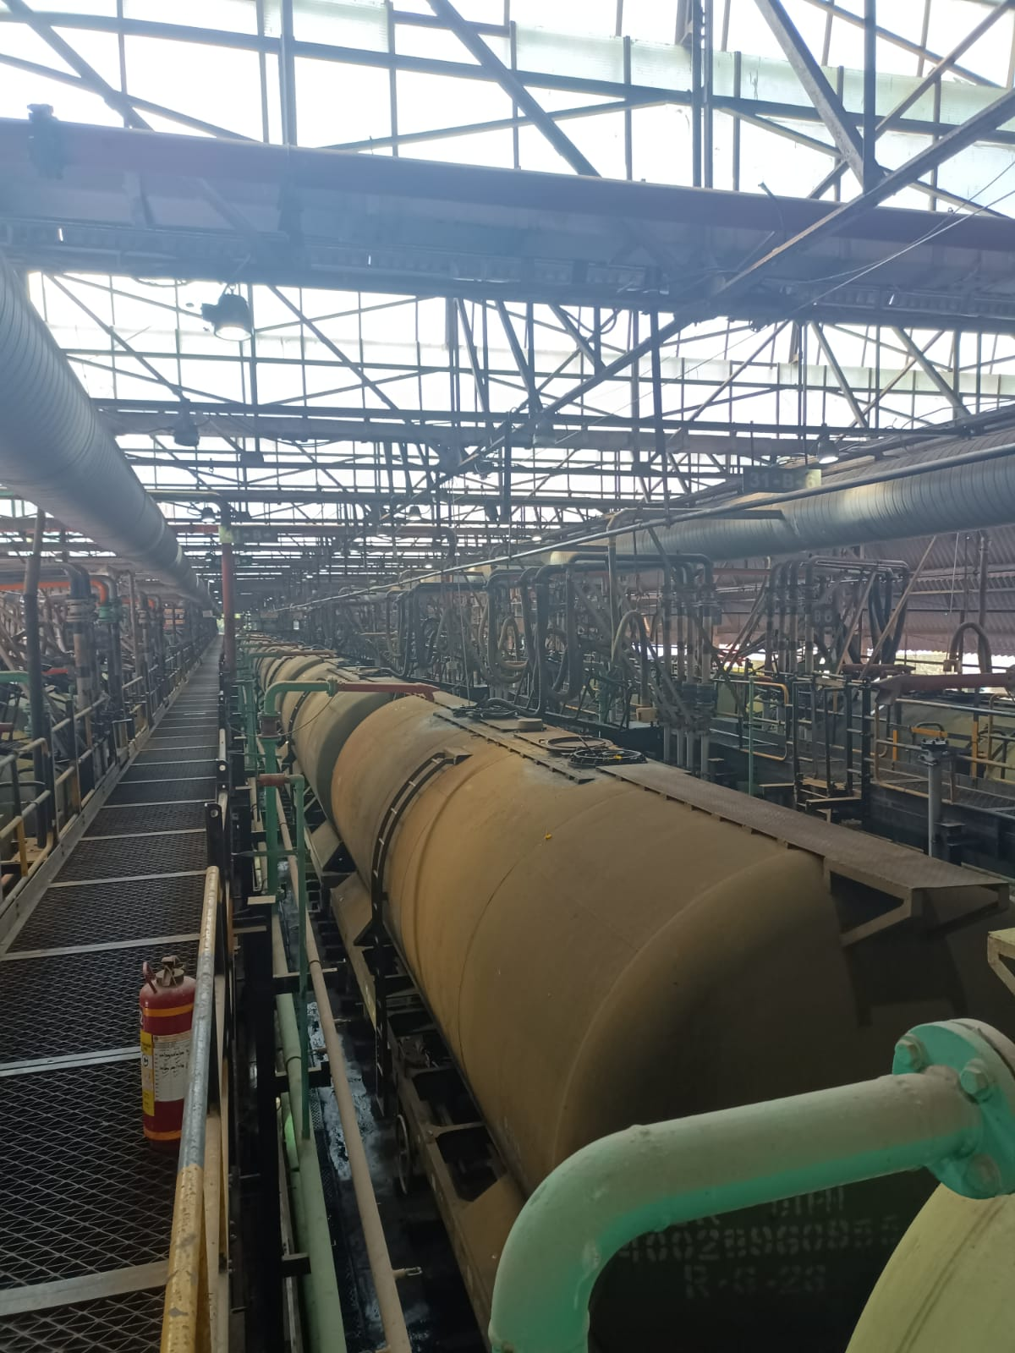

**FIG 7.1 WAGON**

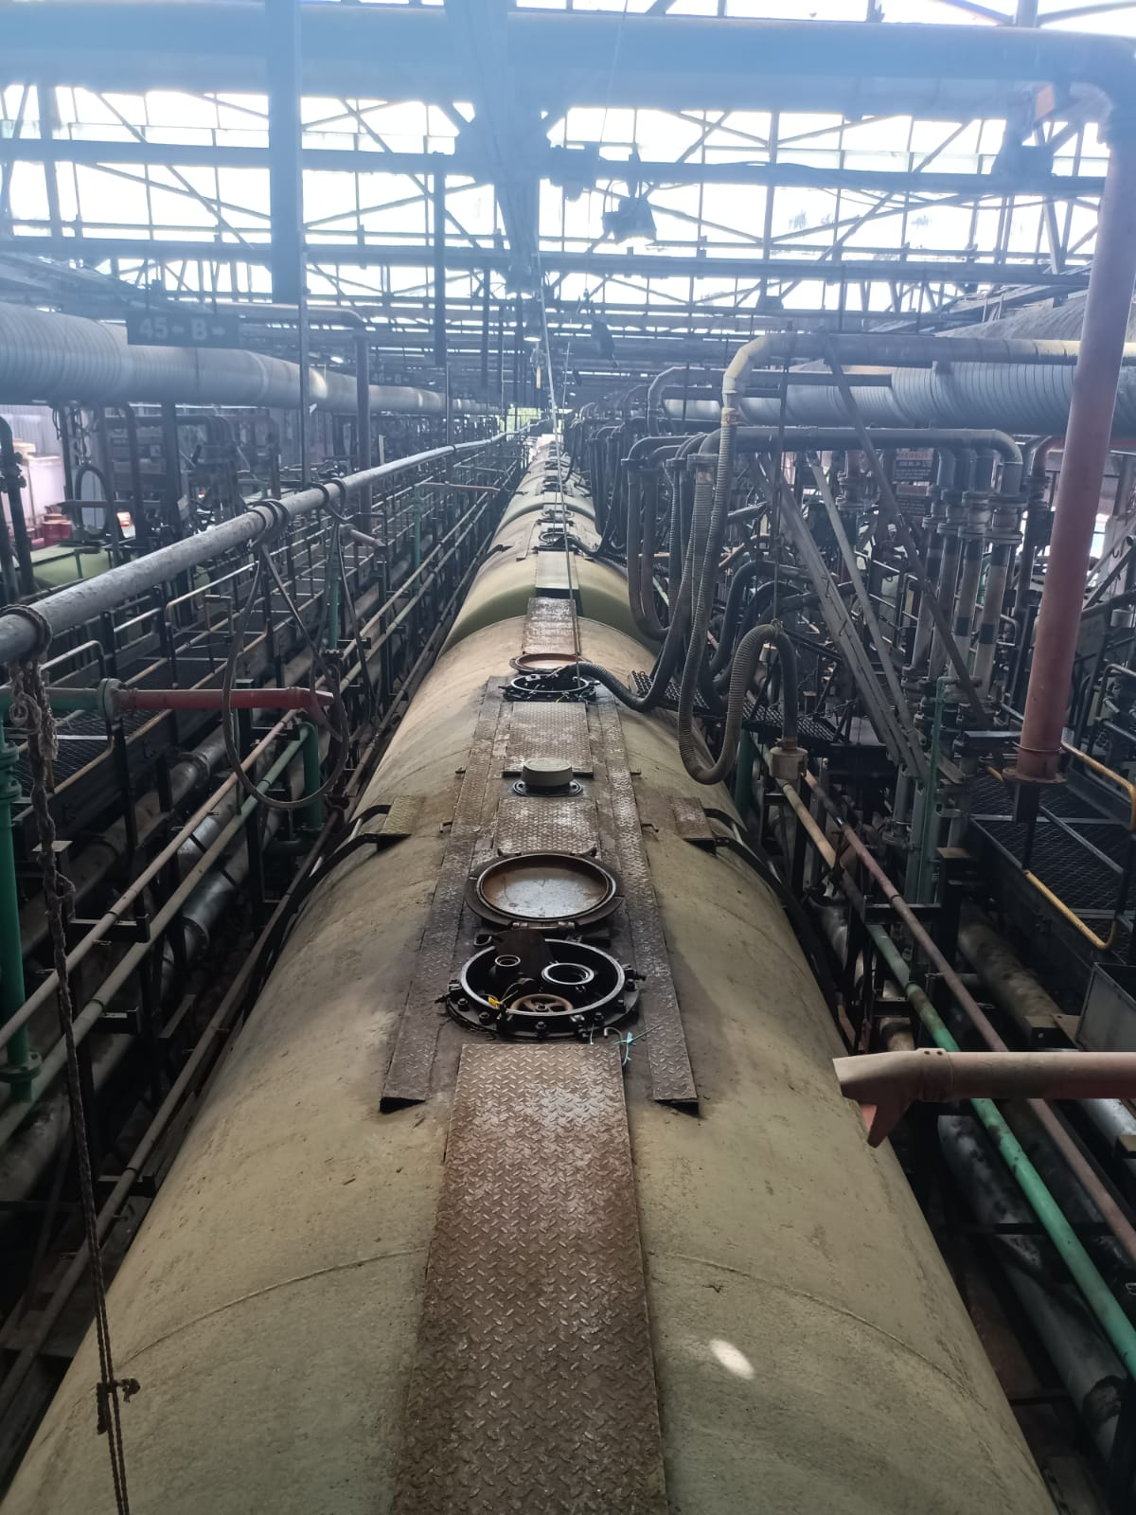

**FIG 7.2 WAGON GANTRY**

IOCL private siding, with three spurs available for loading for Tank Wagons for MS/HSD/ATF. A wagon consists of 50 tanks, which are 70 KL capacity per tank.

###### 7.2 Tank Wagon Loading (TW) Operation:

1. **Standard Operating Procedure for TW Officer In-charge.**
   * Loading plan.
   * Check Proper communication through UHF Sets among various working personnel at different work stations.
   * Verify the following details from the previous chart provided by Railways.
     + TW number with associated railway
   * Check quality of TWs for its suitability to fill with allotted product.
   * Collect Railway fit memo before TW loading and load only fit TWs.
   * Load BS VI MS in wagons placed in C Track only where as other products can be loaded in A,B,C Track.
   * Mark the details of product and dips to be loaded on the board placed near filling spot.
   * Ensure that earthing of Tank Wagons is done.
   * TW loading to take place only after all 50TWs are placed in AIBIC track. Loading to start after LOCO is released and wagon gate to be closed.
   * Ensure that the correct loading hose is inserted into the TW according to the allocation
   * Ensure only Non sparking tools are used by contract workmen
   * For loading of ATF product, grade washing is to be done by 200 liters of product into TW and then checking the bottom sample as given in IQCAM
   * Before commencement of loading of TW in each shift, the white oil product should be drawn from the pipeline at the TW Gantry and subjected to Test 'A' and retained as per IQCM
   * After loading, give minimum 15 minutes of settling time before checking dip. The final dip and top sample of each wagon will be checked as per IQCM jointly with Railway Official and the same is recorded in the loading memo.
   * For recording TW temperature in loading memo, temperatures of a minimum of 1/3rd of TWs placed for loading are measured using cup case thermometers.
   * For ATF after loading, bottom samples from each TW to be drawn and checked for water I sediments.
   * Prepare AV3 for ATF TWs and place in respective TW securely.
   * The loading memo signed by TW officer in-charge and railway officer to be put in man holes of anyone TW(for ATF TWAV3 will be also included along with loading memo) & other copy of loading memo shall be maintained at supply location.
   * Manhole covers and bottom flanges of all the loaded TWs to be sealed properly.
   * The paste on label (OP-30) should be pasted at the designated place on each TW after filling all the relevant details and the numbers of these TWs should be intimated along with other details to the consignee location.
   * Before release TWs should be checked for leak etc. In case of leak, subject TW shall not be accounted on IOC share out.
   * Batch formation test report of the loaded product should be sent to TW receiving location
   * Ensure that loading hose and swing ladder to be lifted and kept in correct position after loading since the same should not disturb the movement of the Tank wagon
   * After completion of TW loading, ensure that all valves are closed and expansion line is kept open wherever provided.
   * The pipeline leading to TW siding at Pump House end is to be closed and the expansion line to be opened by the Pump House Operator after TW loading is completed.
   * Product wise loss I gain analysis for each rake to be carried out.
   * Railways to be intimated for removal of loaded rake from the TW Gantry.
   * Any abnormal observed report immediately to Officer in- charge PLT I LIC.
   * Totally responsible for safe TW loading Operation.
2. **The Standard Operating procedure for TW loading employee**

* Ensure the Safety harness and other PPEs are worn properly before climbing on the TW.
* Check Proper communication through Walkie Talkie Sets among various working personnel at different work stations.
* Ensure that the TW outlet valve are closed and blind flange at bottom is fixed properly.
* Check the master valve of TWs is closed.
* Ensure that the correct loading hose is inserted in the TW for loading allotted product.
* Ensure vapor extraction hose is connected with TW manhole
* Crack opens the valve and check at bottom for leak.
* If no leak is observed at the bottom, continuous loading shall be started with pump by pass fully open and after confirmation from TWG In -charge.
* After 15 min of pump running with bypass fully open, bypass shall be closed and loading shall be continued.
* After reaching 90% of target dip valves are to be controlled and operated with continuous monitoring until the target dip is reached.
* Close valve when target dip is achieved and remove hose from fill pipe and hook it properly.
* Give minimum 15 minutes of settling time before checking the final dip of the TW.
* The final dip and top sample of each wagon will be checked as per IQCM by Loading Officer jointly with Railway Official and same is recorded in the loading memo.
* Totally responsible for safe loading and correct quantity of product in TW.
* If any abnormality observed report immediately to the TW Officer In-charge.
* Do not leave the loading spot while the TW loading operation is in progress.
* Ensure Loading hoses are closed with end cap after completion of TW loading operation.
* Ensure that loading hose and swing ladder kept in upright position; retractable fall arrestor hooked in gantry railing and kept in correct position since the same should not disturb the movement of the Tank wagon.
* After completion of TW loading, ensure that all valves are closed and expansion line is kept open wherever provided

# **CHAPTER 8**

# **SAFETY MEASURES**

# **8.1 TYPES OF SAFETY MEASURES**

There are various safety or risk control measures in Tondiarpet terminal. This includes:

* + Emergency shutdown
  + Hydrocarbon detection system (HCD)
  + Dyke Valve Position Indicator
  + Smoke detector
  + Manual call point

###### 8.2 EMERGENCY SHUTDOWN (ESD):

Purpose of ESD is to stop all on-going process and power a ot entire location. There are two types of ESD, they are:

* Process ESD
* Power ESD

When ESD is pressed from anywhere in the location. Power ESD will get actuated automatically after 100 seconds of actuation of Process ESD.Actuation of process ESD will switch off the power to all facilities except the Siren, Power in Fire Pump House, DG, Foam Shed and PMCC, Emergency Lighting Load, Control room and UPS fed equipment

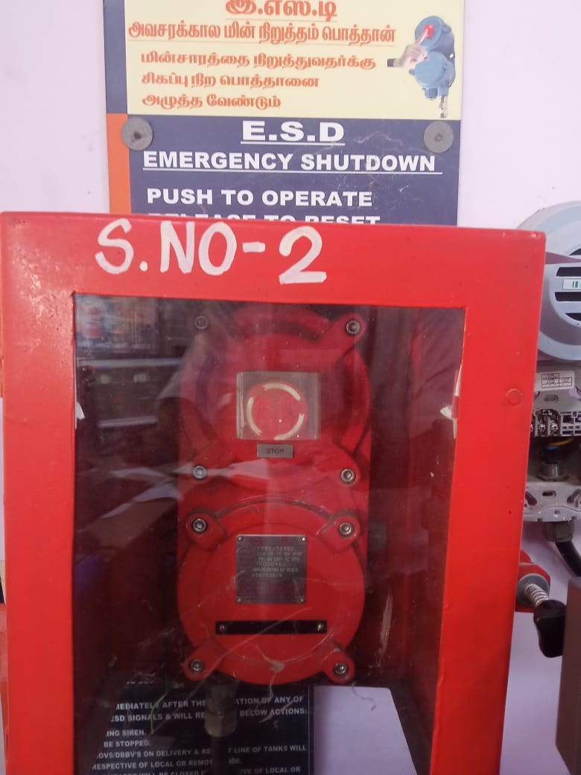

**FIG 8.1 ESD**

##### 

##### 8.3 HYDRO CARBON DETECTION SYSTEM:

Hydrocarbon detection system is provided to detect vapors at area of potential leakages of class ‘A’ petroleum product within location like tank dyke, pump house drains. These detectors are placed in such a way that all possible sources of leaks and collection of products are continuously detected and alarm is set at 20% of lower explosive limit of class ‘A’. There are two types of HCD, they are:

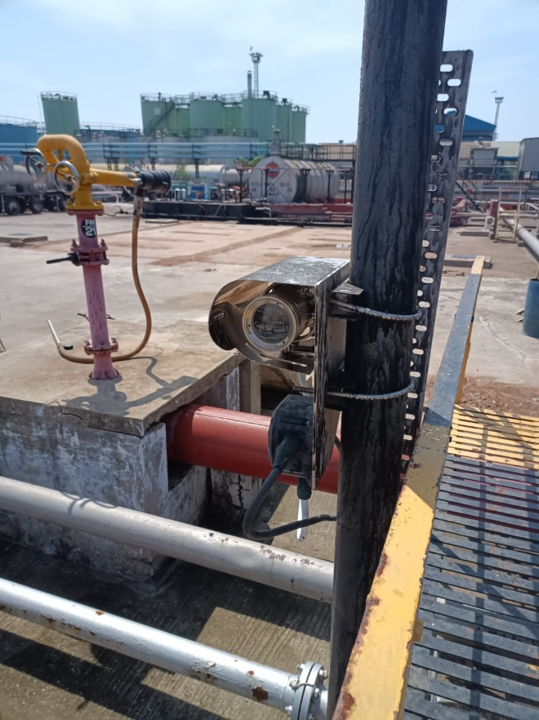

**FIG 8.2 HCD**

##### 8.4 DYKE VALVE POSITION INDICATOR:

Dyke valve position indicator is provided to detect position of dyke valve storing hydrocarbon product. These detectors are placed in such a way that on opening valve (even crack opened) will give an audio-visual alarm in control room. It uses the magnetic proximity sensor to monitor the dyke handle movement also

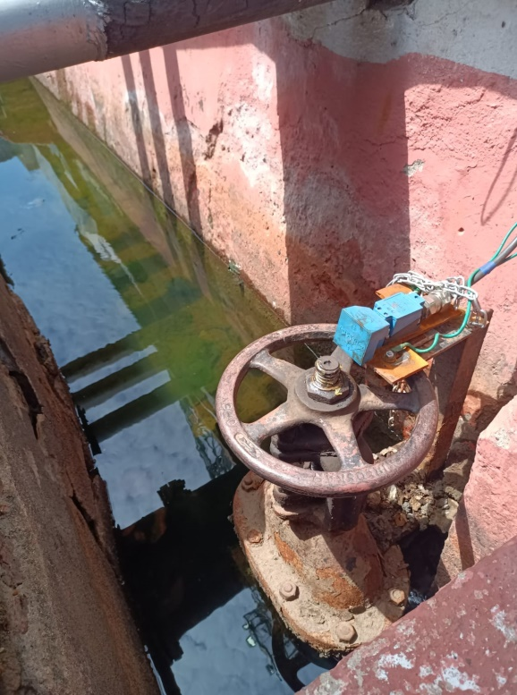

**FIG 8.3 DYKE VALVE POSITION INDICATOR**

### 8.5SMOKE DETECTOR:

A smoke detector is a device that senses smoke, typically as an indicator of fire. Commercial and residential smoke detectors issue a signal to a fire alarm system, while household detectors, known as smoke alarms, generally issue a local audible or visual alarm from the detector itself.

### Photoelectric Smoke Detector working principle

**Light Source and Sensor**: The detector has a light source (usually an LED) and a light sensor positioned at an angle to the light beam.

**Scattering of Light**: When smoke enters the chamber, it scatters the light. Some of the scattered light hits the sensor, triggering the alarm

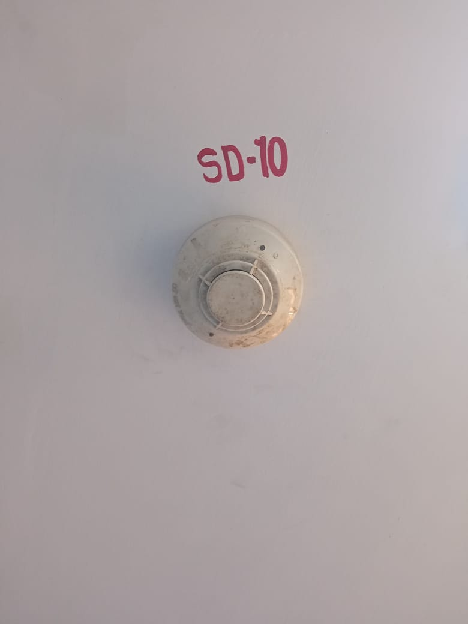

**FIG 8.4 SMOKE DETECTOR**

### 8.6 MANUAL CALL POINT (MCP)

### A manual call point system, consisting of 23 points, allows individuals to manually initiate an alarm in case of an emergency, such as a fire. Each call point is strategically placed for easy access throughout the building or area being monitored. When activated, a signal is sent to the central control panel, triggering the alarm system and alerting occupants and emergency services to the specific location of the incident. This system enhances safety by enabling rapid response and evacuation

##### 

##### FIG 8.5 MCP

##### 

### 8.7 EARTHING SYSTEM

To avoid the risk of static energy generated due to the flow of products, the following measures are implemented:

1. Bonding in Pipe Joints:
   * Bonding is applied at the joints of pipes to ensure electrical continuity and to prevent static charge buildup.
2. Tank Earthing:
   * Earthing is done around the tanks to provide a safe path for the dissipation of static electricity.
3. Grounding the Equipment:
   * Equipment is grounded to prevent the accumulation of static charges, providing an additional layer of safety.

### .

### FIG 8.6 TANK EARTHING

### 

### FIG 8.7 PIPE BONDING

### 8.8 NON SPARKLE TOOLS

### Non-sparkle tools, also known as spark-resistant or spark-proof tools, are specialized tools designed to prevent the generation of sparks when used. These tools are typically made from non-ferrous metals such as brass, bronze, copper-nickel alloys, and aluminum-bronze. The use of these materials ensures that the tools do not produce sparks

### Non Sparking Tools at Rs 4500 | mutton street | Mumbai | ID: 22831880430

### FIG 8.8 NON SPARKLE TOOL

##### CHAPTER 9

##### FIRE FIGHT EQUIPMENTS

##### 9.1 INTRODUCTION

##### Oxygen, heat, and fuel are frequently referred to as the "fire triangle." Add in the fourth element, the chemical reaction, and you actually have a fire "tetrahedron." The important thing to remember is: take any of these four things away, and you will not have a fire or the fire will be extinguished

##### TABLE 9.1 CLASS OF FIREShttps://static.wixstatic.com/media/42192a_68f7e3d9174242b0831cc6a805b3a5a2~mv2.jpg/v1/fill/w_723,h_475,al_c,q_80,usm_0.66_1.00_0.01,enc_auto/42192a_68f7e3d9174242b0831cc6a805b3a5a2~mv2.jpg

##### Types of fire fight equipments:

* Fire Engines
* Jockey Pump Operation
* Sprinkler System
* Foam Pourer System
* High-Volume Long Range Monitor(Hvlrm)
* Fire Extinguishers

##### 

##### 9.2 FIRE ENGINES:

Fire engines are kept in auto mode and fire engine Will start as per the fall of water pressure in fire hydrant network. There are 7 fire engines in Tondiarpet Terminal and the pressure setups are as follows:

### TABLE 9.2 PRESSURE SETTING OF FIRE ENGINES

|  |  |
| --- | --- |
| **Engine** | **Pressure Setting** |
| FireEngine1 | 6.5 KgIcm2 |
| FireEngine2 | 6.0 KgIcm2 |
| FireEngine3 | 5.5 KgIcm2 |
| FireEngine4 | Standby for Fire Engine No.2 |
| FireEngine5 | Standby for Fire Engine No.1 |
| Fire Engine6 | Standby |
| Fire Engine7 | Standby |

### 

### FIG 9.1 FIRE ENGINE

##### 9.3 JOCKEY PUMP OPERATION

Jockey pumps are installed to maintain pressure in fire hydrant network at 7 kg/cm2.They are electrically driven .Auto ON and auto OFF of jockey will operate as per pressure in fire hydrant network.

**TABLE 9.3 PRESSURES SETTING OF JOCKEY PUMPS**

|  |  |
| --- | --- |
| **Operation** | **Pressure Setting** |
| Auto Start | 7.0 Kg/cm2 |
| Auto Cut OFF | 8.0 Kg/cm2 |

### 

### FIG 9.2 JOCKEY PUMP

##### 9.4 SPRINKLER SYSTEM

Water sprinkler system is provided on storage tanks as per norms for the purpose of cooling and preventing to catch fire. The sprinkler system can be operated from two sides on tanks.

### Fire Fighting Pump Accessories, Fire Sprinkler System, Supplier Manufacturer in Pune, India

### FIG 9.3 WATER SPRINKLER FOR TANKS

##### 9.5 FOAM POURER SYSTEM

Fixed Foam pourer system is installed on all A & B Class Product Tanks above ground tank at location for foam application. Fixed Foam Pourers are provided in Tank Wagon Gantry.

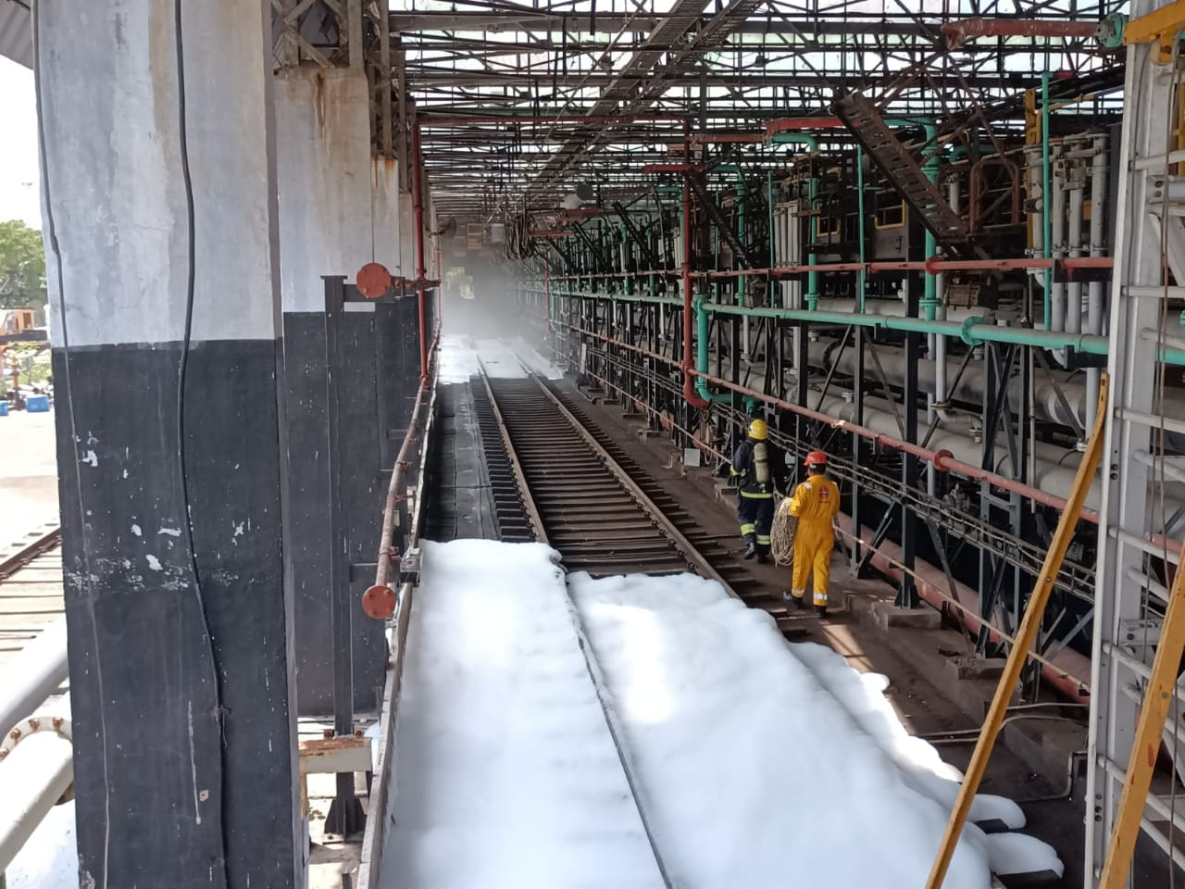

**FIG 9.4 FOAM POURER**

### 9.6 High-Volume Long-Range Monitor (HVLRM)

Remote operated high-volume long-range monitors are installed to fight tank fires. The flow of HVLR can be adjust

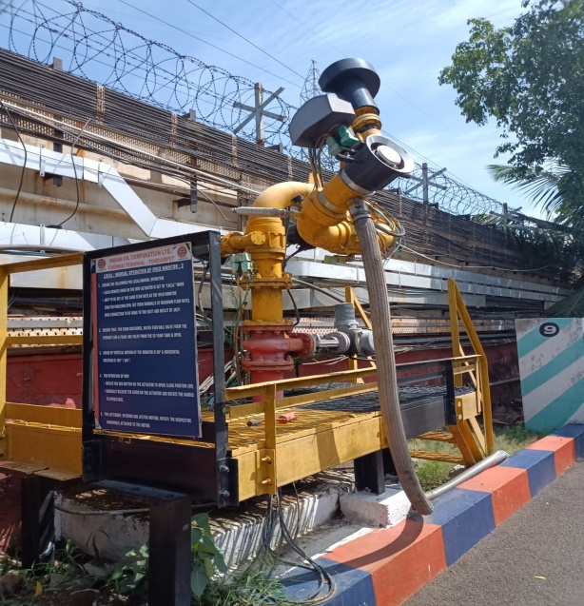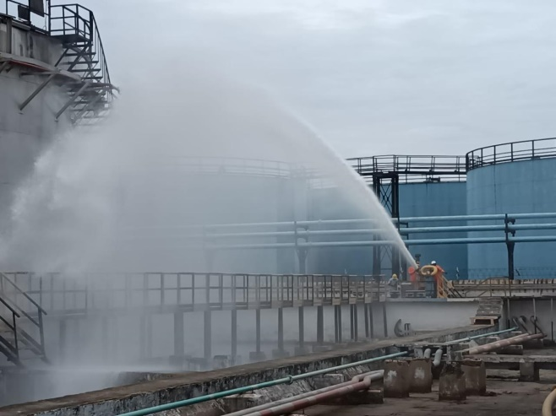

**FIG 9.5 HVLRM**

### 

### 9.7 FIRE EXTINGUISHERS

Usually, three types of fire extinguishers used in Tondiarpet terminal, they are:

* DCP fire extinguishers
* Carbon di-oxide fire extinguishers
* Aqueous film forming extinguishers (AFF)

A dry chemical powder (DCP) extinguisher separate fuel from oxygen in the air and prevents vapor formation. The main base chemicals used in DCP extinguishers are sodium bicarbonate and potassium bicarbonate.

CO2 extinguishers are mainly used for Class B and C fires. CO2 extinguish the fire by displacing oxygen in the surrounding air. It Can be used on electrical electronic equipment. The extinguishing agent in AFF extinguisher is aqueous film forming concentrate in water which forms air foams when Discharged through an aspirating nozzle. It has a blanketing effect excluding oxygen from the surface of the fuel as it spreads on the fuel. Prevents vapor formation from the surface of the burning liquid. It develops a floating aqueous film of solution under the foam on fuel surface and cools the burning surface.

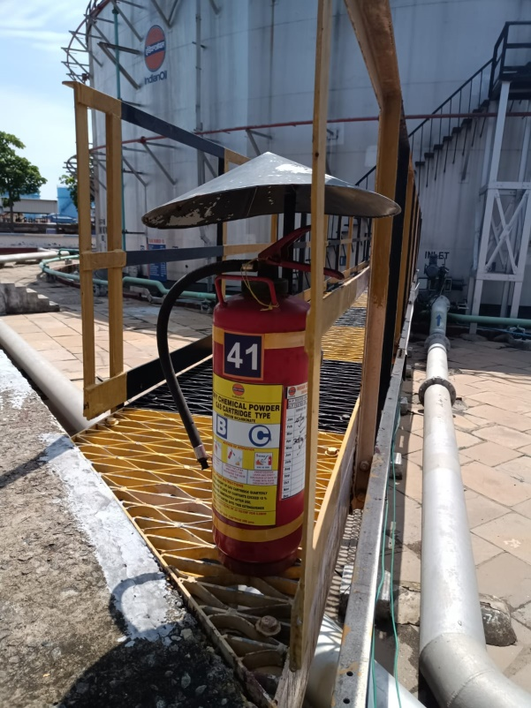

### FIG 9.6 FIRE EXTINGUISHER

### 

### CHAPTER 10

### PROGRAMMABLE LOGIC CONTROLLER

### 10.1 INTRODUCTION

### A programmable logic controller (PLC) is an industrial grade computer that is capable of being programmed to perform control functions. The programmable controller has eliminated much of the hardwiring associated with conventional relay control circuits. Other benefits include fast response, easy programming and installation, high control speed, network compatibility, troubleshooting and testing convenience, and high reliability.

### The PLC is designed for multiple input and output arrangements, extended temperature ranges, immunity to electrical noise, and resistance to vibration and impact. Programs for the control and operation of manufacturing process equipment and machinery are typically stored in battery-backed or nonvolatile memory. A PLC is an example of a real-time system since the output of the system controlled by the PLC depends on the input conditions.

### In Indian Oil, Honeywell PLC is utilized for the tank farm area, and AST is used for the tank truck filling shed. Communication between AST and Honeywell is established through a fiber optics cable and a media converter.

### 

### FIG 10.1 AST PLC

### 

### 

### FIG 10.2 HONEYWELL PLC

### 10.2 PARTS OF PLC

### 

### FIG 10.3 PARTS OF PLC

The basic architecture and workflow of a Programmable Logic Controller (PLC) system, which is typically used in industrial automation. The key components and their functions are outlined below:

1. **Input Control Devices:**

These are the various sensors, switches, and other input devices that provide signals to the PLC system. These devices monitor the status of different parameters and send this data to the input module.

1. **Input Module:**

The input module receives signals from the input control devices and converts them into a form that the controller (CPU) can process. It acts as an interface between the field devices and the controller.

1. **Controller (CPU):**

The CPU is the brain of the PLC system. It consists of a processor and memory. The processor executes the control program stored in the memory, processes the input data, and determines the necessary actions based on the logic defined in the program.

1. **Power Supply Module:**

The power supply module provides the necessary electrical power to all the components of the PLC system, ensuring they operate correctly.

1. **Programmer:**

A programmer (often a computer with specialized software) is used to write, upload, and modify the control program that the CPU executes. It allows for the configuration and troubleshooting of the PLC system.

1. **Output Module:**

The output module receives commands from the CPU and sends control signals to various output load devices. It acts as an interface between the controller and the field devices that perform the required actions.

1. **Output Load Devices:**

These devices, such as motors, actuators, and other machinery, receive signals from the output module to perform specific tasks. They represent the physical operations controlled by the PLC system.

**10.3 ANALOG MODULE:**

Analog input and output modules are used whenever the control process requires the continuously variable type of control, in contrast to the discrete or digital ON/OFF types. Typical analog input detection devices include temperature sensors, potentiometers, and ultrasonic proximity sensors. Typical analog output control devices include control valves, meters, and stepper motors

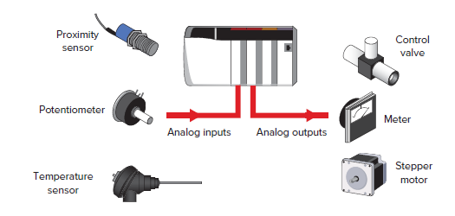

**FIG 10.4 ANALOG INPUTS & OUTPUTS**

### 10.4 DIGITAL MODULE:

### Discrete or digital type input modules are designed to monitor ON/OFF devices such as selector switches, pushbuttons, and limit switches. Likewise, discrete output modules control devices such as lights, relays, solenoids, and motor starters that require simple ON/OFF switching. The classification of discrete I/O covers bit-oriented inputs and outputs. In this type of input or output, each bit represents a complete information element in itself and provides the status of some external contact or advises of the presence or absence of power in a process circuit.

### 

### FIG 10.5 DIGITAL INPUT & OUTPUT

### 10.4 TYPES OF COMMUNICATION PROTOCOLS IN PLC

Communication protocols in PLC (Programmable Logic Controller) systems are essential for ensuring reliable data exchange between various components within an automation system. These protocols define the rules and standards for transmitting information between the PLC and other devices such as sensors, actuators, Human-Machine Interfaces (HMIs), and other controllers. Key communication protocols commonly used in PLC systems include:

1. **Modbus:**

Modbus is one of the most widely used communication protocols in industrial automation. It is a simple, open, and robust protocol that allows communication between various devices over serial lines (RS-232, RS-485) and Ethernet. Modbus supports both master-slave and client-server communication models, enabling interoperability among different devices from various manufacturers.

**RS-232:** RS-232 (Recommended Standard 232) is a standard for serial communication used to connect data terminal equipment (DTE) such as computers and data communication equipment (DCE) like modems. It typically uses a 9-pin or 25-pin connector and operates at relatively short distances, typically up to 50 feet. RS-232 communication is simple and cost-effective, making it suitable for point-to-point connections. However, it is limited by its low data transfer rates and short communication range.

**RS-485:** RS-485 (Recommended Standard 485) is a standard for serial communication that allows for longer distance and higher data transfer rates compared to RS-232. RS-485 supports multi-drop configurations, enabling multiple devices to be connected on the same communication line. This standard is commonly used in industrial environments for robust and reliable communication.

**RS-485 2-Wire Configuration:**

* In a 2-wire RS-485 configuration, a single twisted pair of wires is used for both transmitting (TX) and receiving (Rx) data. This setup requires half-duplex communication, where devices take turns sending and receiving data. The two wires, typically labelled A and B, form a differential pair that helps reduce noise and interference. This configuration is simple and cost-effective, making it suitable for many industrial applications where full-duplex communication is not required.

**RS-485 4-Wire Configuration:**

* In a 4-wire RS-485 configuration, two twisted pairs of wires are used—one pair for transmitting data and the other pair for receiving data. This setup allows for full-duplex communication, where data can be sent and received simultaneously. The additional wires provide greater flexibility and higher performance, making this configuration ideal for applications that require continuous data exchange without interruption. The four wires are typically labeled as Tx+, Tx-, Rx+, and Rx-.

1. **Ethernet/IP:**

Ethernet/IP (Industrial Protocol) is an application layer protocol used in industrial automation applications. It utilizes standard Ethernet for communication, providing high-speed data exchange and integration with IT systems. Ethernet/IP supports both real-time and non-real-time communication, making it versatile for various automation tasks

1. **HART:**

HART (Highway Addressable Remote Transducer) communication protocol is a hybrid communication protocol that combines digital signals with the 4-20 mA analog signal. It was developed to enhance the traditional 4-20 mA standard by adding digital communication capabilities, enabling more detailed information exchange between field instruments and control systems.

**Working Principle:** HART communication superimposes a low-level frequency-shift keying (FSK) digital signal on top of the standard 4-20 mA analog signal. The analog signal continues to carry the primary process variable information, while the digital signal carries additional data such as device status, diagnostics, and configuration details.

The FSK signal uses two frequencies, 1,200 Hz and 2,200 Hz, to represent binary '0' and '1', respectively, allowing for simultaneous transmission of analog and digital data without interference.

.

### 

### CHAPTER 11

## AST PLC IN IOCL TERMINAL

**11.1 INTRODUCTION**

AST PLC is used to monitor the bays where tank filling takes place, allowing for both automatic and manual operations. This is managed by configuring the smart terminal manager and batch controller in the bays, ensuring seamless integration and control. The General Electric PLC monitors equipment in the bays, such as flow meters, Earthing relays, overspill detectors, densitometers, etc., with separate PLCs for process and safety operations.

The process of filling fuel in trucks at Indian Oil terminals has transitioned from manual to automated systems with the implementation of the Terminal Automation System (TAS). Previously, fuel flow through pipelines from tanks was controlled manually using control valves and push buttons. An operator would set the volume of fuel to be filled in the trucks (in kiloliters) using a batch-controlled system, similar to the Tank Lorry Filling (TLF) system.

With TAS, the entire process is automated. Proximity cards, which contain wound coils for data transmission, are issued to all IOCL customers. When truck drivers arrive at the IOCL terminal for filling, they use these proximity cards. The customer’s indent is registered on SAP. The truck driver shows the registered proximity card at the TT parking gate, where the card reader records the TT number and communicates with SAP via TAS software. SAP then creates a sales order and sends it to the Tank Truck Entry System (TTES), issuing an auto Filling Advance Note (FAN).

Once the truck entry is registered during the security check, a bay is allocated. The bay number, batch control ID, and available product are displayed to the driver, and the required volume of fuel is updated in SAP. When the truck reaches the specified bay, the driver presents the proximity card to a sensor attached to the batch controller. TAS verifies that all interlocks are in place, such as ensuring the TT is grounded and the loading arm is correctly positioned. If the interlocks are not in place, fuel dispensing is halted.

As the card is scanned, the vehicle number and product quantity are displayed on the Remote Interaction Terminal (RIT) for operator acknowledgment. After filling, the valves are automatically closed using NO-NC solenoids controlled by a Programmable Logic Controller (PLC). The loading arm is then removed, and the openings are sealed.

Upon exiting, the driver scans the card again at the sensor, rechecking the details and generating an invoice, which is also sent to the customer dealer. Real-time updates are provided to the customer’s ID, including notifications such as TN 09N 4112 “inside loading area”, “ready to fill”, “in progress,” and “dispatched.”

### C:\Users\keerthivasan\AppData\Local\Microsoft\Windows\INetCache\Content.Word\2.png

### FIG 11.1 COMMUNICATION NETWORK BETWEEN AST AND IOCL

### 

### 11.2 SMART TERMINAL MANAGER

The image which is shown below shows the system architecture of TLF. This set up is done using SCADA software. This panel will visible in the control room. It shows which equipment is connected and which ones are online.

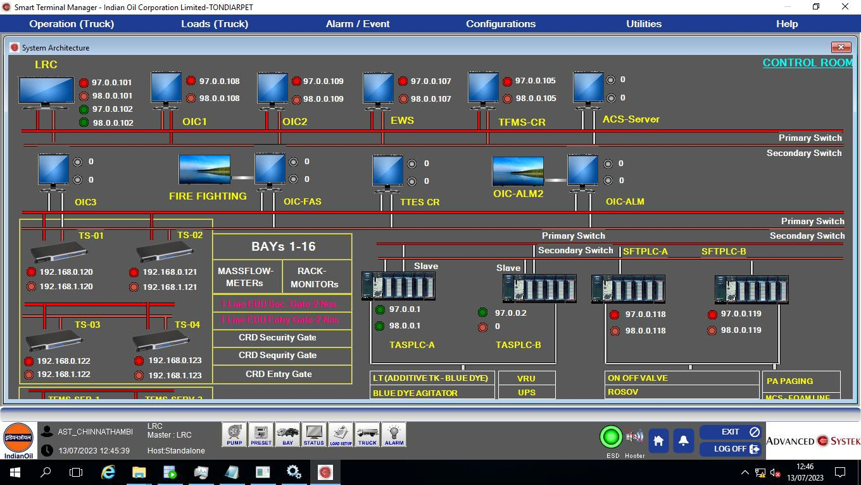

**FIG 11.2 SYSTEM ARCHITECTURE OF AST**

This interface displays the details of trucks in each bay which are getting filled at a time and the details of the trucks which are waiting in queue to get filled in each bay.

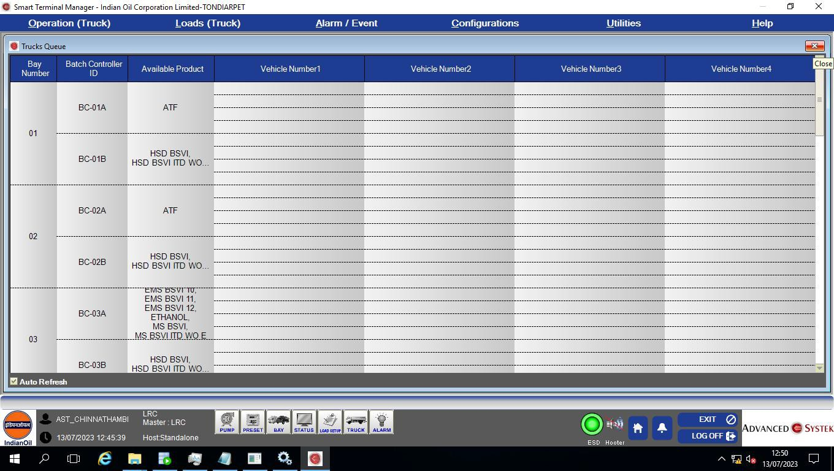

**FIG 11.3 TRUCK QUEUE**

This displays the details of the bay such as whether the filling has started; the progress of filling, quantity filled, whether the TT is grounded,etc.

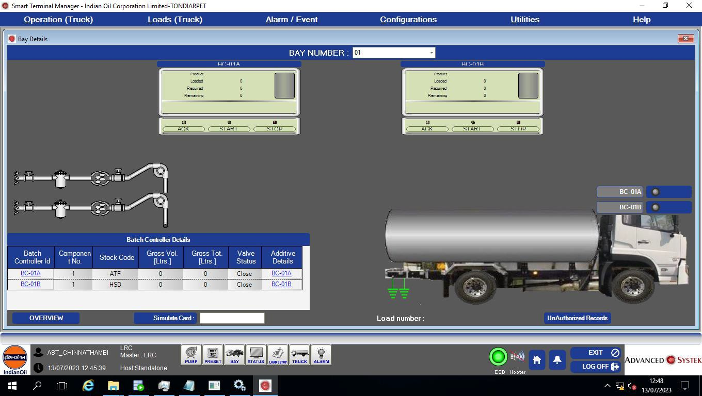

**FIG 11.4 BAY DETATLS**

Tank details can be seen in this tab; the quantity of the product in each tank, its tank code and display number.

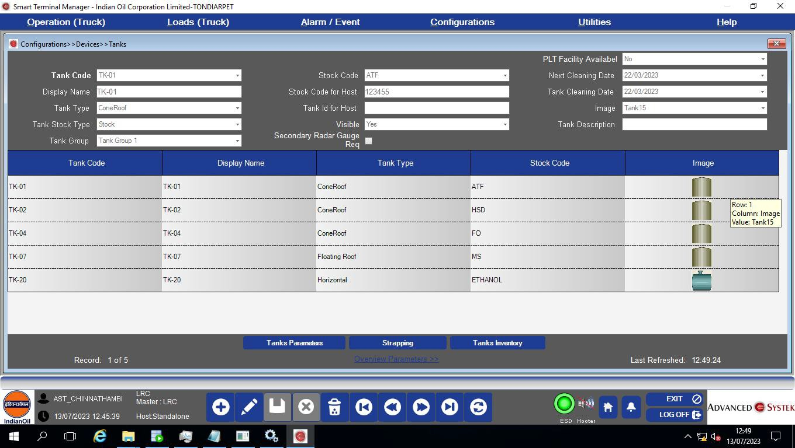

**FIG 11.5 CONFIGURATION OF TANKS**

**11.3 OPERATION PROCEDURE FOR TLF AT IOCL**

1. After getting FAN slip and card to the driver. The driver needs to verify the product TT no. card no. destination party name.
2. Driver take the TT and stop near the entry gate and show the proximity card on entry card reader the gate entry gate will open once green signal appears he need to take the TT and get inside .The entry gate automatically close.
3. The driver need to check the WB signal lamp if it is red indication he need to place the TT in the center on the WB and he get down and show the card reader on WB card reader, once the signal lamp changes from red to green or yellow again it goo to red.then the driver need to move the TT from the weigh bridge.if the signal only blinks red signal he need toinform the officer.

Once TT is green or yellow then the status become TT ready to load.

1. Once the TT reaches the gantry he need to stop the TT front of line on the bay and need to ask the operation officer for placing the TT for filling.
2. Once placed on the gantry he need to connect the earth, adapter & coupler to the manifold of the TT. The driver needs to open the valves of the manifold of the TT & compartment.
3. He need to check the handle valves if it close he need open and show the card on the car reader.
4. He need to check the TT no. and product as per FAN slip in batch controller and he need to acknowledge the yellow button in RIT.
5. Then everything is correct he need to start(press the green button)and filling will start, like he need to complete all the compartments and he need to remove the coupler & adapter.

Complete status will on STM

1. Once dip checking is over he need to take the truck after removing the earth and stopper.
2. He needs to place the TT on the weighbridge for gross weight & he need to show the card on the card reader.

Traffic lamp will be glow according to the weight.(vehicle master)

1. He need to remove the TT and bill will be printed in the S&D or in control room.
2. After getting the bill the driver need to show the card on the exit card reader and gate will open then TT status will be closed and he need to handover the card and get the invoice or bill at S&D.

**11.4 PREPARATTON OF FTLLING ADVICE NOTE (FAN) IN SMART TERMTNAL MANAGER(STM)**

1. Enter user id and password for the STM and Go to setup.
2. Enter the given truck no by pressing the add button on below
3. Select the compartment by pressing the compartment product name, party name, destination name by pressing add button given below and save it show any proximity card on the card reader and press OK.
4. FAN slip will automatically print. If not printed go to vehicle screen and re-print the select truck.
5. Truck no., bay no.will is displayed on display board.
6. FAN slip and same proximity card to be hand over to TT driver for filling

**CHAPTER 12**

**HONEYWELL PLC IN IOCL TONDAIRPET**

**TERMINAL**

**12.1 INTRODUCTION**

Honeywell PLC is connected to the sensors of the tank farm, utilizing a SCADA system named Station for comprehensive monitoring and control. This ensures robust monitoring and control of terminal operations, integrating safety systems, redundancy, and precise measurement tools to manage fuel storage and distribution efficiently**.**

**12.2 SYSTEM ARCHITECTURE OVERVIEW OF HONEYWELL PLC**

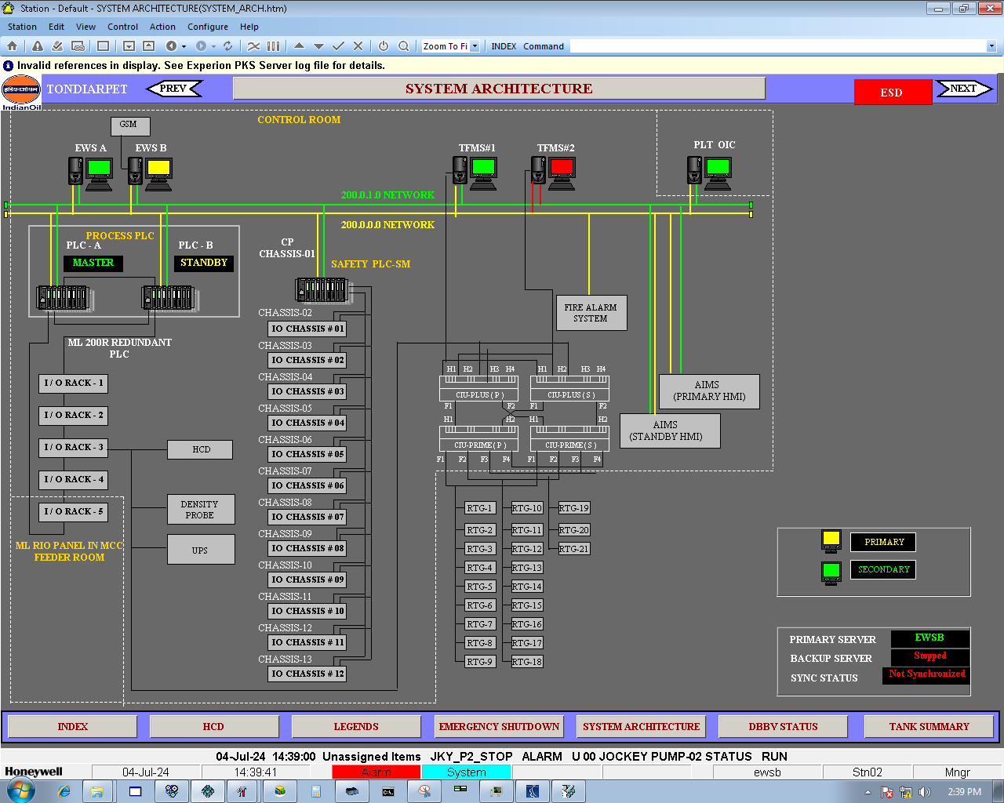

**FIG 12.1 SYSTEM ARCHITECTURE OF HONEYWELL PLC**

**Control Room:**

* Equipped with two Engineering Workstations (EWS), labeled EWS A and EWS B, for primary and standby operations.
* These workstations are connected via a 200.0.0.0 network, ensuring seamless data communication and control capabilities.

**PLC Configuration:**

* **Process PLC:**
  + PLC-A (Master), handling the primary control tasks and data processing.
  + PLC-B (Standby), providing redundancy to take over in case of PLC-A failure.
* **Safety PLC:**
  + Safety PLC-SM, connected to fire alarm systems and critical monitoring points, ensuring immediate response during emergencies.

**I/O Racks:**

* Five I/O racks connected to the ML 200R Redundant PLC, managing various inputs and outputs for comprehensive control.
* A dedicated I/O rack for the density probe, crucial for monitoring the quality of stored fuel.
* UPS (Uninterruptible Power Supply) included to ensure a constant power supply to critical components, maintaining system reliability.

**Chassis Configuration:**

* Multiple chassis (#01 to #12) connected to various inputs and outputs, facilitating extensive monitoring and control throughout the terminal.

**Fire Alarm System:**

* Integrated into the network, ensuring safety and timely response during emergencies by triggering alarms and initiating protective actions.

**HMI Systems:**

* Primary and Standby AIMS (Automated Integrated Management System) for human-machine interface, allowing operators to monitor and control processes effectively.
* Each HMI system is connected to ensure redundancy and continuous operation, minimizing downtime.

**RTG (Radar Tank Gauges):**

* Multiple RTGs (#1 to #20) connected for precise level measurement in storage tanks, ensuring accurate monitoring of fuel levels and preventing overfill or depletion.

**Primary and Secondary Servers:**

* EWS B is the primary server, handling the main data processing and control tasks.
* EWS A is the secondary server, providing redundancy to ensure continuous operation.
* Sync status indicates the need for alignment, ensuring both servers are synchronized for redundancy.

**Redundancy and Safety Features:**

* The system includes various statuses and alarms, indicated by color codes: Red for alarms, Green for system running, and Yellow for attention required.
* System information includes time, date, and specific alerts like "TANK_15_OVERFLOW" indicating an overflow status for a specific tank, or "VALVE_03_FAULT" indicating a malfunctioning valve.

**12.3 Main index of station SCADA:**

The main index screen provides a comprehensive overview of various systems, utilities, and statuses at the Tondiarpet terminal. This centralized dashboard allows for efficient monitoring and control of different operations within the terminal. Below is a breakdown of the different sections and their functionalities:

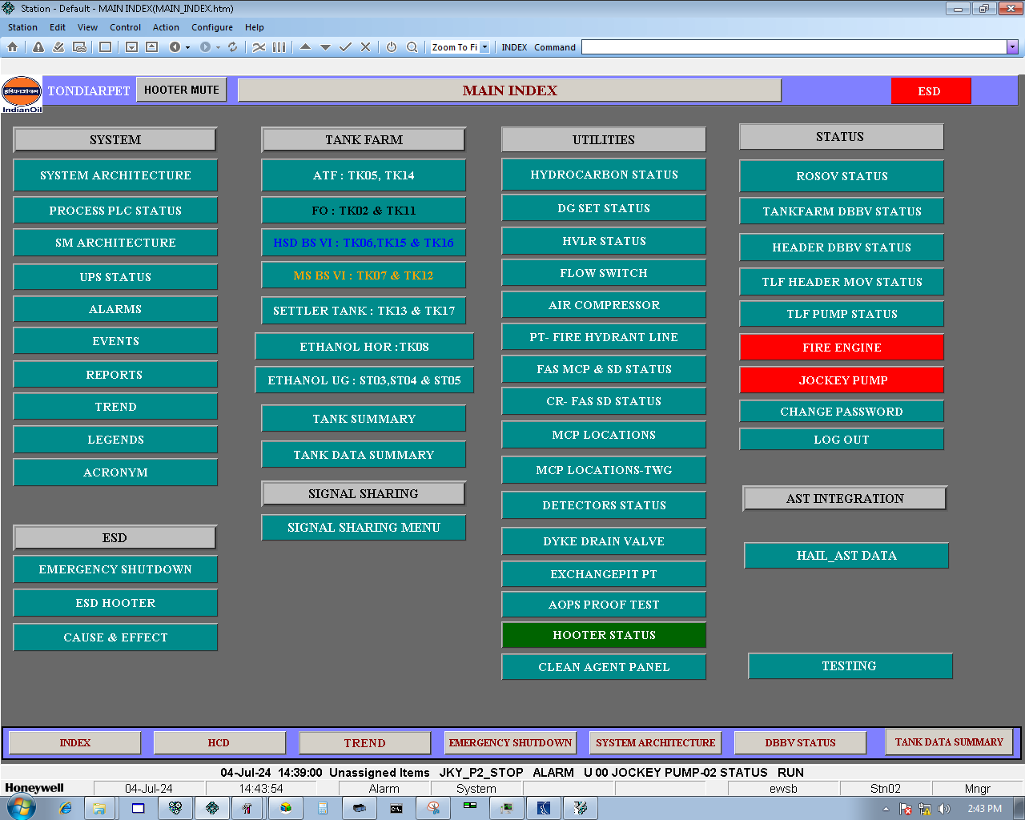

**FIG 12.2 MAIN INDEX OF STATION**

1) **System Section**

* **System Architecture:** Provides a visual representation of the entire system layout.
* **Process PLC Status:** Monitors the status of process PLCs (Programmable Logic Controllers) that control various terminal operations.
* **SM Architecture:** Displays the architecture of the Smart Management system.
* **UPS Status:** Shows the status of Uninterruptible Power Supplies ensuring continuous power.
* **Alarms, Events, Reports, Trend:** Essential for tracking and logging different operational events, generating reports, and analyzing trends.
* **Legends, Acronym:** Helps in understanding the symbols and abbreviations used in the system.
* **ESD (Emergency Shutdown):** Contains options for emergency shutdown procedures including hooter status and cause & effect analysis.

#### 2) Tank Farm Section

* **Specific Tanks:** Details status and management of various tanks including:
  + **ATF (Aviation Turbine Fuel):** TK05, TK14
  + **FO (Fuel Oil):** TK02, TK11
  + **HSD BS VI (High-Speed Diesel BS VI):** TK06, TK15, TK16
  + **MS BS VI (Motor Spirit BS VI):** TK07, TK12
  + **Settler Tank:** TK13, TK17
  + **Ethanol HOR:** TK08
  + **Ethanol UG (Underground):** ST03, ST04, ST05
* **Tank Summary & Data Summary:** Provides summaries and detailed data of all tanks.
* **Signal Sharing:** Menu for managing signal sharing configurations.

#### 3) Utilities Section

* **Status Monitors:** Monitors status of various utilities essential for terminal operations, including:
  + Hydrocarbon, DG Set (Diesel Generator), HVLR (High Volume Low Speed Rotary), Flow Switch, Air Compressor, PT (Fire Hydrant Line), FAS (Fire Alarm System) MCP & SD, CR (Control Room) FAS SD, MCP Locations, Detectors, Dyke Drain Valve, Exchange Pit PT, AOPS (Automatic Overfill Protection System) Proof Test, Hooter Status, Clean Agent Panel.

#### 4) Status Section

* **ROSOV (Remote Operated Shut Off Valve) Status:** Monitors the status of ROSOVs.
* **Tank farm DBBV (Double Block and Bleed Valve) Status:** Displays the status of DBBV systems.
* **Header DBBV Status:** Monitors DBBV at the header.
* **TLF (Truck Loading Facility) Header MOV (Motor Operated Valve) Status, Pump Status:** Displays the status of valves and pumps in the TLF.
* **Fire Engine & Jockey Pump:** Monitors the status of fire engines and jockey pumps, crucial for safety.
* **Change Password, Log Out:** Options for security and system access management.
* **AST Integration & HAIL AST Data:** Manages Aboveground Storage Tank integration and data.

**12.4 A detailed view of the HSD BSVI storage tanks 6, 15 and 16 at the Tondiarpet terminal in station SCADA:**

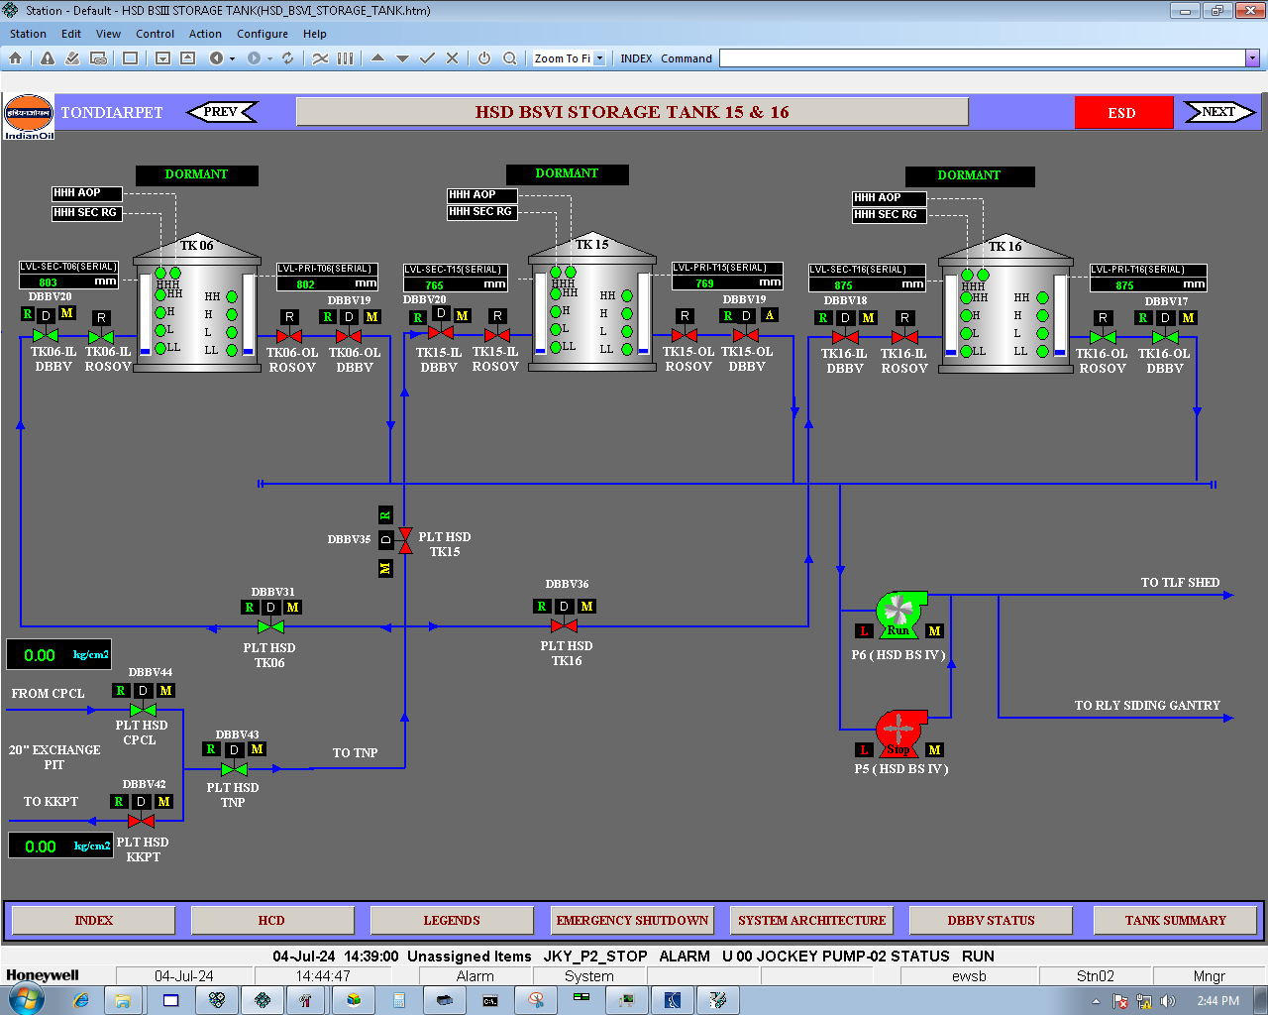

**FIG 12.3 TANK 6,15,16 STATUS IN STATION VIEW**

• **Storage Tanks:**

* **TK06, TK15, and TK16:**
  + Each tank is equipped with various level indicators: H (High), HH (High High), LL (Low Low), and OL (Overflow Level).
  + Each tank also has ROSOV (Remote Operated Shut Off Valves) for safety and control.
* **Pipeline Network:**
* The diagram shows the flow of HSD (High-Speed Diesel) from the tanks through various pipelines.
* **DBBV (Double Block and Bleed Valves):**
  + DBBV31, DBBV32, DBBV33, DBBV35, DBBV36, DBBV42, DBBV43, and DBBV44 are indicated along the pipeline network for isolating sections and ensuring safety.
* **PLT HSD (Pipeline Transport for HSD):**
  + Indicates different sections such as TK06, TK15, and TK16 along with connections to CPCL, TNP, INP, and other destinations.
* **Pressure Gauges:**
  + Displays the pressure in kg/cm² at various points to monitor the flow and ensure it is within safe limits.
* **Pump Configuration:**
* **P5 and P6 (HSD BS IV Pumps):**
  + Indicates the status of the pumps (RUN or STOP).
  + These pumps are responsible for moving the HSD from storage tanks to different destinations like the TLF shed and the railway siding gantry.
* **Tank Gauging and Safety Systems:**
* **LL, HH, HHH AOP (Auto Overfill Protection), HHH SEC RG (Secondary Remote Gauge):**
  + These safety measures ensure that tanks do not overflow and that levels are maintained within operational limits.
* **Dormant Status:**
  + Indicates tanks that are not currently in active use or are being maintained.
* **Flow and Control:**
* **Valve Control:**
  + The network includes various control valves that can be manually or remotely operated to direct the flow of HSD.
* **Legend and Indicators:**
  + Red (R), Yellow (A), Green (D), and Blue (M) indicators show the status of valves and flow points, helping operators quickly identify the operational state.

**CHAPTER 13**

**PROJECTS**

**13.1 LIST OF PROJECTS**

I have actively contributed to the successful execution of the projects listed above.

* + 1. Enhancing Fuel Delivery Accuracy through Automated Calibration of Positive Displacement Meters at Tondiarpet Terminal Bays for truck filling

2) Field Data Collection for Tracking Calibration Due Dates and Serial Numbers of PD and Mass Flow Meters at Indian Oil's Tondiarpet Terminal

3) CPU Card Replacement and Parameter Reconfiguration for Bay 3 Batch Controller

4) Installation of Magnetic Proximity Sensor for Dyke Drain Valve 10 on Tank 2

5) Testing and Verification of AOPS at Tanks 15 and 16 Systems at Various Locations in the Tank Farm

**13.2 Enhancing Fuel Delivery Accuracy through Automated Calibration of Positive Displacement Meters at Tondiarpet Terminal Bays for truck filling**

**Steps Involved:**

1. **Setup:**
   * Fix the master PD meter skid between the tank (from which the product comes) and the bay PD meter skid in which trucks are filled.

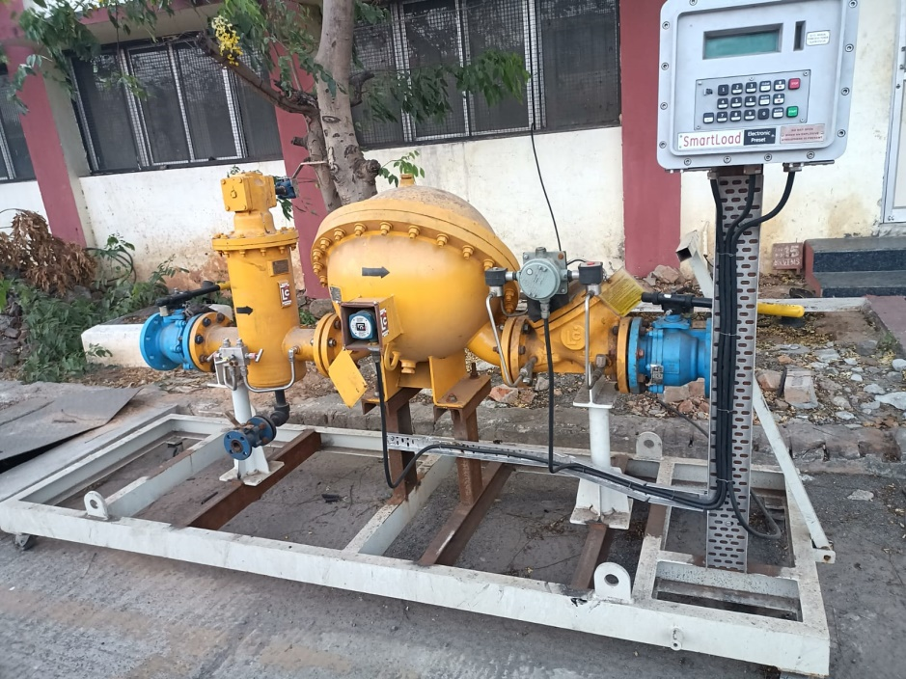

**FIG 13.1 MASTER PD METER SKID**

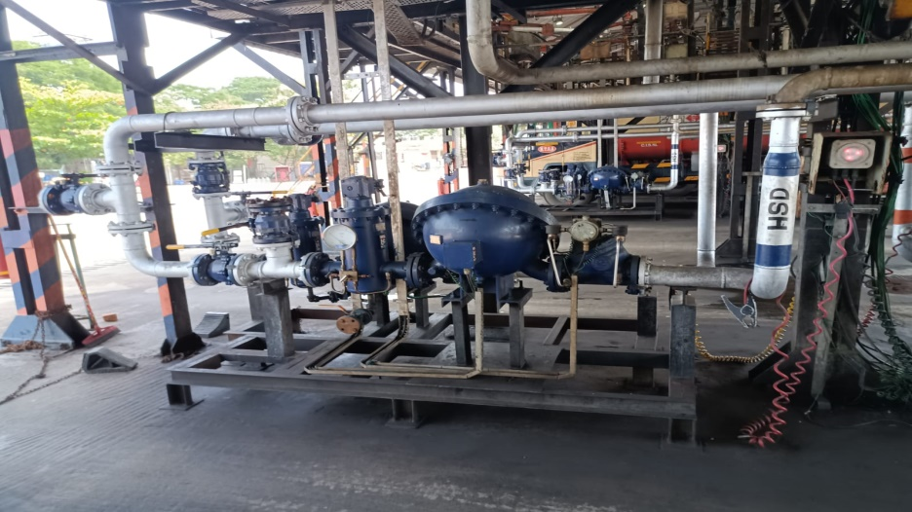

**FIG 13.2 BAY PD METER SKID**

1. **Preset Values:**
   * Set the Preset value in the master batch controller (e.g., 4000) and in the bay's batch controller.
   * Check the delivery quantity in both the master controller and specific bay batch controller.
2. **Dip Quantity:**
   * Manually check and note the dip quantity in the truck compartments.
3. **Accuracy Check:**
   * Determine the exact amount of excess or fewer products filled in the truck.
4. **Readings Noted:**
   * Record the details manually such has truck number, truck loading bay number, flow rate (lpm), product name, Preset quantity (l),delivered quantity(l),dip quantity (l)and calibration place of truck
   * Covert the reading into excel sheet
5. **Repetition:**
   * Repeat the process for each truck and bays from 14/06/24 to 19/06/24
   * An excel is created separate for trucks calibrated in tondairpet terminal and korukkupet terminal
   * With this excel we can find average how much litres filled in the trucks from each bays
   * We can conclude the error in each bays in filling trucks compartment
6. **Calculate New Meter Factor:**
   * Take the average dip quantity and Preset quantity for individual bays
   * Using the reading of dip quantity to preset quantity from the batch controller in the bays, multiply it with the old meter factor of the PD meter:

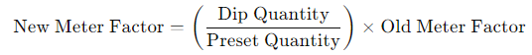

1. **Enter New Meter Factor:**
   * Input the new meter factor into each batch controller in the bays
2. **Batch Controller Configuration:**
   * Press Alt + Clear.
   * Enter the passcode.
   * Click Setup.
   * Enter the new meter factors and related parameters:

**TABLE 13.1 PARAMETRS IN BATCH CONTROLLER TO BE CHANGED**

|  |  |
| --- | --- |
| 540 | Number of factors/component |
| 541 | Meter factor method |
| 542 | Nominal K-factor |
| 543 | Master meter factor |
| 544 | Stop rate |
| 545 | Flow rate 1 |
| 546 | Meter factor 1 |
| 547 | Flow rate 2 |
| 548 | Meter factor 2 |
| 549 | Flow rate 3 |
| 550 | Meter factor 3 |
| 551 | Flow rate 4 |
| 552 | Meter factor 4 |

1. **Repeat:**
   * Repeat the same procedure for each batch controller in the bays.
2. **Verification:**
   * Check again whether the dip quantity matches the preset quantity, referring to the Excel calibration sheet for accuracy.

**13.3 Field Data Collection for Tracking Calibration Due Dates and Serial Numbers of PD meters, and Mass Flow Meters at Indian Oil's Tondiarpet Terminal**

**Steps Involved:**

1. **Field Survey:**
   * Conduct a thorough search around the terminal to locate all types PD meters and Mass Flow Meters.
   * Record the serial numbers and make of each meter.
2. **Document Verification:**
   * Use the collected serial numbers and make to check the corresponding documents and records.
   * Also search for the responsible company for calibration whether IOCL or AST
   * Verify the calibration status and due dates for each meter.
3. **Data Entry:**
   * Create an Excel spread sheet to systematically log the serial numbers and calibration due dates.

**13.4 CPU Card Replacement and Parameter Reconfiguration for Bay 3 Batch Controller**

The CPU card in the batch controller for Bay 3 due to slower response times. The steps ensured that the new CPU card was properly configured with the necessary parameters.

**Steps Involved:**

1. **Note Existing Parameters:**
   * Record all the parameters from the current CPU board in the batch controller. This includes around 701 parameters that need to be re-entered into the new CPU card.
2. **Replace the CPU Card:**
   * Open the batch controller.
   * Carefully remove the old CPU board.
   * Install the new CPU board.
3. **Enter Parameters into the New CPU Card:**
   * Press Alt + Enter to access the parameter setup menu.
   * Enter the passcode to unlock the setup configuration.
   * Navigate to the setup section.
   * Enter all the noted parameters into the new CPU card manually.



**FIG 13.3 BATCH CONTROLLER**

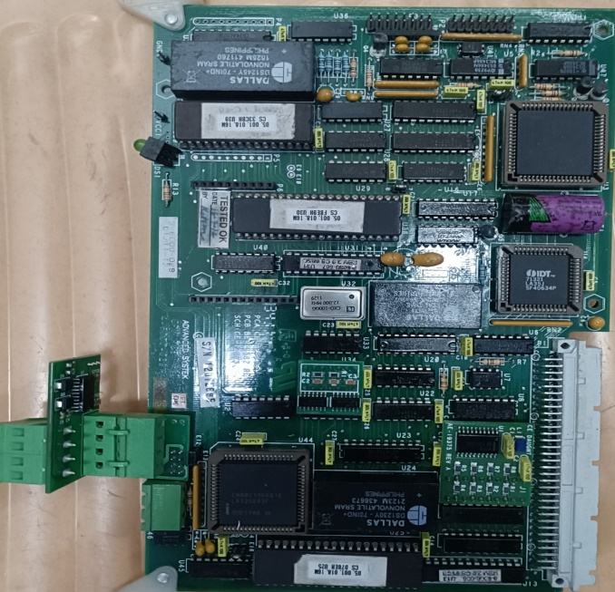

**FIG 13.4 CPU CARD OF BATCH CONTROLLER**

**13.5 Installation of Magnetic Proximity Sensor for Dyke Drain Valve 10 on Tank 2**

**Apparatus Required:**

1. OSNA Magnetic Proximity Sensor
2. Barrier Relay
3. Connecting Wire
4. Flange

**Working Principle:**

The magnetic proximity sensor continuously supplies a 4V signal. When a change in the dyke drain valve position is detected, the sensor outputs 8V to the barrier relay. The barrier relay then amplifies this 8V signal to 24V, which is sent to the Honeywell PLC. The PLC processes this signal, and if an undesired change in the valve position is detected, it triggers a hooter alarm in the control room, alerting operators to the issue. This ensures continuous and precise monitoring of the valve's position for enhanced safety and operational integrity.

**Steps Involved:**

1. **Placement of Magnetic Proximity Sensor:**
   * Position the OSNA magnetic proximity sensor correctly to detect even small changes in the dyke valve's position. Ensure that the sensor can detect any movement of the valve.
2. **Connecting the Sensor:**
   * Connect the output wire of the magnetic proximity sensor to terminals 1 and 2.
   * In Barrier relay the output from proximity sensor is given to 1,3 as input, supply at 9(-), 12(+), output of barrier relay is taken from 7,8
3. **Connecting to Barrier Relay:**
   * Connect the sensor's output wire to the barrier relay. The barrier relay is essential for ensuring that the signal from the sensor is safely transmitted.
4. **Connecting to PLC:**
   * Connect the output voltage from the barrier relay to the Honeywell PLC. This connection allows the PLC to receive signals from the proximity sensor.
5. **Hooter Alarm Configuration:**
   * Configure the system so that when the magnetic proximity sensor detects a change in the valve's position, the barrier relay sends a signal to the PLC. Based on this output, the hooter alarm in the control room will ring, alerting the operators of any changes.

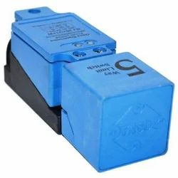

**FIG 13.5 MAGNETIC PROXIMITY SENSORS**



**FIG 13.6 OSNA BARRIER RELAY**

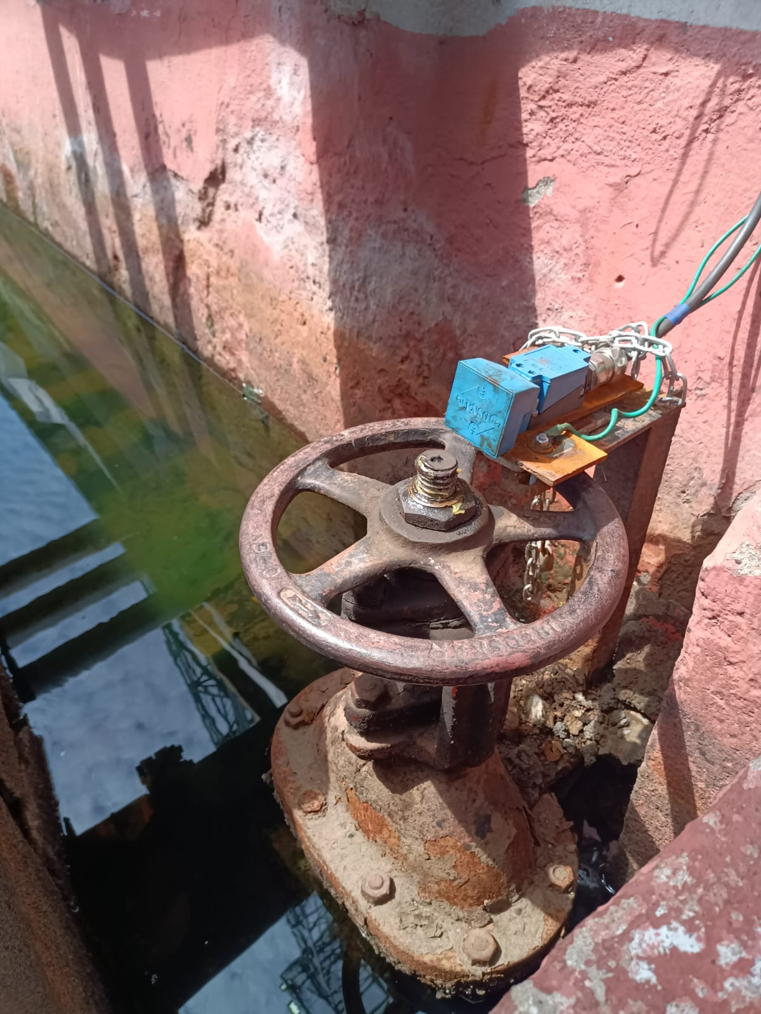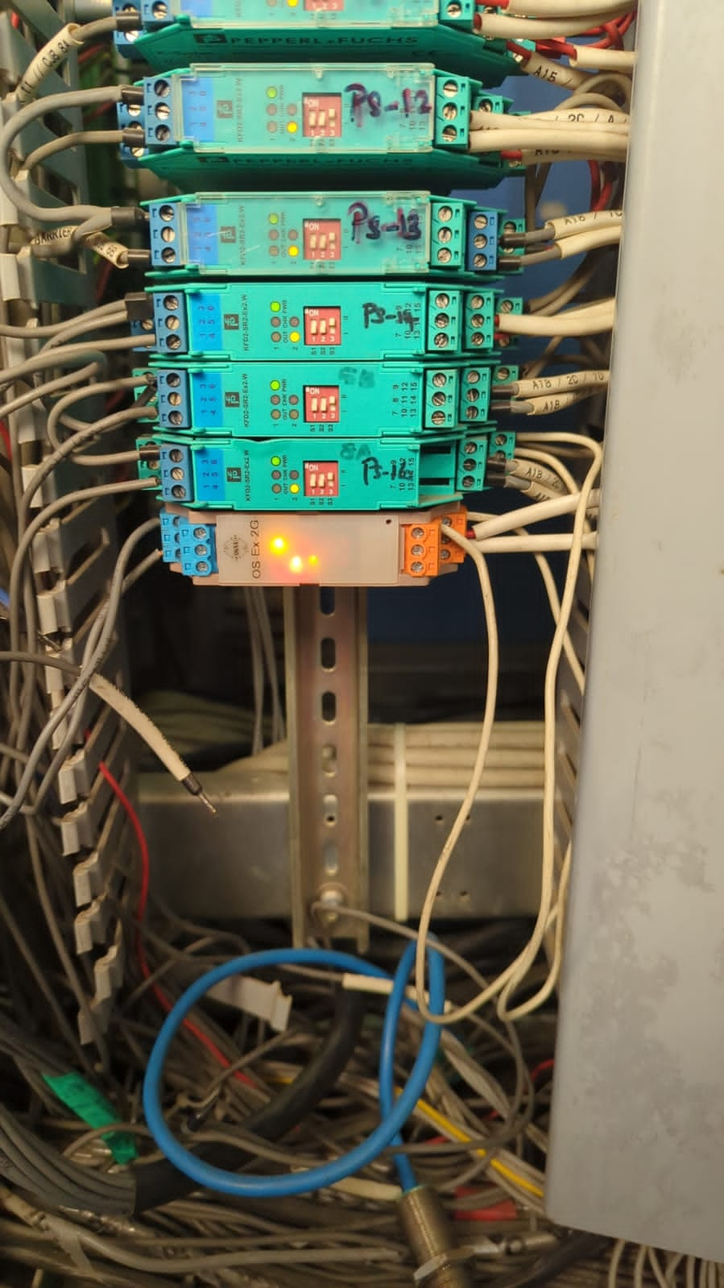

**FIG 13.7 INSTALLATION OF MAGNETIC PROXIMITY SENSOR**

**13.6 Testing and Verification of AOPS at Tanks 15 and 16, and MCP Systems at Various Locations in the Tank Farm**

**Apparatus Required:**

1. Non-sparkle tools to remove AOPS
2. Bucket of water

#### Steps Involved:

1. **Force AOPS in Station SCADA:**
   * For safety purposes, force the AOPS in the Station SCADA system.
2. **Verify ROSOV Initial State:**
   * Ensure that the ROSOV (Remote Operated Shut Off Valve) is in the open state initially.
3. **Safely Remove AOPS:**
   * Using non-sparkle tools, carefully remove the AOPS from the tank without disturbing the tuning fork.
4. **Disable Forced Condition:**
   * Disable the forced condition on the SCADA system.
5. **Test AOPS in Water Bucket:**
   * Place the AOPS in a bucket of water.
   * Observe if the ROSOV closes. If the ROSOV does not close, the AOPS is not functioning correctly and needs replacement.

These steps ensure the proper testing and verification of AOPS at Tanks 15 and 16

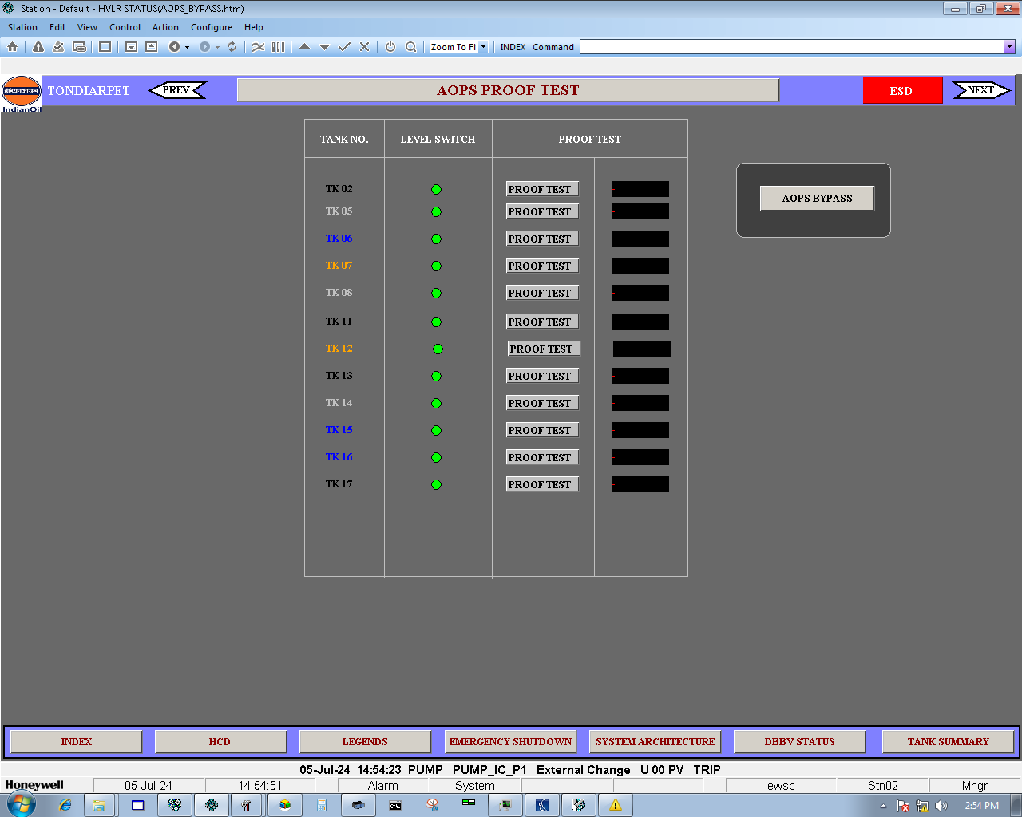

**FIG 13.8 STATION VIEW OF AOPS**

**CHAPTER 14**

# **CONCLUSION**

We hereby conclude that this report is a condensed version of the knowledge we gained and project during my internship period in IOCL -Tondiarpet Terminal during the period from 12.06.24 to 12.07.24

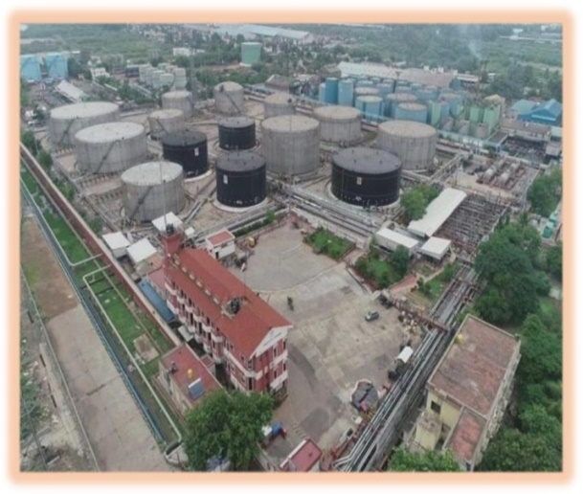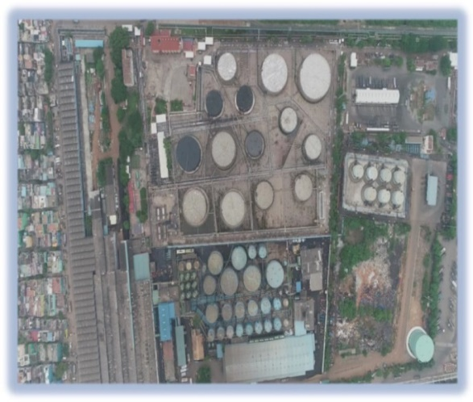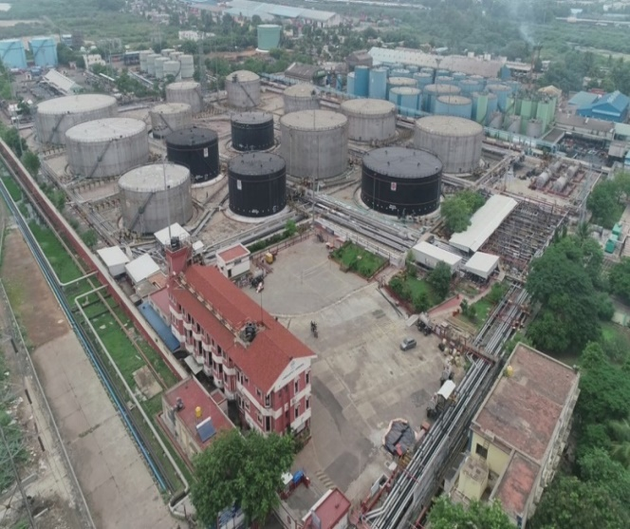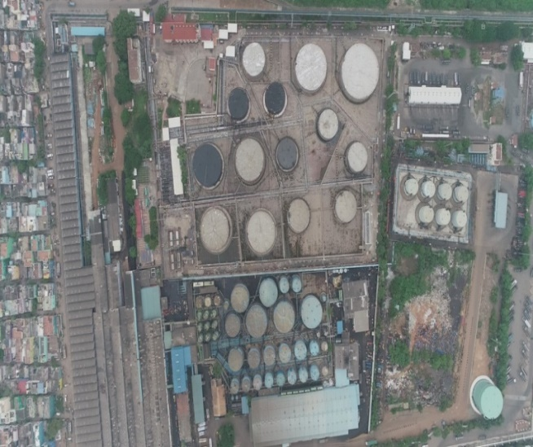

**FIG 14.1 AERIAL VIEW OF TONDAIRPET TERMINAL**